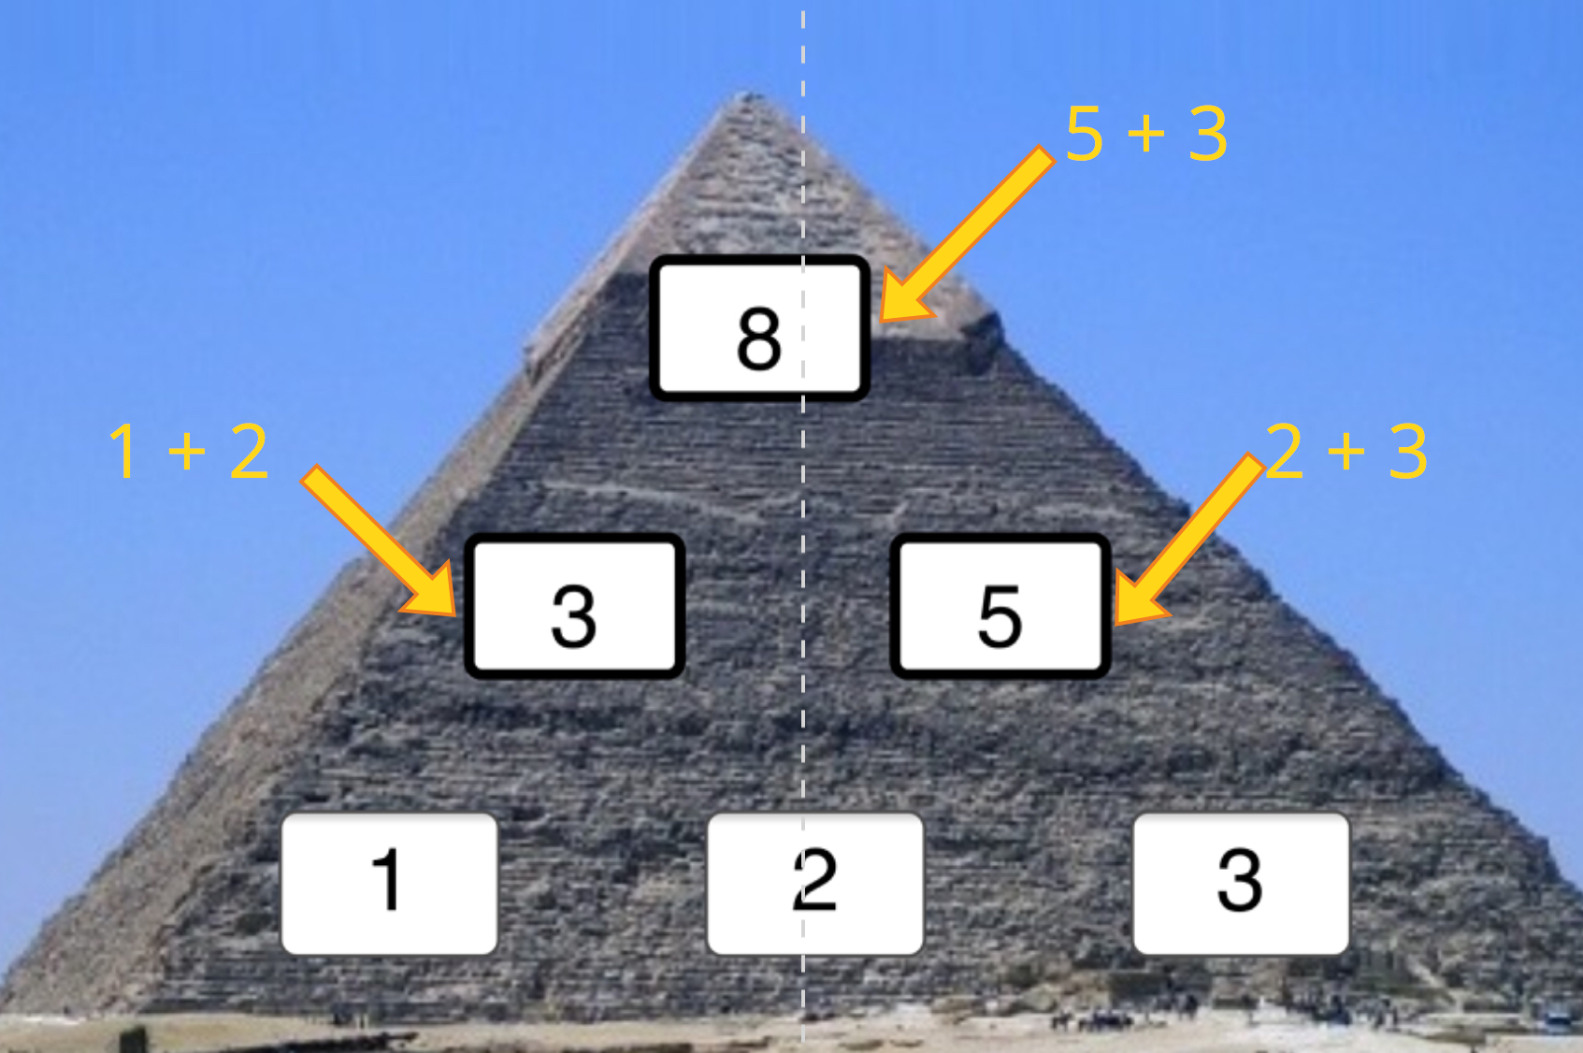
The pattern to this pyramid is that a number is the sum of the two numbers below. For example, in the diagram, 3 = 1 + 2, 5 = 2 + 3, and 8 = 3 + 5. To find the top layer without finding the middle layers, I first thought that for the three bottom layers should be a, b, and c. A is the bottom left number, b is the bottom middle number and c is the bottom right number. That means the middle layers are a + b, and b + c because of the pattern of the pyramid. That causes the top layer to be a + b add b + c so it’s a + b + b + c. That makes the formula of finding the top number a + 2b + c. If you change the order of the bottom layer, the top number will change. This happens because the number that is used twice has to be the middle number.

