Find the range of values of x for which $\sqrt{x}+\frac{1}{\sqrt{x}}<4$ where $\sqrt{x}$ is the positive root.

graphic approach:
The graph of the function y =$\sqrt{x}+\frac{1}{\sqrt{x}} , x>0$ is like shown below (the pink one). Neither very large nor very small values of x satisfy the inequation $\sqrt{x}+\frac{1}{\sqrt{x}}<4$ . If the values of x converge 0, the first summand $\sqrt{x}$ will be so small, that it does not play a crucial role anymore. The more x converge 0, the greater the value of y and the y-axis becomes the asymptote. If the values of x are infinitely large, the result of $\sqrt{x}+\frac{1}{\sqrt{x}}$ is surely greater than 4. 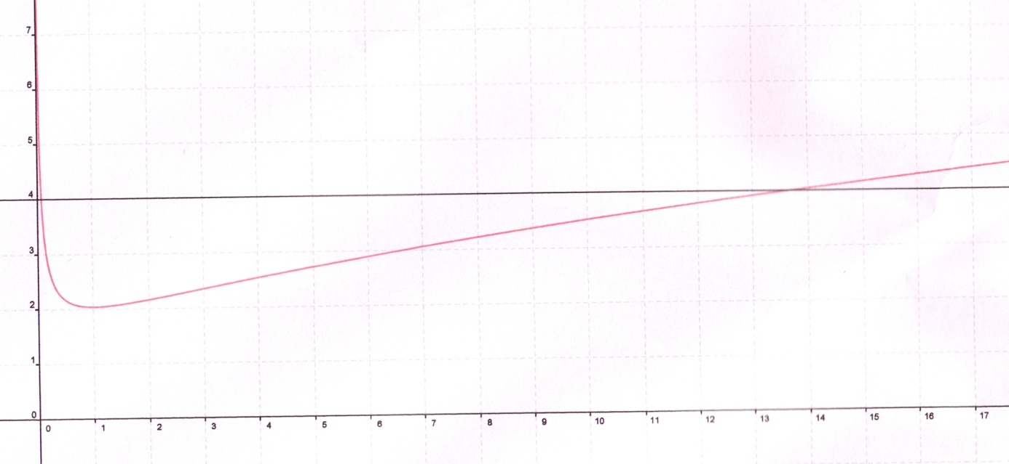
In order to find out the range of values of x for which $\sqrt{x}+\frac{1}{\sqrt{x}}<4$ graphically, it is important to detect all x-values whose y-values, y =$\sqrt{x}+\frac{1}{\sqrt{x}}$ , are less than 4, which means, we draw y=4 (the black graph) and the piece of the pink graph below y=4 meets the condition$\sqrt{x}+\frac{1}{\sqrt{x}}<4$ .
The intersections on the LHS and RHS between y=4 and y =$\sqrt{x}+\frac{1}{\sqrt{x}}$ set limits of x-values’ range.
This method of identification of intersections´ x-values by reading off is extremely imprecise; on the LHS we have $≈0,1$ , on the RHS $x≈14$, hence 0,1 < x < 14 for $\sqrt{x}+\frac{1}{\sqrt{x}}<4$.

For knowing the exact range of values of x for which $\sqrt{x}+\frac{1}{\sqrt{x}}<4$ , we should have a look on another approach:
algebraic solution:
$$\sqrt{x}+\frac{1}{\sqrt{x}}<4$$
$$x+1<4\sqrt{x}$$
$$x-4\sqrt{x}+1<0$$
${(\sqrt{x})}^{2}-2*\sqrt{x}*2+2^{2}+1-2^{2}<0$ (by completing the square)
$${(\sqrt{x}-2)}^{2 }<3$$
$$i) \sqrt{x}-2<\sqrt{3} or ii) \sqrt{x}-2>-\sqrt{3}$$

$$i) \sqrt{x}< \sqrt{3}+2 ii) \sqrt{x}> -\sqrt{3}+2$$
$x<{(\sqrt{3}+2 )}^{2} x> {( -\sqrt{3}+2)}^{2}$
$x<3+4\sqrt{3}+4$ $x> 3-4\sqrt{3}+4$

$$7- 4\sqrt{3} <x<7+4\sqrt{3}$$

$$remarks: 7- 4\sqrt{3}≈0,0718 7+4\sqrt{3} ≈13,9282$$

