The solution for 4 Dom

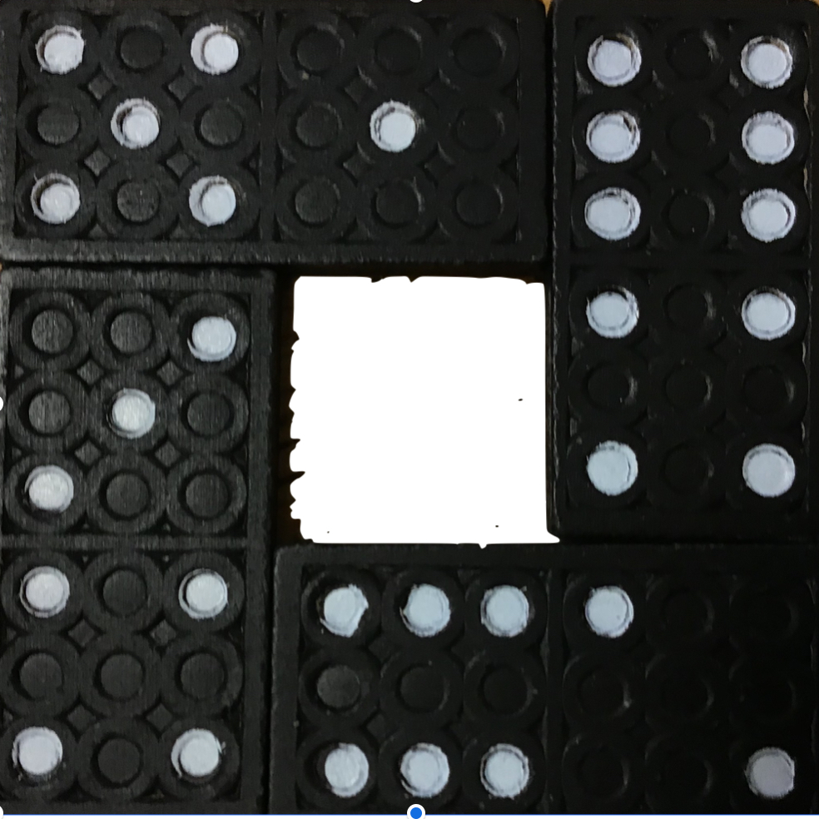
How we solved it:

We solved 4 Dom by firstly trying random solutions to try and find a logical pattern to the results we got. After a lot of trial and error, we found that the sides must equal a number less than 16 because the biggest possible side total you can make is 16 but even then you can make only 1 side with this number 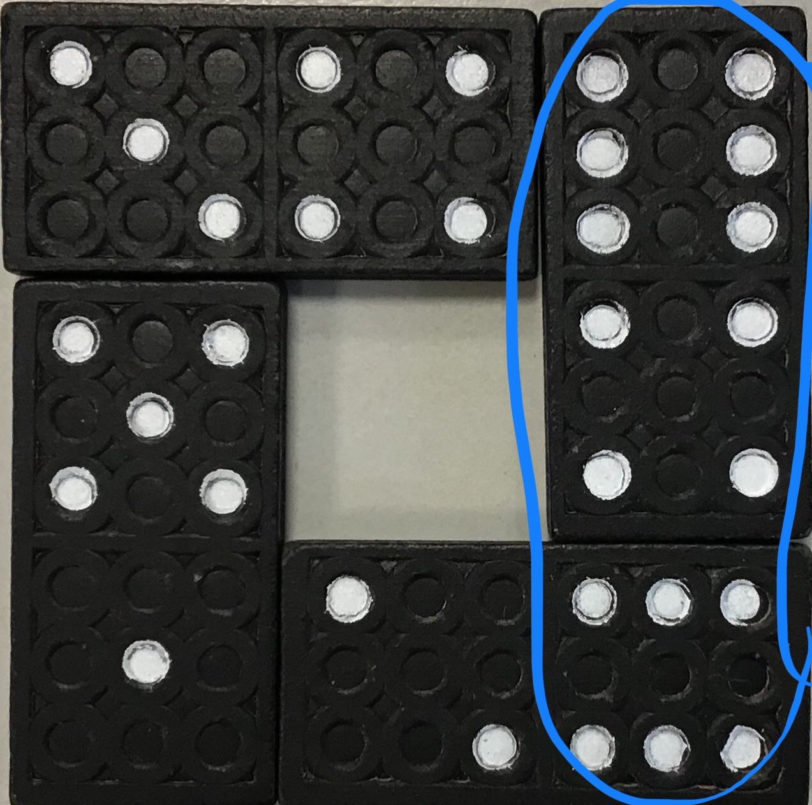
After this we worked out that the smallest number you could make on one side is 8 but again this number is only possible on 1 side 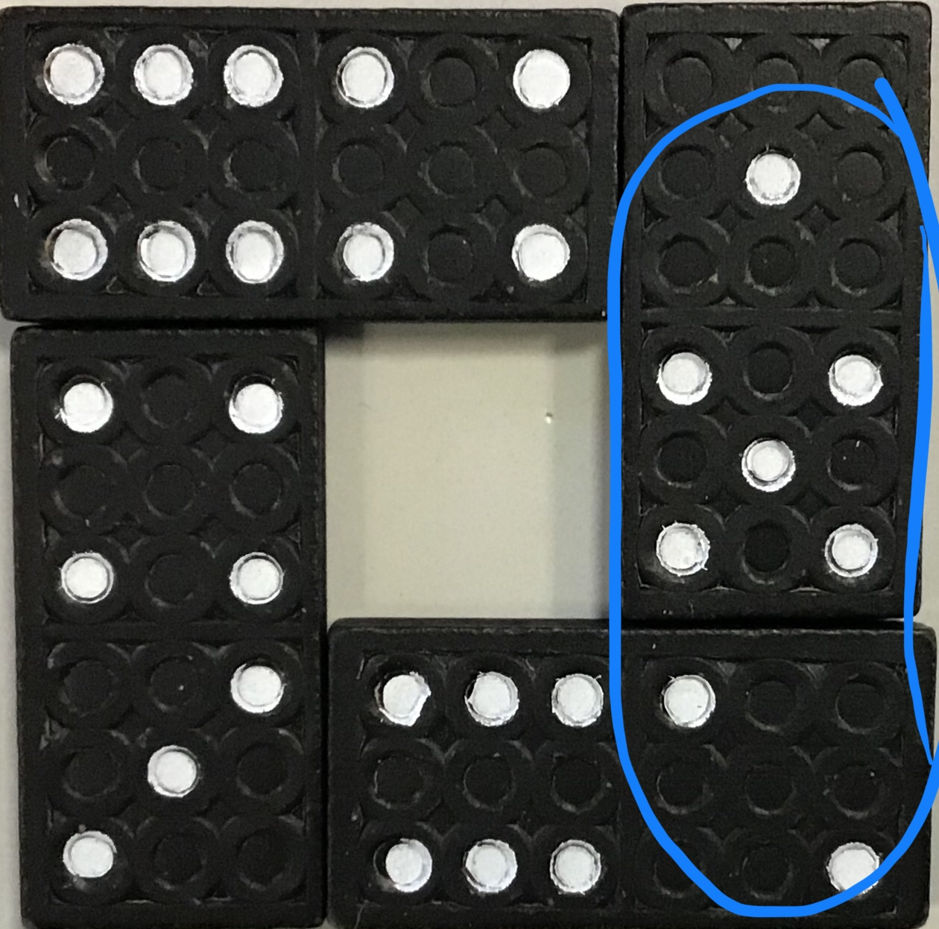
So by this point we knew the number had to between 8 and 16. After we found this we realised that no numbers other than 11, 8, 12 are possible to have on more than 1 side so that narrowed it down any more. After knowing this we tried to get 11 on 3 sides ( can’t do ) get 8 on 3 sides ( can’t do ) so the answer must be 12 ( see first photo)

By Megan Follows, Henry field, Jonny Rumsby, Alexandra Follows and Scarlett Bowers ( Dame Bradbury's School )

