Cookie problem
JU said “We stuck 20 pieces of paper in our books and numbered them.” IA said “Then we drew a circle on every 2nd one for the icing.” JJ said “Then we drew a red dot on every 3rd one for the cherries.” “What about the brown dot on every 4th one for the chocolate button,” said DM.
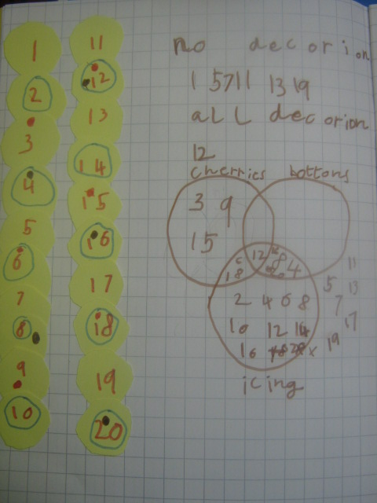
IA said “We found that only odd numbers have no icing on.”
“Even numbers all have some decoration on,” said JJ.
“There was nothing on 1, 5, 7, 11, 13, 17 and 19,” they read out. “They are all odd numbers” said JU”. “But some are missing” added DM.
“Number 12 got all decorations.” They all agreed.
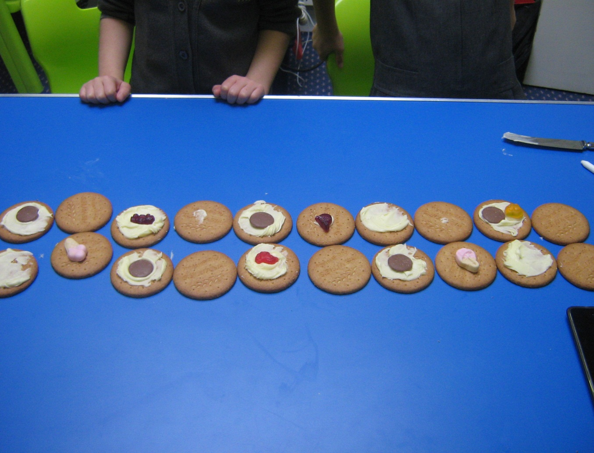
Then Mrs Clarke helped us to draw a Venn Diagram.
After this we tried it with real biscuits using “randoms” instead of cherries!!!
By JJ, JU, IA and DM, Year 2 Problem Solving Group, Ardley Hill Academy, Dunstable.

