Here is our solution:
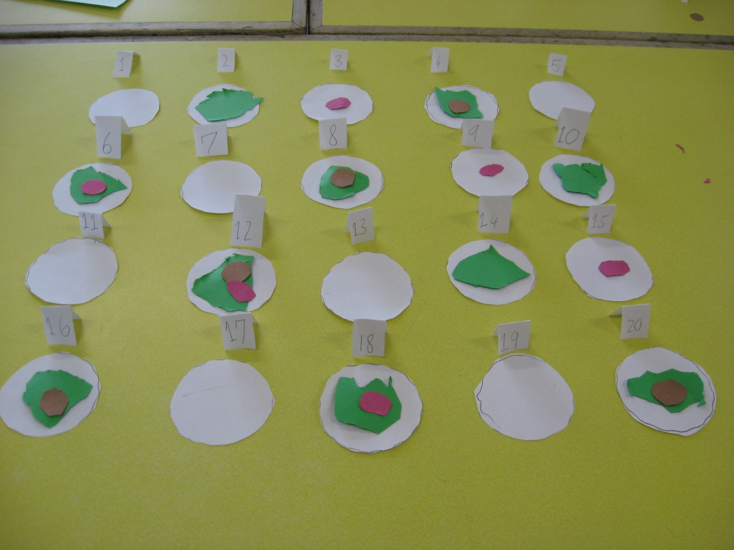
Biscuits numbered 1, 5, 7, 11, 13, 17 and 19 all had no decorations. This is because they are all prime numbers (except for one).

Biscuit number 12 has all three toppings on it because 12 is in the 2, 3 and 4 times tables (they are factors of 12) and all the decorations are on these multiples.

We noticed that all the even numbers had icing as they are in the two times tables.

There is always a chocolate button on a biscuit that has icing because every
multiple of four is even and even biscuits always have icing (e.g biscuits 4, 8, 12, 16 and 20)

We found a pattern in the 3 times table where each multiple goes odd, even, odd, even. We noticed that the cherries are on their own, then with icing, on their own, then with icing etc because that is the pattern of the 3 times tables (e.g 3, 6, 9, 12)

