Xavi’s t-Shirt Solution

Myself Shubhangee (Facilitator) had worked collaboratively on ‘Xavi’s T-shirt’ with a group of 15 students of 5th to 7th grade, in online mode, in ‘Ganit Kreeda’, Vicharvatika, India. The names of the students are:
Dia, Shaunak, Nishika, Ruhaan, Neelmadhav, Kivisha, Deethya, Mithravinda, Abheer, Udit, Uday, Vidyut, Adhrit, Arjun and Aditya.
We worked for 3 sessions on this task in a very systematic way.
A picture of Xavi’s T-shirt was shown and kids were asked to notice and wonder without giving any questions.
The observations noted by kids during the session were:
- Multicoloured circles.
- There are 10 rows and 99 circles.
- First circle is missing.
- Some of the circles are coloured in just one colour.
- All the circles have different pattern.
- In every alternate column there is a red colour.
- And there is no red colour in other alternate columns.
- Every third circle has green colour.
- Yellow colour is visible only in 5th and 10th column and every circle from 5th and 10th column has yellow colour in it.
- Circles with orange colour forms a slanting line.
Then I told them that this is a pic of 100-Board and ask them to figure out the significance of these different colours.

Then kids started working on following questions.
(Kids explored it in different small groups and it was very enjoyable to see how they slowly arrived at the right answer as these are representing Prime Factorisation.)

What is special about the circles that are not split up?
They are Prime numbers.
Can you explain what is happening in the top row?
First circle is missing.
Every alternate circle has red colour and every third circle has at least one green section. There are 4 circles in single colour and not divided. Also, there are 3 circles which are divided into sections but coloured with a single colour.
What do you notice about the colours in the fifth column?
Every circle has at least one yellow section. All are multiples of 5.
What is happening in the far-right column?
Every circle has at least one yellow and one red section. All are multiples of 10, which in itself is 5 x 2.
Take a look at the colours of the first two circles (2 and 3).
What is special about the circles/numbers that have these two colours?

They are multiples of both 2 and 3 (or multiples of 6). E.g. 6, 18, 24, 30,42,60…
What is special about the circles/numbers that have only these two colours?
Shaunak explained it beautifully as:
6 multiplied by a number which is not 2, 3 or a multiple of 6 will give a circle which has another colour excluding red and green.
So, the special thing about these circles/numbers is if they are 6 x 2 or 3 0r a number whose prime factors are 2 and/or 3 only. E.g. 6, 12,18, 24, 36, 48…
Why do multiples of 11 appear on a diagonal line?
11 is 10 + 1 and adding 10 to a number on this board will place one on the same column, but on the next row. Adding 1 will put one in the next column but on the same row.
So, adding 11 to a number will place one 1 row below and one column right. Doing this repeatedly, one sees that one gets a diagonal line toward the bottom right.
Why do multiples of 9 appear on a diagonal line?
9 is 10 - 1 and adding 10 to a number on this board will place one on the same column, but on the next row. Subtracting 1 will put one on the previous column but on the same row.
So, adding 9 to a number will place one 1 row below and one column left. Doing this repeatedly, one sees that you get a diagonal line toward the bottom left.
Look at the circle that represents 8. The three parts are all the same colour.
How many other circles/numbers will also be split into three identical colours?
There will be one more circle, namely 27, that will be split into three identical colours.
2³ = 8, so the circle for 8 will be split into three identical colours.
3³ = 27, so the circle for 27 will be split into three identical colours.
But, 4³ is equal to 2⁶, so the circle for 64 will be split into 6 identical colours rather than 3 identical colours. And 5^3 is 125 which is bigger than 100.

On the bottom row, 93, 94 and 95 appear as three consecutive circles/numbers, each split into two, and no colour is repeated.
Can you find a similar set of four consecutive circles/numbers where no colour is repeated? If not, why not?
There is no set of 4 consecutive circles where no colour is repeated. Circle with a red part appears in every alternate row, which means red will appear in every alternate circle. If the first circle of the four consecutive numbers has a red, then the third circle will also have a red. If the second circle has a red, then the fourth circle will also have red.
What other patterns can you see? Can you explain why they occur?
i) Prime factorizing a number will give you certain prime numbers. Each of these prime numbers has a colour on the 100 board. If the colours of each of the factors are combined to make one circle, this will be the same circle for the number which is the product of the prime factors.
For example, prime factorizing the number 20 will give you
20 = 5 x 2 x 2
The colour of the circle for 5 is yellow and the colour of the circle for 2 is red. If you combine 1 yellow and 2 reds, you get a circle which looks like the circle for 20 on the 100 board.
ii) 2 red – 2^{^2}= 4. The circle for four has 2 red parts.
3 red – 2^{^3} = 8. The circle for eight has 3 red parts.
2^{^4} has four red parts.
2^{^5} has five red parts.
iii) The circle for 10 has 1 red and 1 yellow. These two colours have appeared at least once in 20, 30, 40, 50, … 100.
Can you anticipate how many circles in the whole T-shirt will be split into six sections?
Can you anticipate how many circles will be split into five sections?
Can you anticipate how many circles will be split into four sections?

Attaching solution given by Shaunak. Kids checked why there can’t be more. As other options will generate numbers bigger than 100.

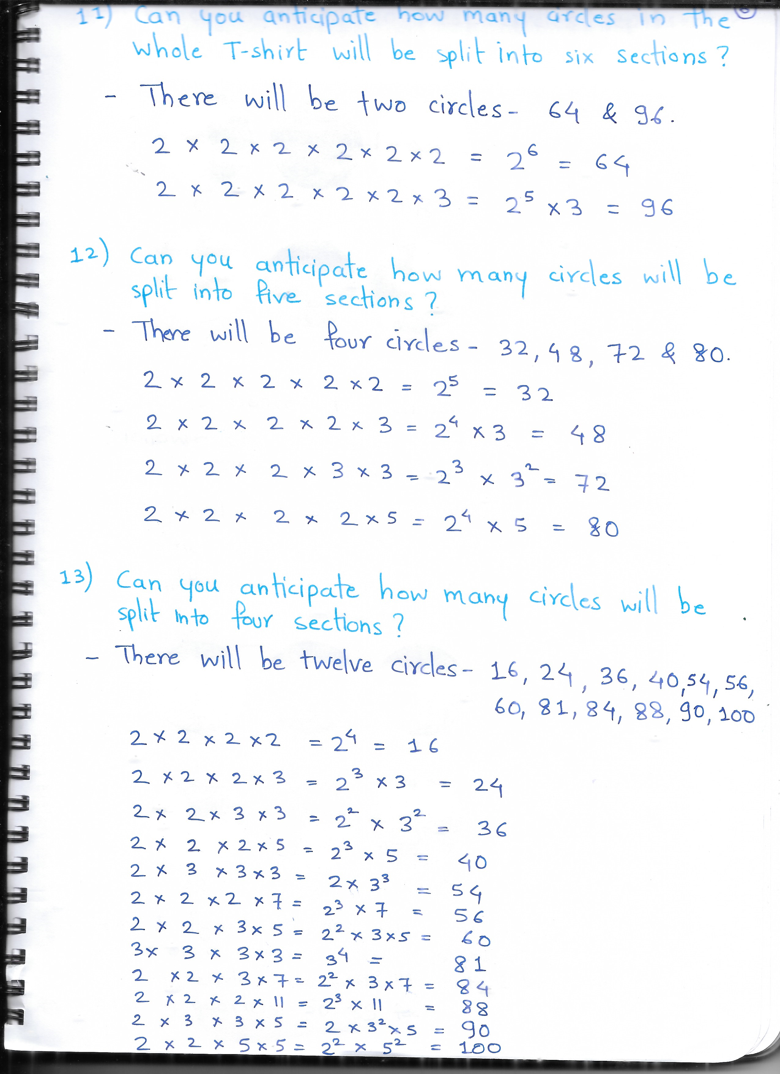
All the students worked on 8 challenges. I am attaching one student’s original work.
But different students used different logic. Some of them started with trial and improvement and systematically arrived at the right solution.
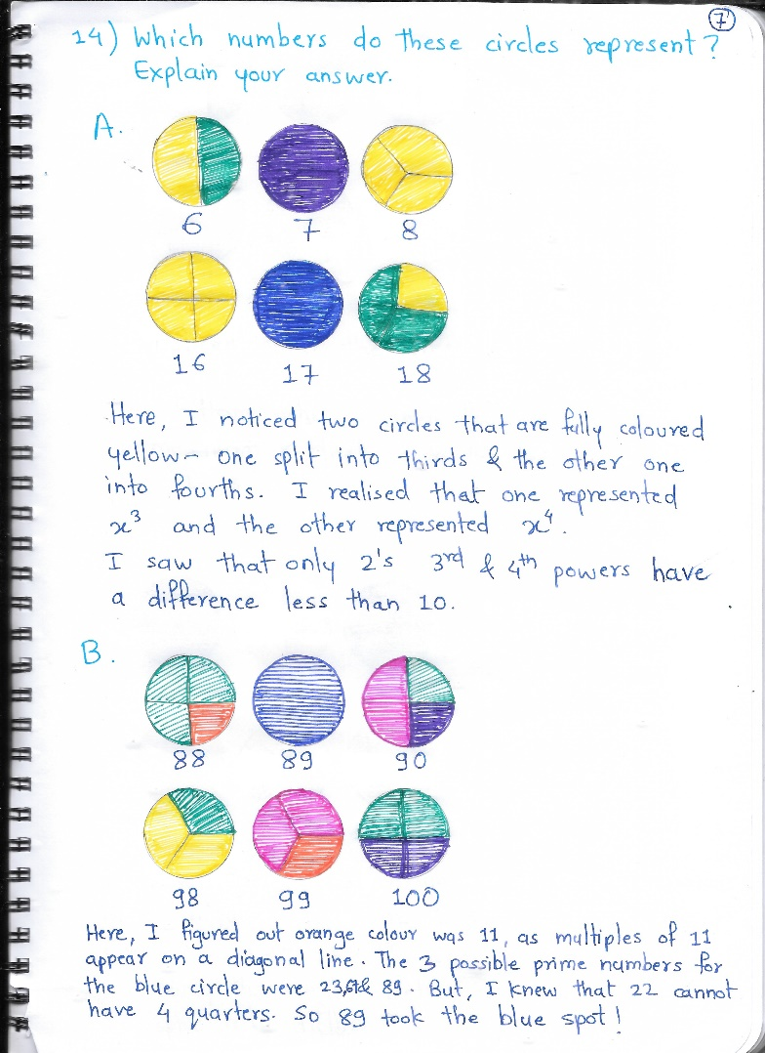
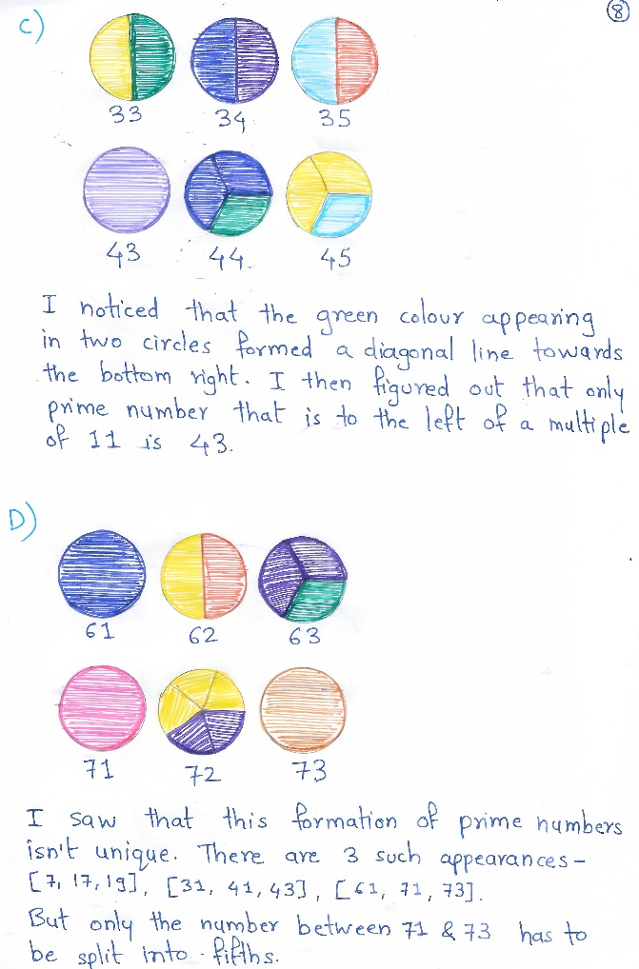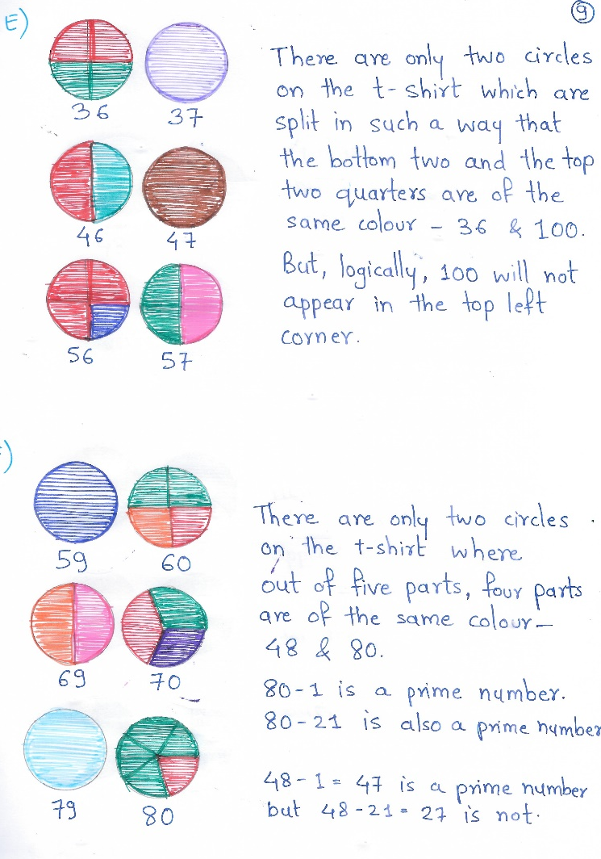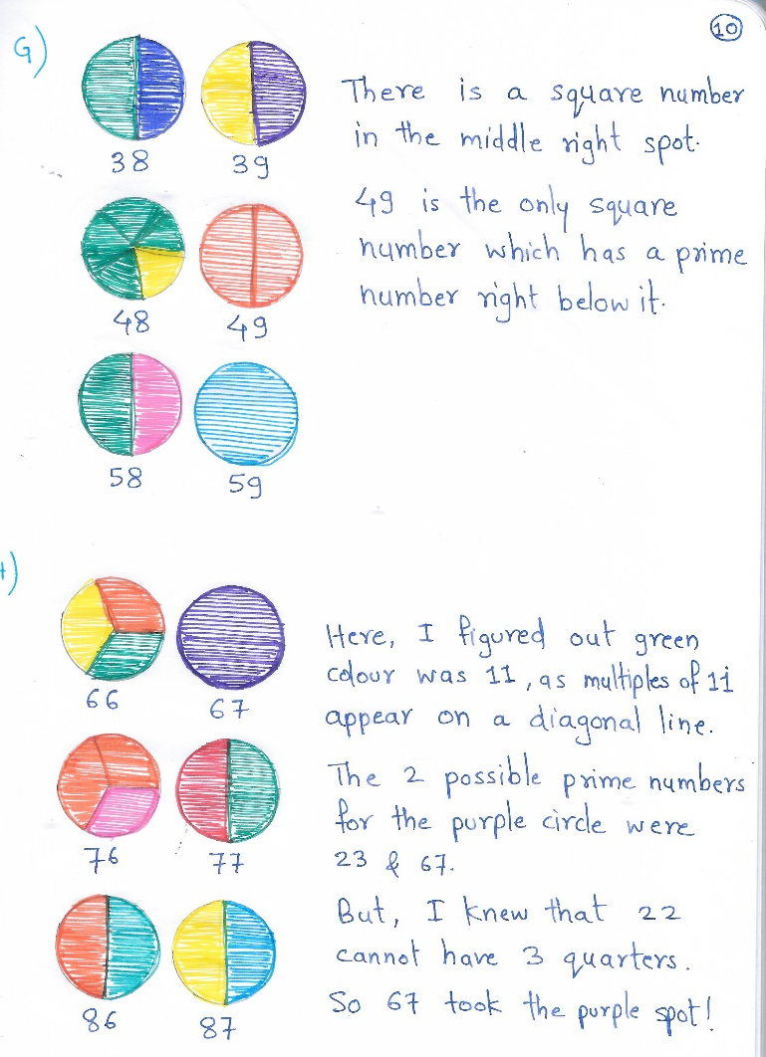
Attaching 10 solutions by Shaunak, one of our student from Ganit kreeda. He had worked on different puzzles from interactivity.
