Within the rules, you can win by making a three wide, one high triangle and place one of your triangles to automatically win.

I have also noticed that you can also use other quadrilaterals to win, like a square or a rectangle.
However, this strategy will only work if you go first, if you go second, you will always lose.

Here is my process for going first.
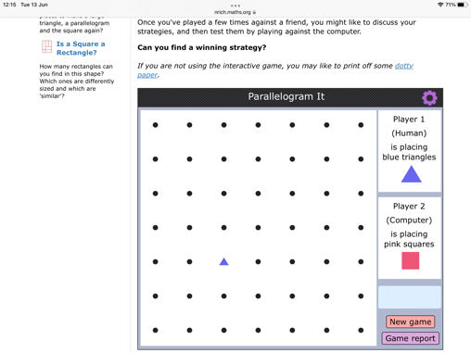
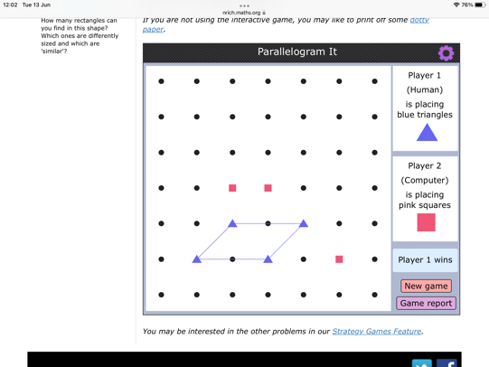
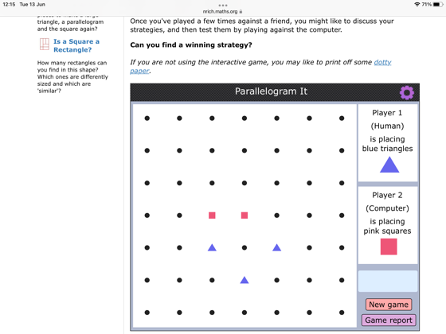
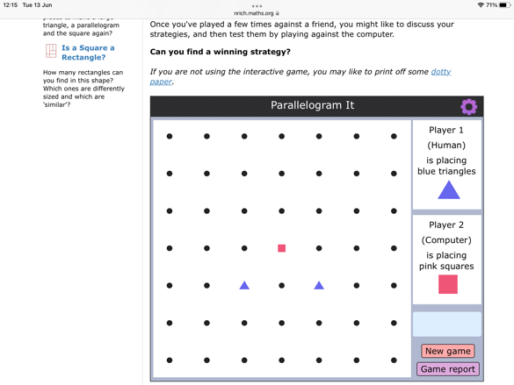
In step one, I place one triangle.

In step two, I place another two away.

In step three, I place one more in the middle, one upwards.

In step four, I place one to the opposite of where the computer has put his.

And the only next step is win.
4
3
2
1.

