Seeing Parallelograms

In maths we are looking at seeing parallelograms there were tricks cheats and strategy’s.
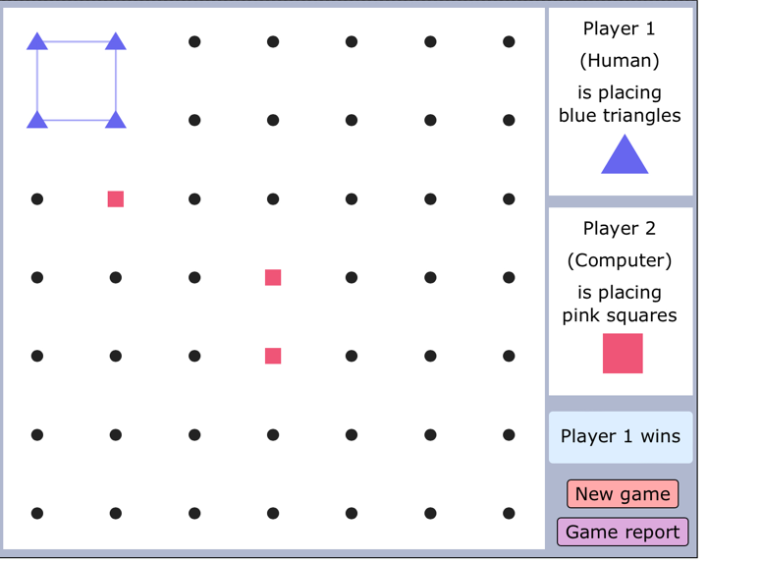
Firstly you can use squares and rectangles witch felt like cheating. And there were a few ways to always win.
This is unfair and should be fixed soon.
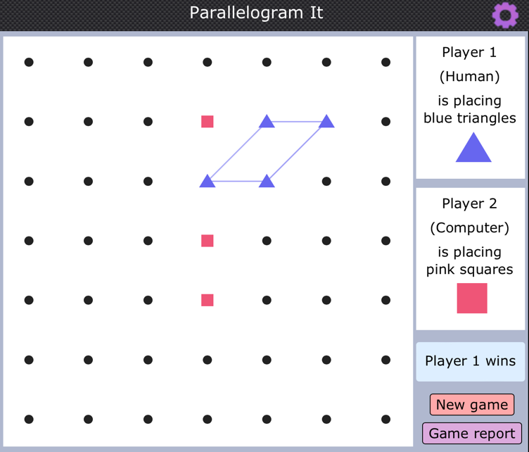
Although this game was really fun and I really enjoyed playing with my friends. The robot was a real challenge and was really hard to win against. You had to use your shape knowledge to figure out what the shapes really were.going in the corners especially top left you win every single time. Which is pretty unfair. Over all the game was pretty good but just a few things needed to be fixed.
I really hope you look at my review and make the game even better.

Thank you!! Bye! From Kaiyan Josh and Dray.

