Parallelogram It – Rishik Kar
Link - https://nrich.maths.org/15164
Although this game asks the player to form a parallelogram, the player has the option to also form a rectangle, square or rhombus as these shapes also share the exact same properties as a parallelogram and they may not appear as the same shape, but they are ‘technically’ a parallelogram.
1) Similarly with the previous Square It game, the player should try to go first if given a choice as it allows them more opportunities to win and capturing the middle point is quite useful whilst playing. When, I played against the computer and placed my counter elsewhere, the computer always irrespective of where I placed my counter, would capture the centre spot if vacant.
2) One formation which the player should try to form is a triangle, in any size and in any rotation. It is also important to note that the triangle can have any side lengths as your opponent will be able to easily recognise simple triangles, so you should aim to form a triangle discreetly. The triangle allows two chances for you to win, either by making a square /rectangle or a parallelogram. Your opponent can only place one counter at a time, so your victory is determined as you always have the other option to win as well. In some cases, it is even possible for the player to form another parallelogram by placing their counter above the triangle if the space is vacant, but you may not always have this additional opportunity.
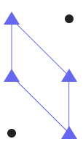
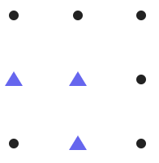

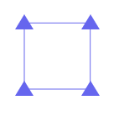
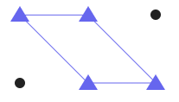

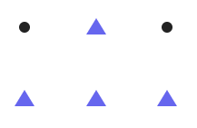
3) Besides this, we can also use the arrow formation which can also be used in the Square It game, as this will enable you victory when forming a square. The arrow formation can be used in any rotation or size.

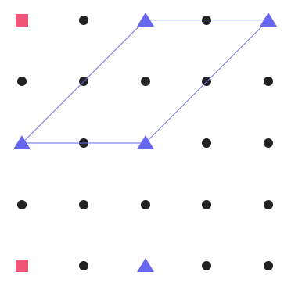
4) Another benefit of the arrowhead formation pictured above is that, besides forming a square or rectangle you can also form a parallelogram and this formation is one of the most efficient which should be used when tackling this game. From this image, the red circles indicate 4 possible places to win. Even if your opponent manages to recognise your arrowhead shape and prevent you from winning, you will still be able to form two parallelograms behind it.

