Cyclic Quadrilaterals Proof that the opposite angles still add upto 180° when the center of the circle is not within the quadrilateral.

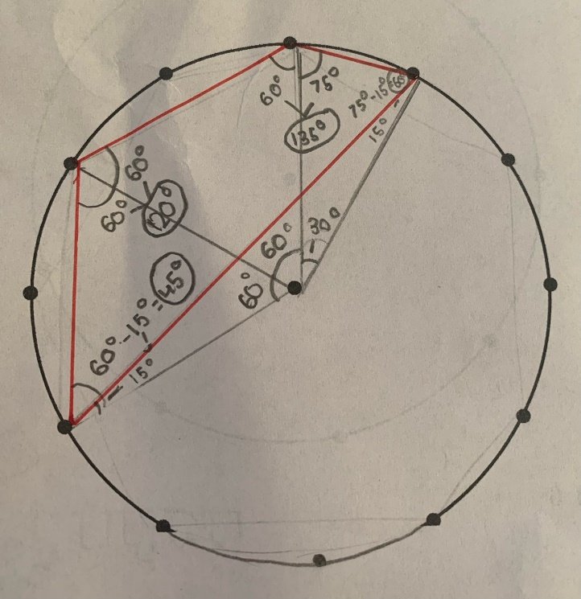
D
C
B
A
3
2
1
A,B,C,D: Triangles
1,2,3,4,5: vertices
4
51

- First I connected each vertice of the quadrilateral to the center point.
- This made 3 isoceles triangles (A,B,C) + 1 another triangle outside the quadrilateral (Triangle D, vertices 154)
- I calculated the angles at the center point : 60°, 60° and 30°
- Using these angles I subtracted each of them from 180
  - Triangle A: 180 – 60 = 120°
  - Triangle B: 180 – 60 = 120°
  - Triangle C: 180 – 30 = 150°
- Then because the 2 base angles are identical as these are isoceles triangles, all I have to do is divide the balance by 2 to get:
  - Triangle A: 120/2 = 60°,60°
  - Triangle B: 120/2 = 60°,60°
  - Triangle C: 150/2 = 75°,75°
- Triangle D: I used the totals of the angles from the centre (150°) and subtracted them from 180 to get the equal angles of the triangle, which are° 15, 15.
- Finaly we calculate the angles:
- Vertice 2: 60° + 60° = 120°
- Vertice 3: 60° + 75° = 135°

  - Vertice 1: 60° – 15° = 45°
  - Vertice 4: 75° – 15° = 60°

- And now that we have found out all the angles for this quadrilateral, we can prove that opposite angles here also add upto 180, even when the

Vertice 2+ Vertice 4: 120° + 60° = 180°
Vertice 3+ Vertice 1: 135° + 45° = 180°

