Myself, Shubhangee, had worked in Ganit Kreeda, Vicharvatika with 13 kids, Ananya, Kanaa, Twisha, Niya, Valerie, Ved, Anika, Kimaya, Swara, Mrunmayee, Ayansh, Aarav and Shivashree ; of 2nd and 3rd grades on Windows Frame task.
They had used matchsticks for this task. Some of the kids used drawing on paper to first count and then observe the result along with the picture to understand the pattern.

Challenge 1:
All of them found out that number of Panes/Frames is equal to product of height and width of window. (They spotted this pattern by actually doing it using matchsticks.)

Kanaa was able to find out the total number of match sticks based on the number of matchsticks in the previous row of the table and she explained it using different colours in 2nd picture.
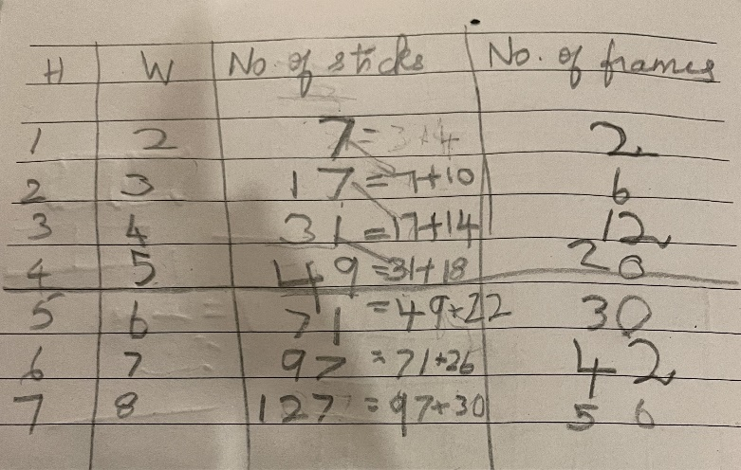
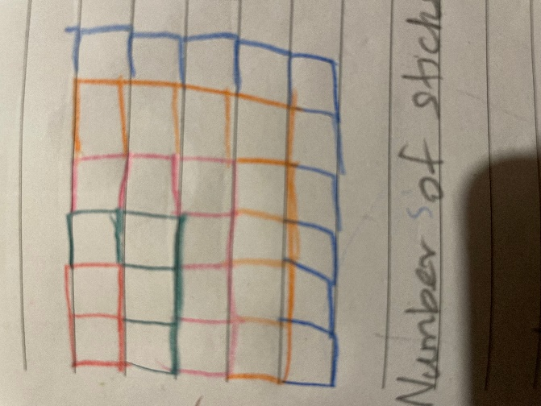
- Mrunmayee explained how she calculated for 4x5 window frame as:
4x5 = 20
20 + 20 = 40
40 + 4 + 5 =49
- Aarav, Niya and Ayansh very clearly explained with reasons how they calculated using vertical and horizontal sticks. Kids then generalised the method as
total number of vertical sticks = (h+1) x w
total number of horizontal sticks = (w+1) x h
total number of sticks = (h+1) x w + (w+1) x h
In the process kids found one more interesting pattern that
total number of vertical sticks is always bigger than
total number of horizontal sticks by 1.
Kids then used this fact to calculate solutions for bigger dimensions.
Aarav calculated h x (w+1) and added 1 to get other number to add.
Niya first calculated w x w and then she subtracted 1 to get second number to be added.
Can you see how this method of Aarav, Niya and Ayansh is same as Mrunmayee’s?

Ayansh also came up with the next pattern that
# of sticks = 2 * Frames + height + width
Ananya shared one enlightening incident which highlights the importance of use of hands-on material at early age.
While experimenting with 10 x 11 window frame she ran out of matchsticks and she was forced to spot some pattern. She intuitively found that she added 21 sticks every time and that is because she added 10 horizontal and 11 vertical sticks to complete one row.
For the first row she needed 31 sticks and after that she added 21 sticks every time. She also explained as she needed 11 such rows, she added 21 to 31; 10 times as: 31, 52, 73, 94,115, 136, 157, 178, 199, 220, 241.
What an AHA moment for a teacher.
https://drive.google.com/drive/folders/1g7YcxWhQ-eCoU4aRx8xrvER44fMkw2Fe?usp=drive_link

For Challenge 2:
All the kids worked on second challenge independently and then discussed it together.
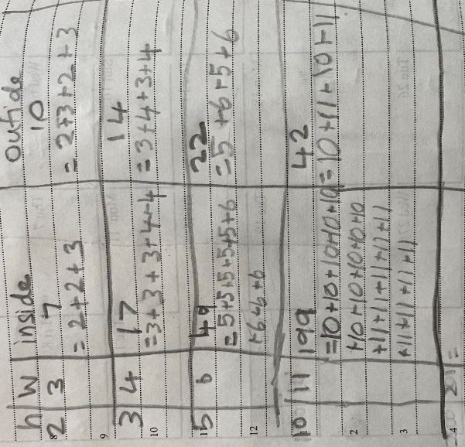

To find outside green sticks Aarav added doubled the width to doubled the height. He explained that for every window boundry, there are 2 horizontal lines each made up of sticks equal to its width and 2 vertical lines each made up of sticks equal to its height.
Kanaa calculated it little differently as w + h + w + h.
For inside blue sticks, Aarav subtracted this number from the total sticks he got from challenge 1.
For 5x6 window frame, Kanaa added 5 (i.e.height), 5 times and 6 (width), 4 (i.e. (5-1)
or (h-1) times) as number of horizontal lines inside the rectangle will be 1 less than the height.

