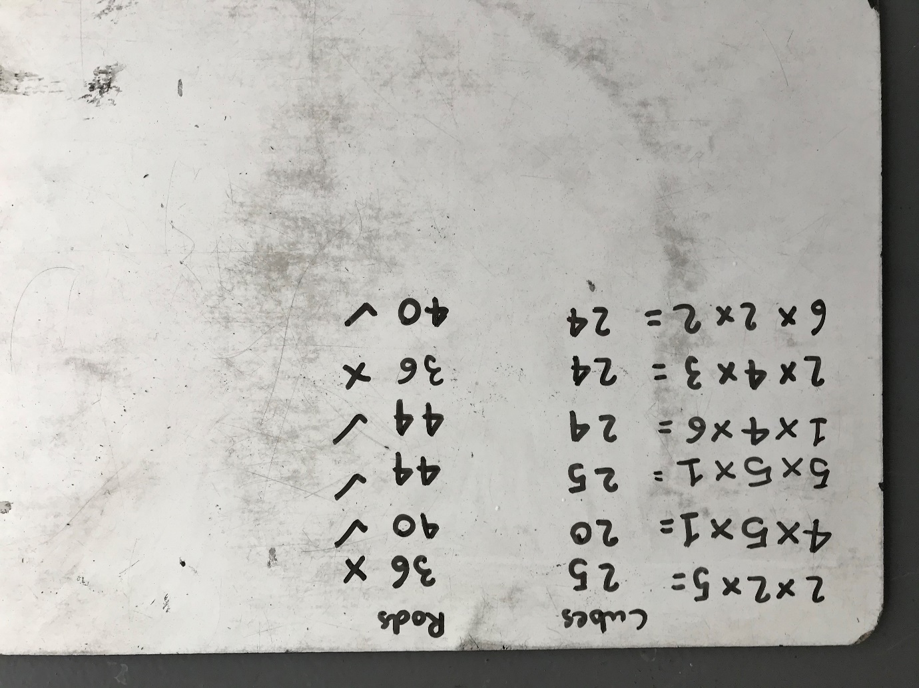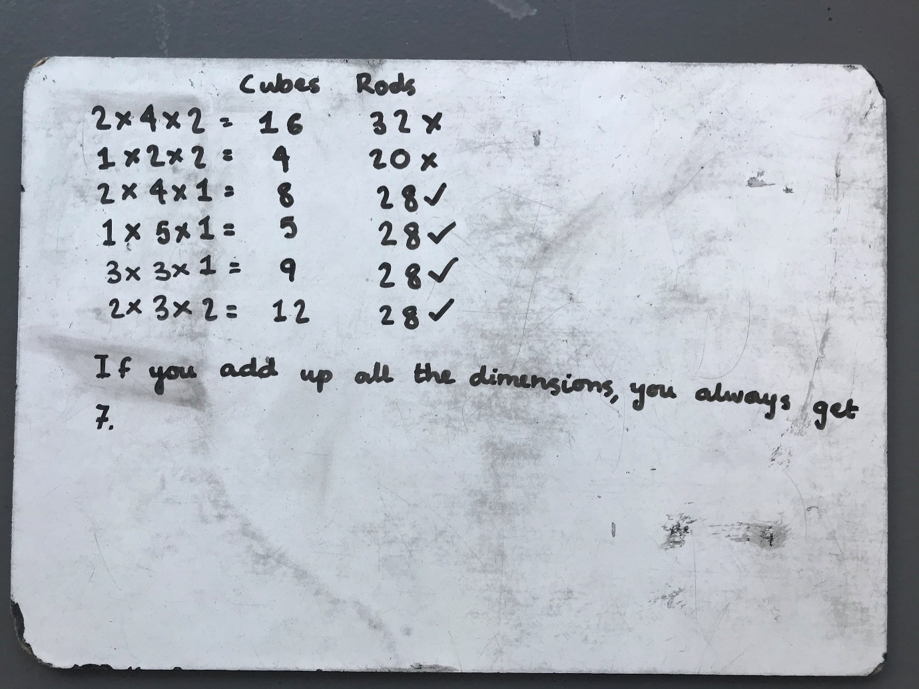
We noticed that the numbers are all multiples of 4 and if you add 1 to one of the dimensions the number of rods goes up by 4.
