If you count this counting stick by each individual square one by one there are 10 squares. I drew a chart to help me understand the problem it looks like this:
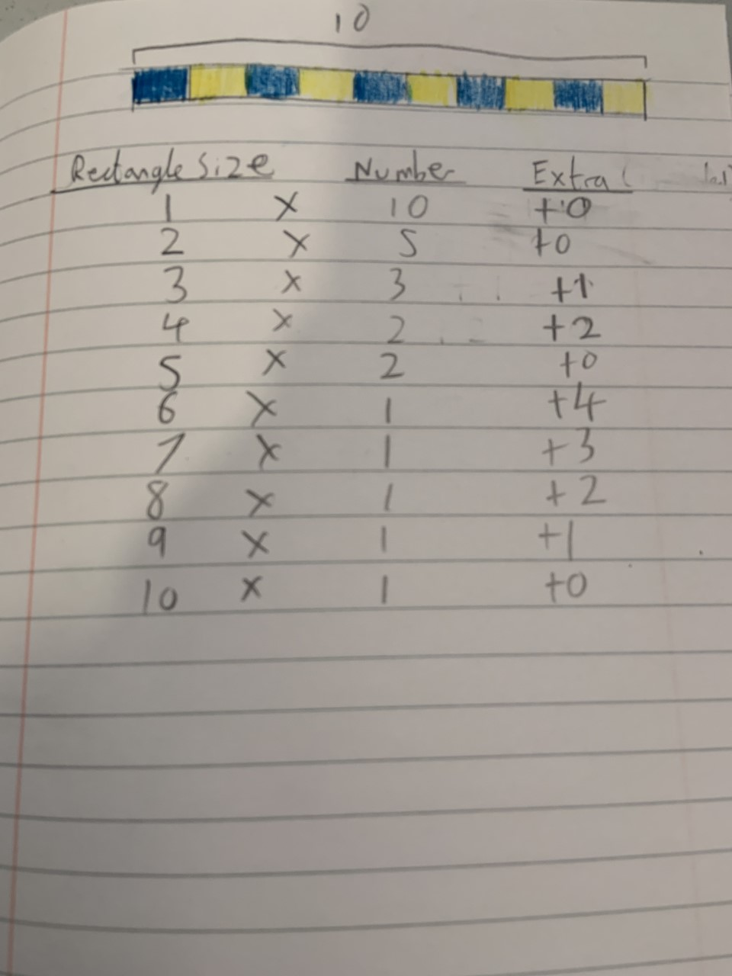
Here is the counting stick again:

Notice on the chart that every row equals 10.
Even if the number of rectangles you group multiplied by a number does not equal 10 (Or any other number of squares you have) exactly you can always add rectangles to make the number 10.
I tested this method by drawing the bar and using trial and error to test out the different possibilities, I started off 2 and as 5 x 2 is 10, we don’t need to add any rectangles. Then I checked the other amounts going up from 1 to 10. This method can also work different lengths of counting sticks. Knowledge of multiplication is extremely helpful for solving this question.

