- First, we made a list of clues in a shorter format (eg. E = F # of flats). (picture of the list clues). 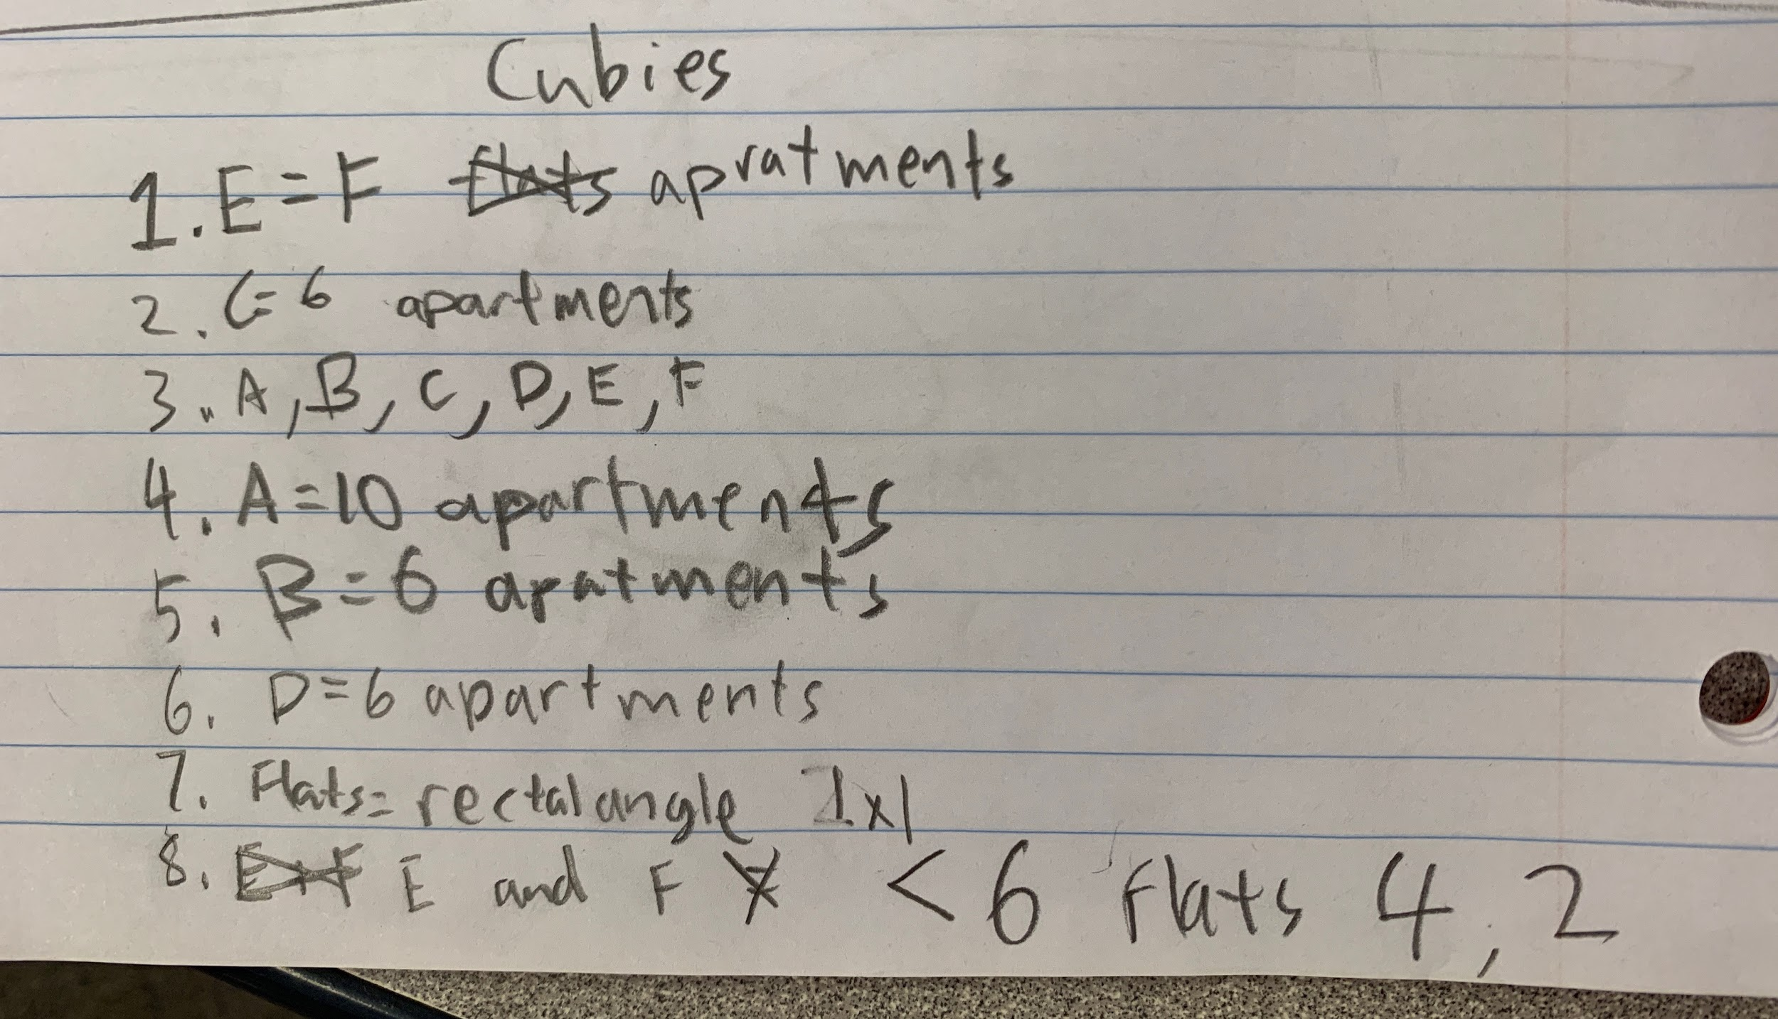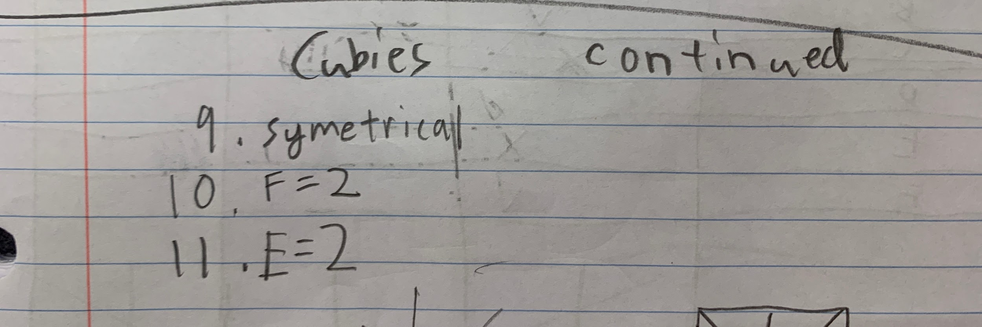
- As we read the clues, we figured out that some of them were not connected to the problem we needed to solve. For example, “The bins are emptied on a Wednesday,” was not a clue that helped us figure out the number of flats, the shape of the building, the number of families or the number of cubies. This helped us eliminate clues that we didn’t put in our list.
- After the first nine clues, we figured out how many flats were on each floor and we used wooden cubes to build a model of the block. We then drew a picture of it in our notebooks.
(picture of drawing).
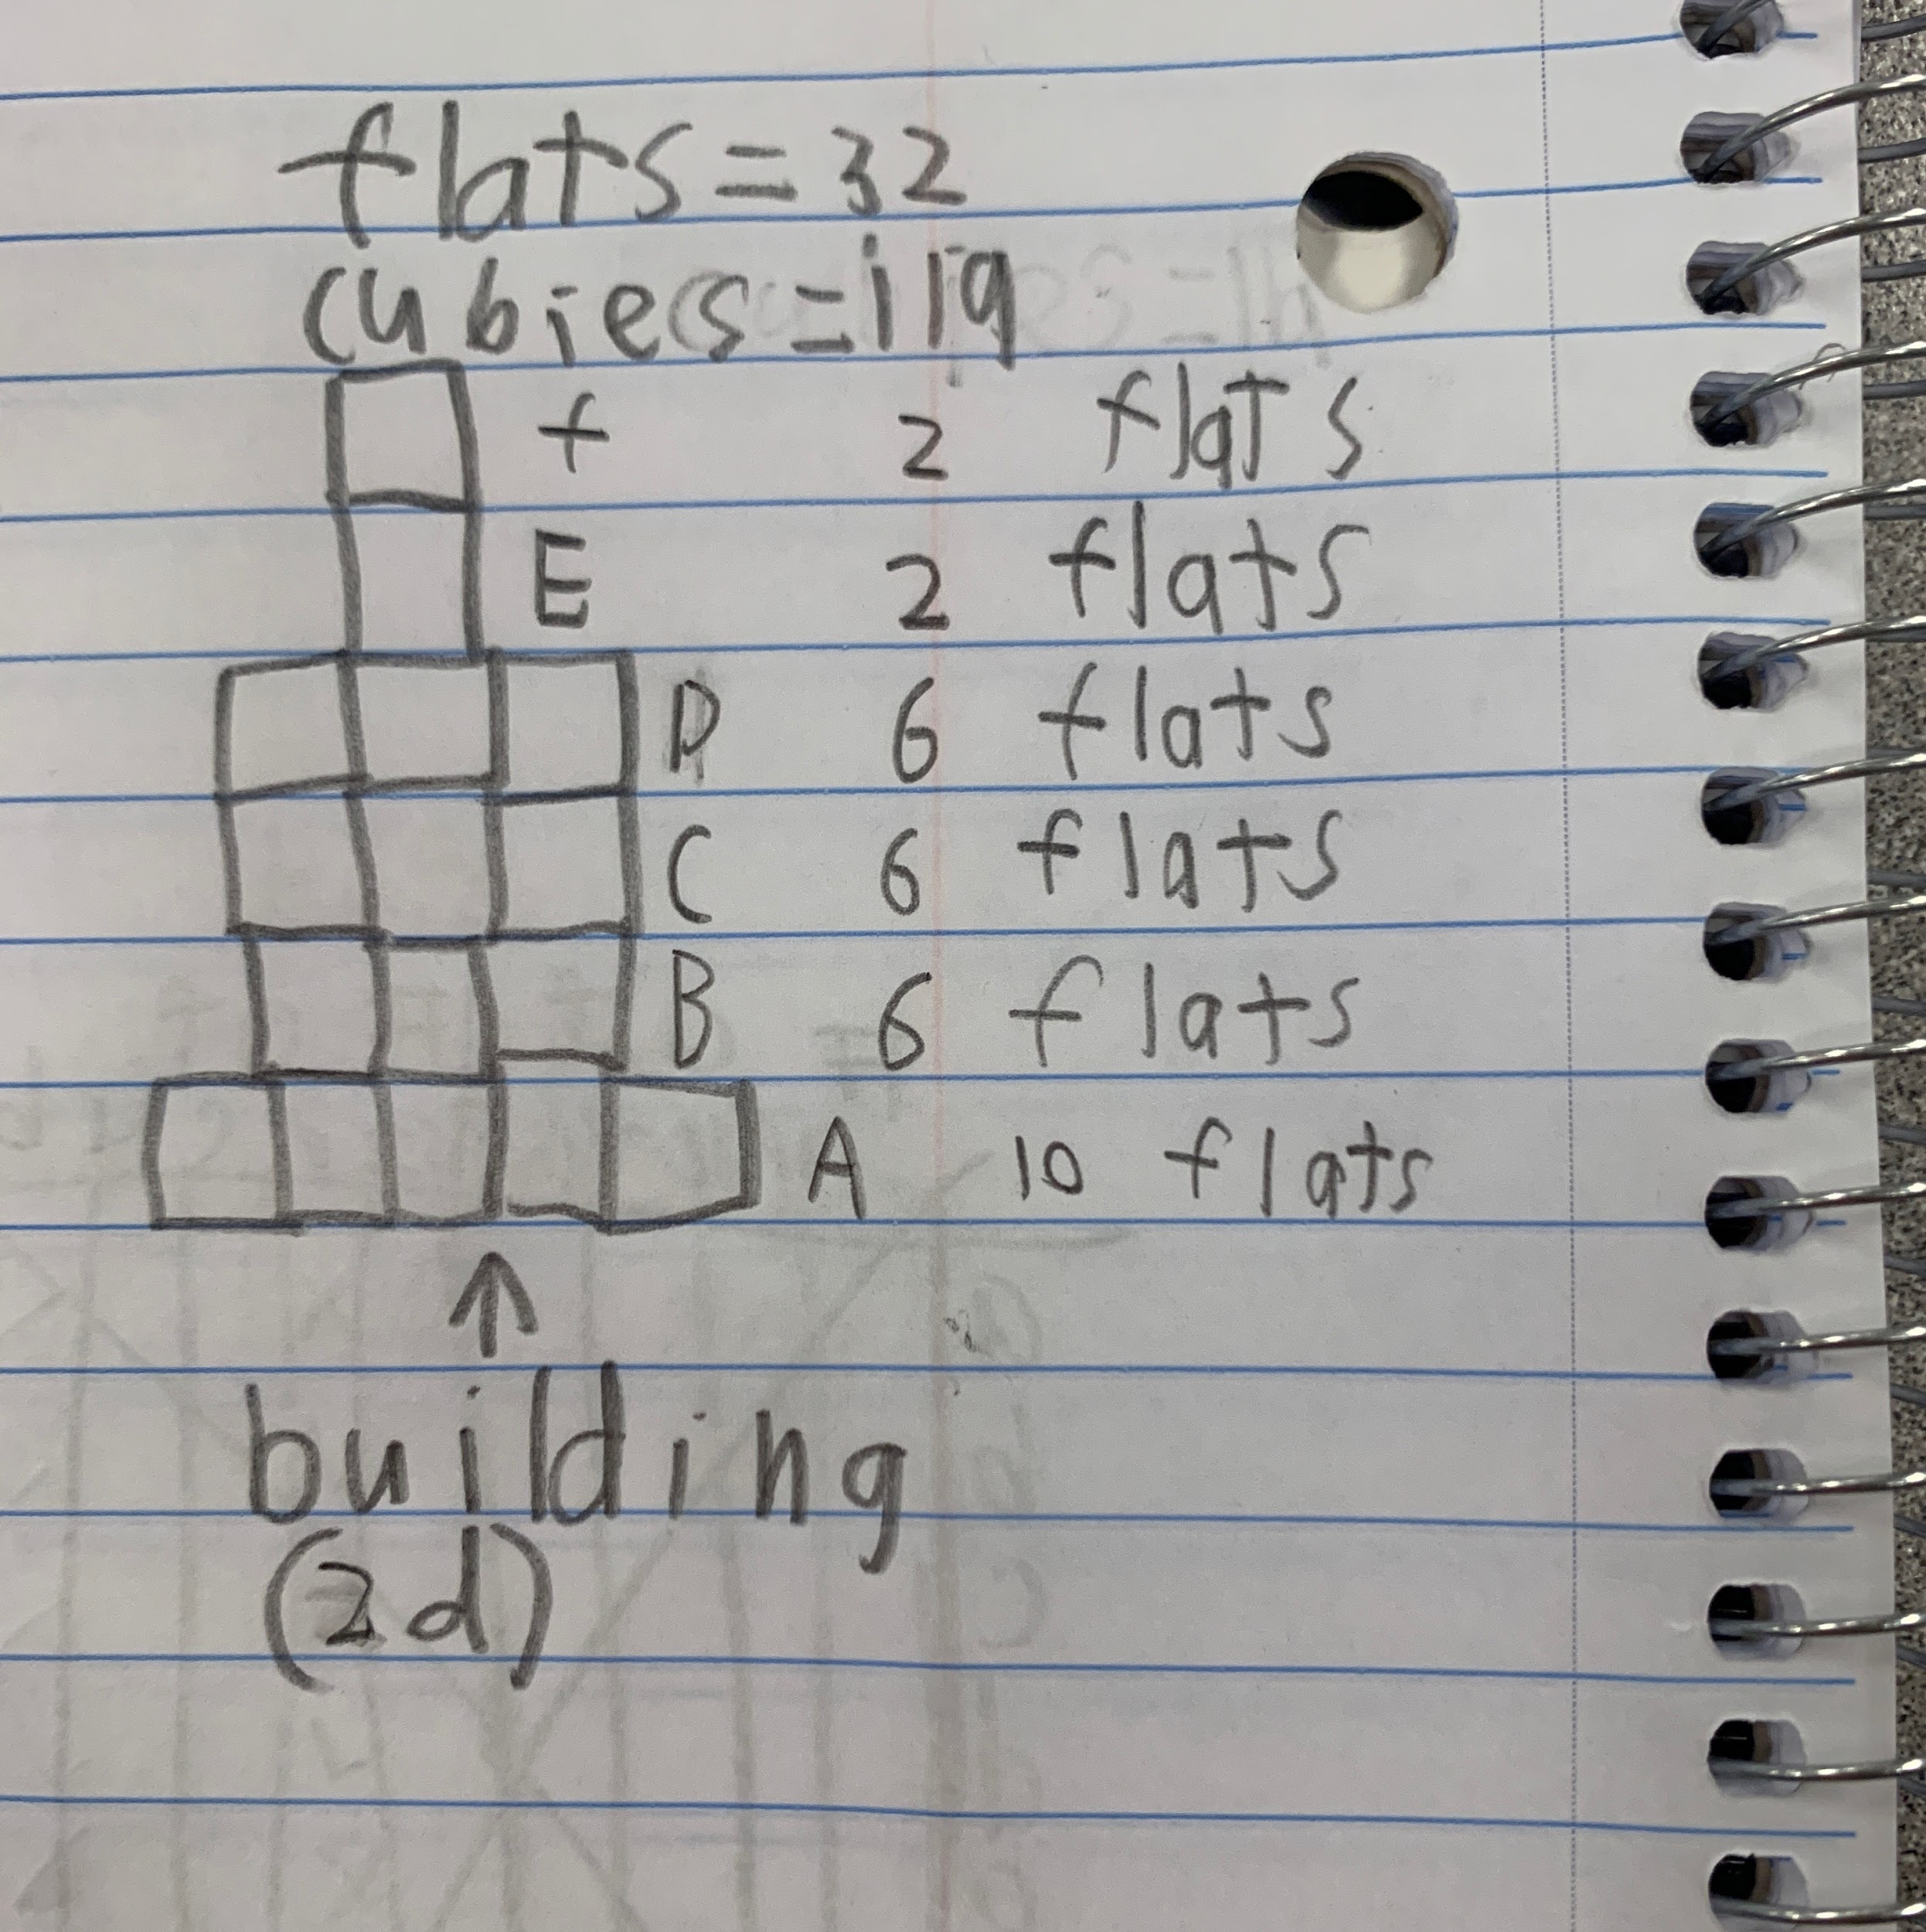
- Once we got through 11 clues, we realized that a chart would help us keep track of the size and number of cubie families better. Down the side, we had the names of each of the floors. Across the top, we had the possible number of cubies per family. We made a second part of the chart below the first that tracked the number of families in the block that have each different number of cubies. (picture of chart). 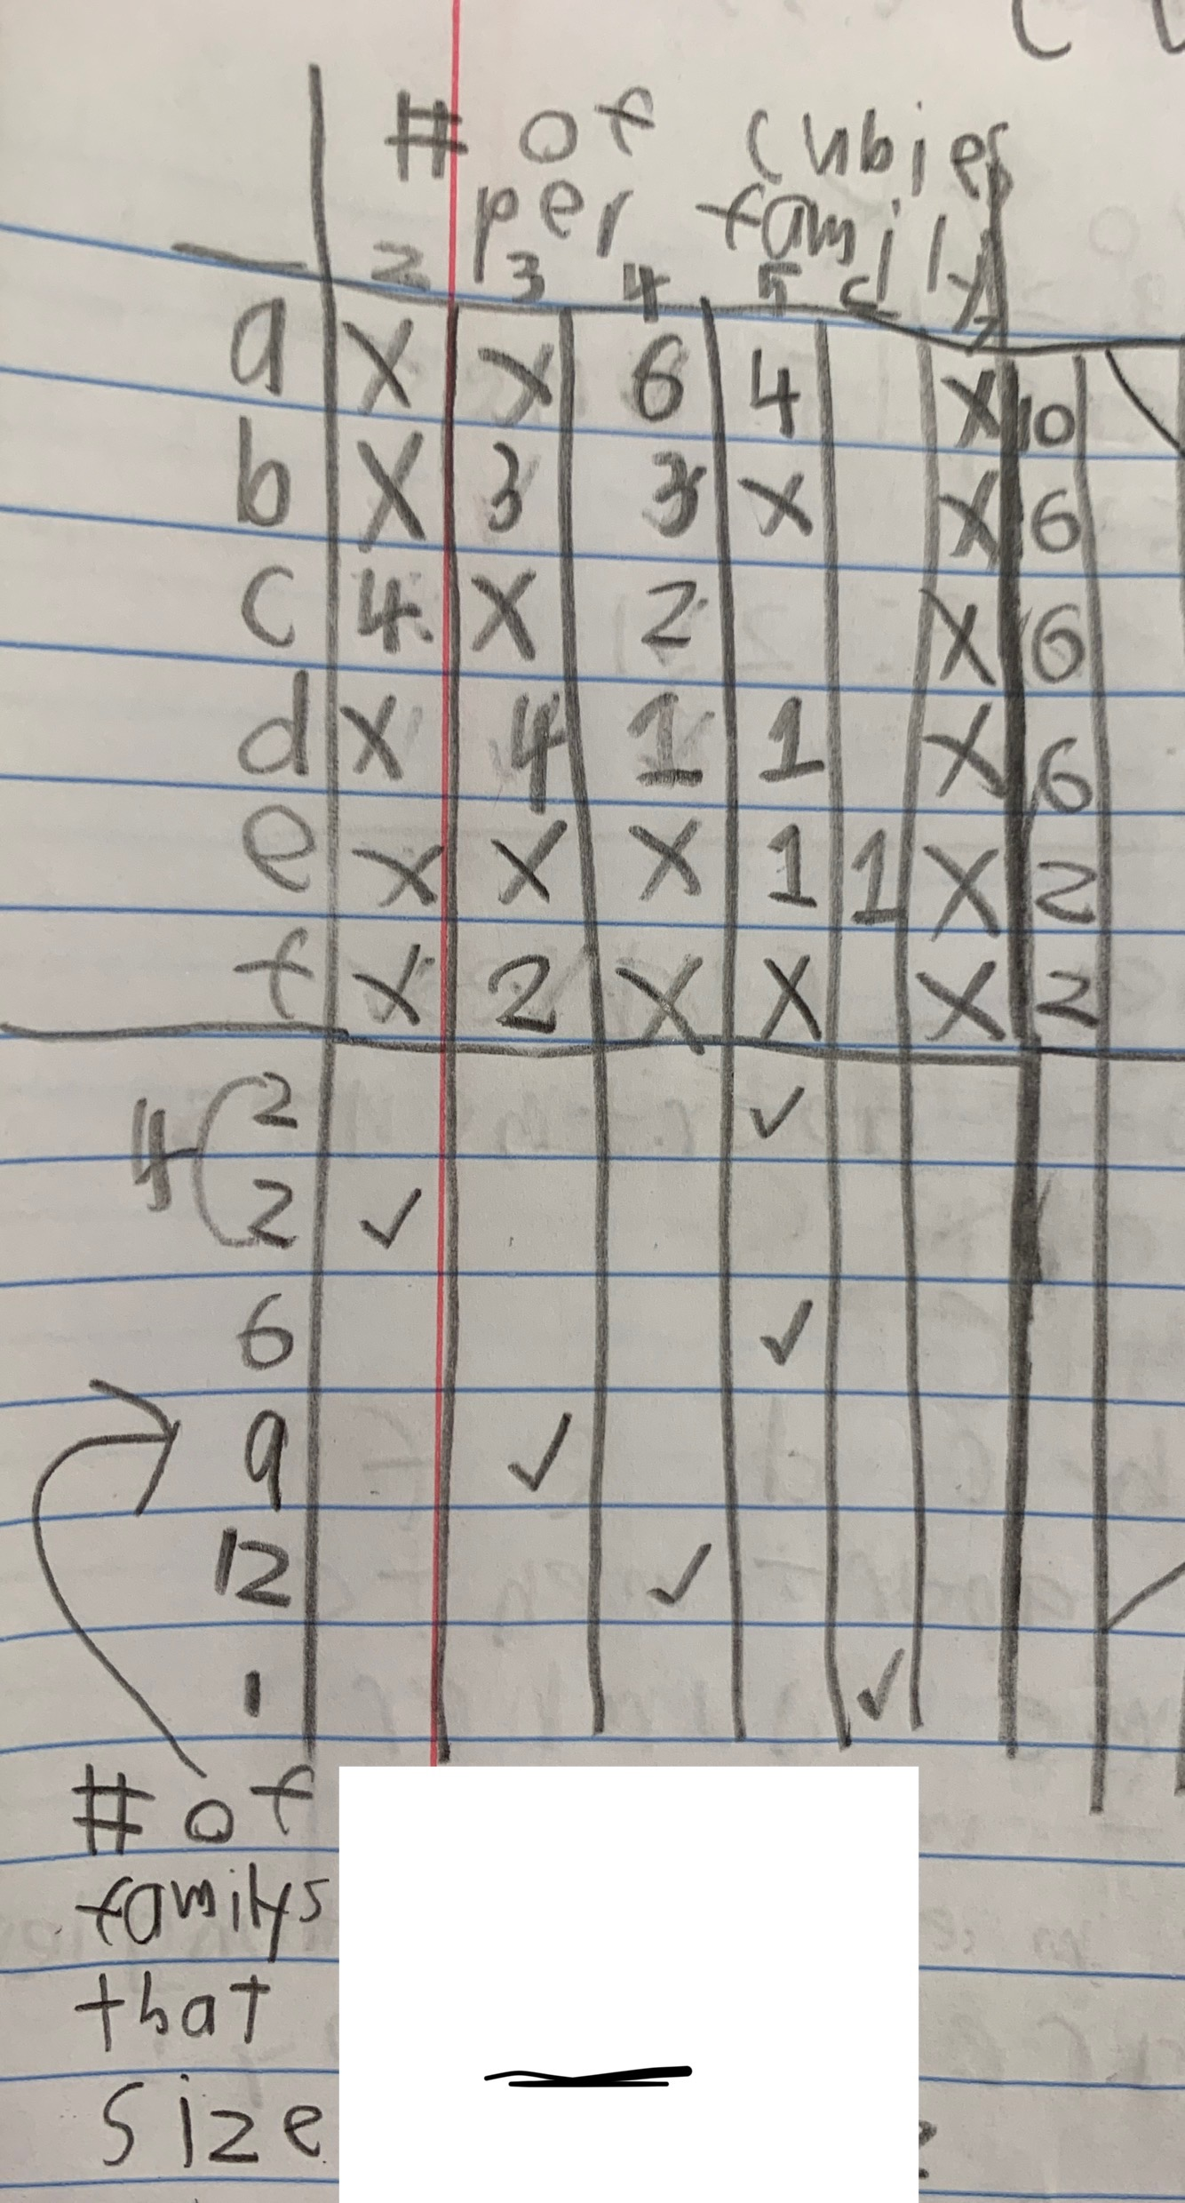
- On the chart, we started with checks and xs to represent whether there were families of that size on that floor. As we got new clues, we replaced the checks with the number of families that size on that floor.
- Finally, once we had gathered all the clues and put them in our chart, then we multiplied the number of cubies per family by the number of families that size on that floor (eg. 6 families of 4 (24) AND 4 families of 5 (20) live on Floor A, so there are 44 cubies on floor A ). After multiplying we added all the cubies on each floor to find a total population. We found that 119 cubies live in the block. (picture of multiplication work)