-POCKET MONEY-
By: Kazuma and Luanne
Bangkok Patana School, Mr. Wadsworth’s Class

- Without doing any working out, which one would you choose, and why?
- We would choose the third option as the amount of money given would double each time, causing the sum to increase rapidly. It would give us the most money in the long run.

- In a month with 31 days, how much money would you have by the end of the month, under each system? You may wish to explore using a spreadsheet.
- We used Excel and applied a simple formula to achieve our desired results.
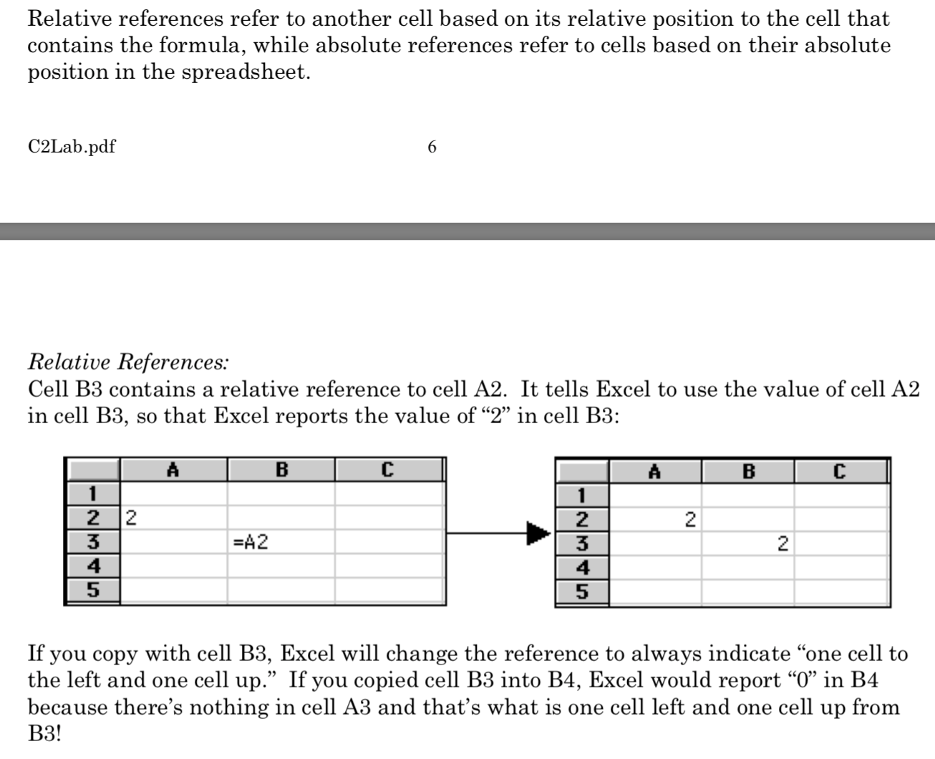
- The formula we used was a relative reference formula. The source we used is shown below
- Applying this concept, we used the formula “=A1+0.5” for option 2 and “=A1*2” for option 3, copying the cell values until day 31. (Note: Option 1’s values stay at £10 throughout)

Day | Option 1 | Option 2 | Option 3
1 | 10 | 3 | 0.01
2 | 10 | 3.5 | 0.02
3 | 10 | 4 | 0.04
4 | 10 | 4.5 | 0.08
5 | 10 | 5 | 0.16
6 | 10 | 5.5 | 0.32
7 | 10 | 6 | 0.64
8 | 10 | 6.5 | 1.28
9 | 10 | 7 | 2.56
10 | 10 | 7.5 | 5.12
11 | 10 | 8 | 10.24
12 | 10 | 8.5 | 20.48
13 | 10 | 9 | 40.96
14 | 10 | 9.5 | 81.92
15 | 10 | 10 | 163.84
16 | 10 | 10.5 | 327.68
17 | 10 | 11 | 655.36
18 | 10 | 11.5 | 1310.72
19 | 10 | 12 | 2621.44
20 | 10 | 12.5 | 5242.88
21 | 10 | 13 | 10485.76
22 | 10 | 13.5 | 20971.52
23 | 10 | 14 | 41943.04
24 | 10 | 14.5 | 83886.08
25 | 10 | 15 | 167772.16
26 | 10 | 15.5 | 335544.32
27 | 10 | 16 | 671088.64
28 | 10 | 16.5 | 1342177.28
29 | 10 | 17 | 2684354.56
30 | 10 | 17.5 | 5368709.12
31 | 10 | 18 | 10737418.24
 | 310 | 325.5 | 21474836.47

In conclusion, we found out that option three had the largest value as you can see in the table. (The row highlighted yellow is the sum of all the values above). Therefore, in 31 days, option 3 would be the most beneficial.
- In which months would option 1 be better than option 2?
- Firstly, we shall establish that there are only 4 options for months. 31 days, 30 days, 28 days and 29 days. (The latter being February in a leap year)
Option 1 | Option 2 | Option 1 | Option 2 | Option 1 | Option 2
30 days |  | 29 days |  | 28 days
10 | 3 | 10 | 3 | 10 | 3
10 | 3.5 | 10 | 3.5 | 10 | 3.5
10 | 4 | 10 | 4 | 10 | 4
10 | 4.5 | 10 | 4.5 | 10 | 4.5
10 | 5 | 10 | 5 | 10 | 5
10 | 5.5 | 10 | 5.5 | 10 | 5.5
10 | 6 | 10 | 6 | 10 | 6
10 | 6.5 | 10 | 6.5 | 10 | 6.5
10 | 7 | 10 | 7 | 10 | 7
10 | 7.5 | 10 | 7.5 | 10 | 7.5
10 | 8 | 10 | 8 | 10 | 8
10 | 8.5 | 10 | 8.5 | 10 | 8.5
10 | 9 | 10 | 9 | 10 | 9
10 | 9.5 | 10 | 9.5 | 10 | 9.5
10 | 10 | 10 | 10 | 10 | 10
10 | 10.5 | 10 | 10.5 | 10 | 10.5
10 | 11 | 10 | 11 | 10 | 11
10 | 11.5 | 10 | 11.5 | 10 | 11.5
10 | 12 | 10 | 12 | 10 | 12
10 | 12.5 | 10 | 12.5 | 10 | 12.5
10 | 13 | 10 | 13 | 10 | 13
10 | 13.5 | 10 | 13.5 | 10 | 13.5
10 | 14 | 10 | 14 | 10 | 14
10 | 14.5 | 10 | 14.5 | 10 | 14.5
10 | 15 | 10 | 15 | 10 | 15
10 | 15.5 | 10 | 15.5 | 10 | 15.5
10 | 16 | 10 | 16 | 10 | 16
10 | 16.5 | 10 | 16.5 | 10 | 16.5
10 | 17 | 10 | 17
10 | 17.5
300 | 307.5 | 290 | 290 | 280 | 273

In conclusion our results show that option 1 had a bigger value than option 2 in a February when there was 28 days, excluding Leap Years. In a February (Leap Year), option 1 would yield the same result as option 2. In the months with 30 days, option 2 would result in more money than option 1, which is also the case in months with 31 days. Once again, the highlighted cells are the sums of the columns above.

- If your family stopped your pocket money on day 8, which option would give you the most?
Day | Option 1 | Option 2 | Option 3
1 | 10 | 3 | 0.01
2 | 10 | 3.5 | 0.02
3 | 10 | 4 | 0.04
4 | 10 | 4.5 | 0.08
5 | 10 | 5 | 0.16
6 | 10 | 5.5 | 0.32
7 | 10 | 6 | 0.64
8 | 10 | 6.5 | 1.28
 | 80 | 38 | 2.55

Based on the table we found out that option 1 was the most ideal option over the course of 8 days.

- On which day of the month does option 3 become the most fruitful?
- We used guess and check to solve this problem. Working backwards from day 28 (which has been shown above), we calculated the possible options.
- We deduced that the third option became the most fruitful on day 14.

- If you choose option 3, how many days will it take for you to become a millionaire?
- Once again, we worked backwards from day 28.
- We found out that you would become a millionaire on day 27.

