Swimming Pool Tiles Investigation by Tom (Stourport Primary Academy Y6)
I decided to investigate the 4 times table and discovered a diagonal pattern.

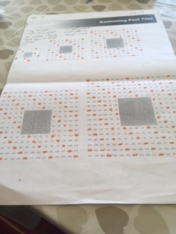

Next I decided to colour the 4s, 8s and 12s on the same grid. Exactly the same numbers were coloured because of course the 8 and 12 times tables are also multiples of 4.
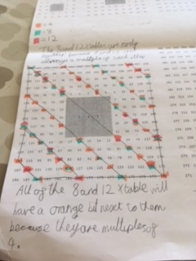
I also spotted that if you join up the diagonal lines and join up the sides you make 6 isosceles trapeziums.
This lesson was one of my favourite ever maths lessons.

