Complex Puzzle
By Alastair – 11th January 2018
Immediate Solutions:

u + v = h
u + w = b
v + w = d
u + v + w = e

uv = g
uw = f
vw = a
uvw = c

How I did them: The Easy Visual Way

For the addition problems, the simplest trick I stumbled upon was this:

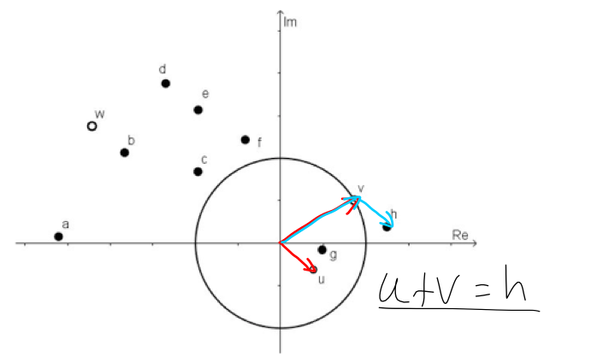
Add up the origin vectors from the points (u,v,w) you’re given to find where the final answer lies.
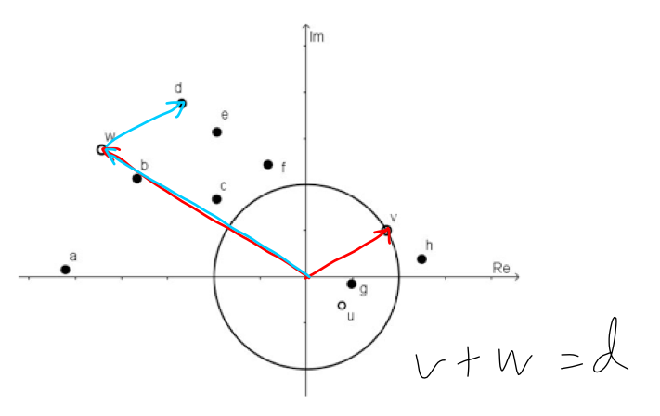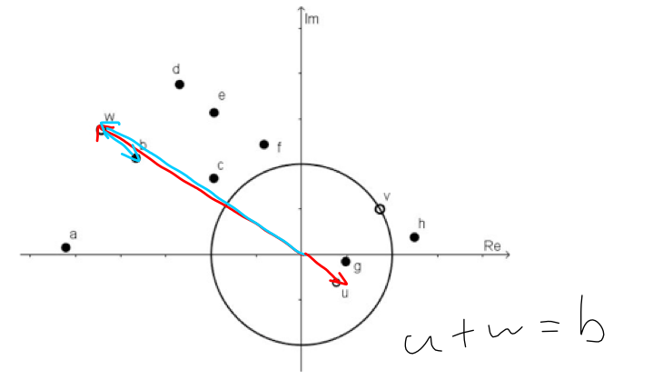
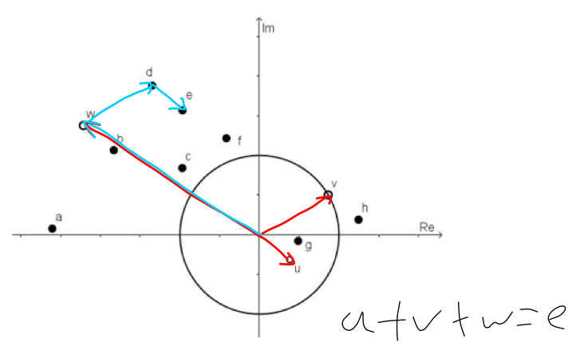

The Slightly Mathier Way:
My reasoning for this was because the way complex numbers are written. They're kind of already in their x-axis and y-axis, or imaginary axis, components. If you add two of them together, then it's as simple as the real numbers operating on each other, and the imaginary numbers doing the same.
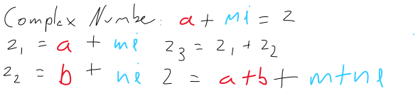
The x-axis only works on the x-axis, and the imaginary axis does likewise. Here are some vectors and their notation:
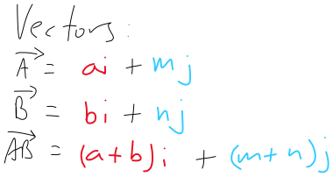

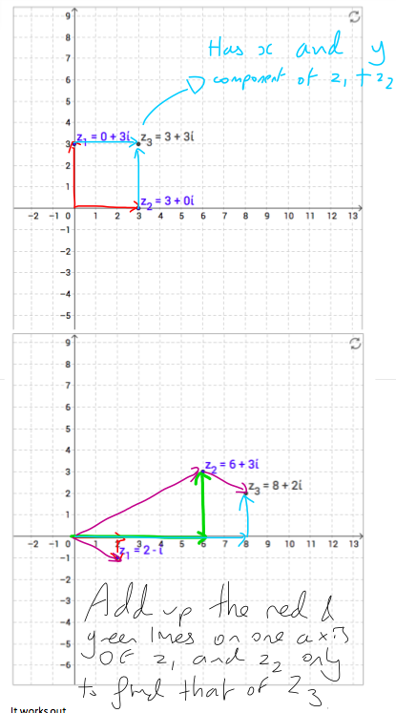
So, you can see where I'm getting at. They kind of follow the same thing, the logic remains the same - add the x components up and you'll get the x component for the final equation, and do the same with the y axis. The two don't influence each other. Here it is in a nice graphy form:

It works out.

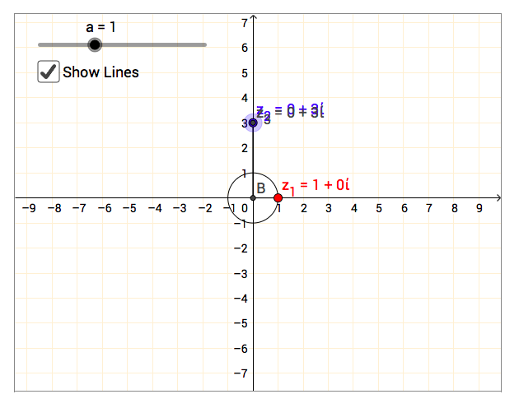
For the multiplication problems, we'll need graphs again.

Not much to see here. We can see that Z₁ lies on a circle with a radius of one, which makes it one unit away from the origin wherever we put it. Z₂ is in the same place as Z₃.
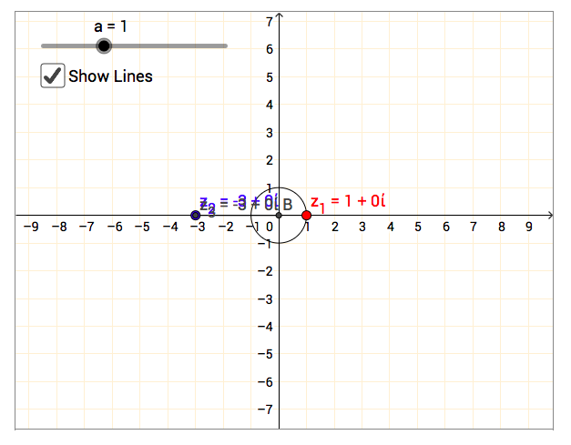
What we can infer from this is that multiplying Z₁ and Z₂ gives us Z₃. If we're being arbitrary, we can keep in mind that there's probably some secret to do with angles, because there's a circle, and I'd be damned if angles didn't come into play if we're moving a point at a set distance but varying angle.

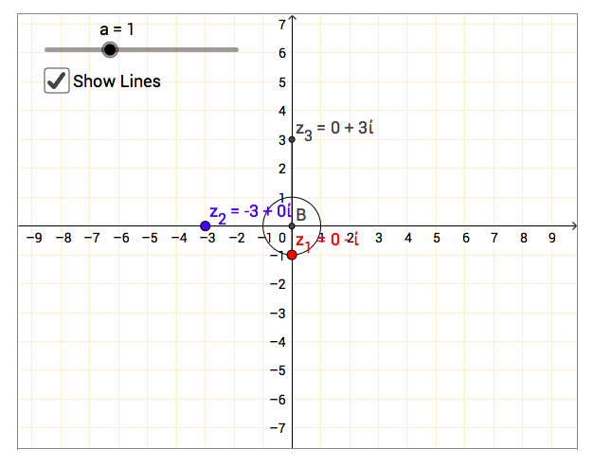
Okay, so we moved Z₂ 90° left and didn't change its magnitude. Well, Z₃ seems to have done the same. Let's assume the first thought into our mind to be right: the angle we move Z₂ is the same angle Z₃ will move.
Uh-oh, things have gone awry. Shuffling Z₁ 90° anticlockwise has caused Z₃ to do the same!
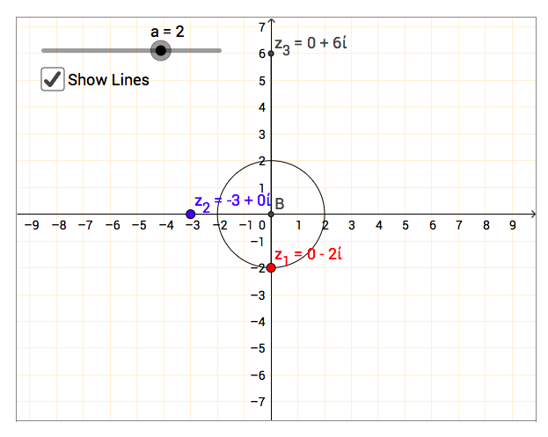
Well, let's use the logic we had in the addition bits of the explanation: The angle of Z₃ is the sum of Z₁ and Z₂s angles. Of course, if we're measuring an angle, it needs a relative position to measure it from. Thankfully, it looks like the positive x-axis is gonna be our guide here.
Gasp, magic has occurred. We've changed the radius of Z₁. It's now two. And Z₃s magnitude has changed. It's now double of what it was before. Therefore, the product of the magnitudes of the Z₁ and Z₂ is the magnitude of Z₃.

Okay, now here's a little magic tip. When we were tackling the addition problems above, we used Cartesian coordinates, that is, we used x and y components, and adding the coordinates of our given points gave us the coordinates of the final point.

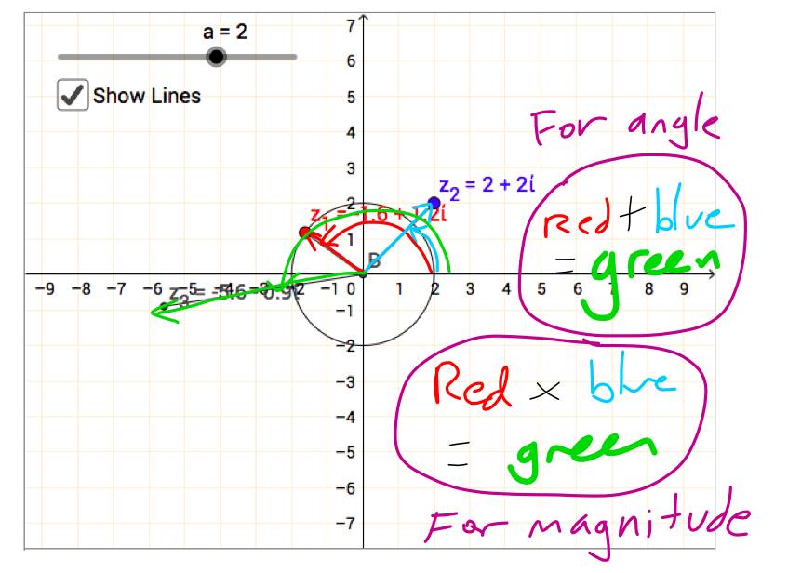
There's another kind of coordinate system. Polar coordinates. The way these babies work: instead of x and y coordinates, they use the angle the coordinate is away from the x axis, working anticlockwise, and the magnitude or distance away the point is from the graph's origin.
But disregarding all the numbers, visually, it's pretty easy to figure out where a point would be just from looking.
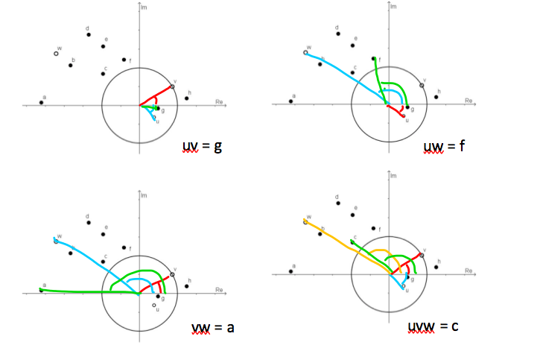
Thus:

And now time for the mathsy algebraic explanation:
Let's use an example provided by nrich:
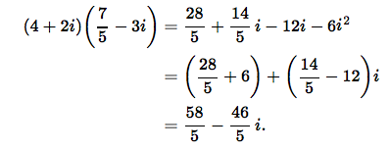
Okay, the algebra doesn't immediately shout out at us why the pattern exists. We can see that, yeah, the imaginary component of the final complex number is a result of one of the complex components being multiplied by the other complex number's real aspect… the real aspect is influenced by the imaginary numbers being multiplied together, switching their sign around because i is √-1 and squaring it makes it -1… Bleh, right? Ain't as pretty as the graphical way.

It seemed so easy with the polar coordinates.

Let's give them angles.

Now, we're not actually going to convert them into polar coordinates, just take them halfway. Here's some trig:
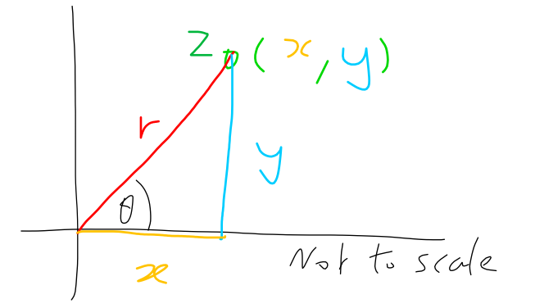cos(θ) = x/r
sin(θ) = y/r

So,

x = rcos(θ)
y = rsin(θ)

Yay, we have angles thrown in, and the magnitude's represented by r. Now we gotta have these guys back as complex numbers, which means the "y" bit gets an "i". See below.

So,

Z = rcos(θ) + irsin(θ)

= r(cos(θ) + isin(θ)) = x + iy

Now we can see that in this form, complex numbers have both magnitude and angle for us to see. Let's see what happens when we multiply two together:

Z₁ = r₁( cos(θ₁) + isin(θ₁) )

Z₂ = r₂( cos(θ₂) + isin(θ₂) )

Z₃ = r₁( cos(θ₁) + isin(θ₁) ) · r₂( cos(θ₂) + isin(θ₂) ) = Z₁ · Z₂

But at least we can see why the magnitudes do indeed multiply with each other. With a bit of rearranging, observe the magnitudes in red:

Z₃ = r₁ · r₂ · (( cos(θ₁) + isin(θ₁)) · ((cos(θ₂) + isin(θ₂))

So, Z₃'s magnitude is the product of Z₁ and Z₂'s magnitude. Nice, that makes sense.

Now the ugly coses and sins. Multiplying out the two trig parts, we get this:

r₁ · r₂ · ( cos(θ₁) + isin(θ₁) ) · ( cos(θ₂) + isin(θ₂) )

= r₁ · r₂ · ( cos(θ₁)cos(θ₂) - sin(θ₁)sin(θ₂) + isin(θ₂)cos(θ₁) + isin(θ₁)cos(θ₂) )

Pay attention to the i next to the sins, in yellow and grey. When they're multiplied with each other, their i becomes "-1", which is why the sign changes there. A little thing you might've missed.

= r₁ · r₂ · ( cos(θ₁)cos(θ₂) - sin(θ₁)sin(θ₂) + i[sin(θ₂)cos(θ₁) + sin(θ₁)cos(θ₂)] )

Okay, that's looking neater. The next bit requires you to know your trig identities. Although, if you're reading this, you'll probably know them. If not, the internet! We live for maths!

Here they are, the two angle sum trig identities everyone learns first:

sin(θ₁ + θ₂) = sin(θ₂)cos(θ₁) + sin(θ₁)cos(θ₂)

cos(θ₁ + θ₂) = cos(θ₁)cos(θ₂) - sin(θ₁)sin(θ₂)

I'm not going to explain how this works, just know that it involves a rectangle and, obviously, trig. Again, google is your friend! Wikipedia explains it well. Pursue your interests, that's what you're here for.

So, further simplifying everything:

= r₁r₂ ·(cos(θ₁ + θ₂) + isin(θ₁ + θ₂))

…And breathe. Ah.

That's so much nicer. We can see that the angles add up. If you googled the proof for the trig identities, then you can see that it really does work.

Let's just make sure it's true with some actual numbers, we'll use the example from before:

Z₁ = 4 + 2i

Z₂ = 3.5 - 3i

We then have to get it in r( cos(θ) + isin(θ) ) form. Look above if you've forgotten how.

Finding r is as simple as using the Pythagorean Theorem:

Z = x + yi

r = √(x² + y²)

For Z₁:

r = √20 = 2√5

Z₁ = 2√5( cos(θ₁) + isin(θ₁) )

Theta's easy enough to find. Take your pick of sin(θ₁) = 2/2√5 or
cos(θ₁) = 4/2√5, or even use tan(). If your calculator is in radians, which it should be if it isn't, you peasant, then θ₁ ≈ 0.4636. I won't stick it in for now, otherwise it'll get annoying. Do the same thing for Z₂, and you get θ₂ ≈ -1.1341

Okay, thing's are looking complicated. Because now we have to deal with this:

Z₁ · Z₂ = 2√5( cos(θ₁) + isin(θ₁) ) · 0.2√274( cos(θ₂) + isin(θ₂) ) = Z₃

Bleeeeeeehhhh… Just power through.

2√5 ( cos(θ₁) + isin(θ₁) ) · 0.2√274( cos(θ₂) + isin(θ₂) )

= 2√5 · 0.2√274 · ( cos(θ₁) + isin(θ₁) ) · ( cos(θ₂) + isin(θ₂) )

= 14.8 · (cos(θ₁ + θ₂) + isin(θ₁ + θ₂))

Plug in the angles:

= 14.8 · (cos(0.4636 - 1.1341) + isin(0.4636 - 1.1341))

= 14.8 · (cos(-0.6705) + isin(-0.6705))

Okay. The only thing left is to check with our final coordinates to see if it's right.

Z₃ = 58/5 - 46i/5

r₃ = √((58/5)² + (-46/5)²) = 14.8

The magnitude's right!

sin(θ₃) = (-46/5)/14.8

arcsin((-46/5)/14.8) = -0.6705

And so is the angle.

Z₃ = 14.8 · (cos(-0.6705) + isin(-0.6705))

There's nothing left to do. My job's done.

I hope you enjoyed it all. Blargh.

