To work out all of the number families I firstly started at the basics and found the even numbers which were: 2, 8, 36, 56, 64 and 136.
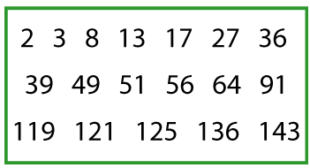
Secondly I found all of the odd numbers which are:3,13,17,27,39,49,51,91,119,121,125,143.
Thirdly I started going up the numbers from one and finding their multiples in the grid. However as 2 was the same as the even numbers I started from three which came up with: 3, 27, 36, 39 and 51. The trick behind this is if you want to check if a number is a multiple of three you add all the digits together and if the number is a multiple of three the original number is a multiple of three.
I continued this onto four and the multiples of four were: 8, 36, 64 and 136. Next I looked to see if there were multiples of five and as there were only one it does not meet the requirements of the question therefore it is not classified as a number family in the question. The same rule applies for the numbers 6 ,7 , 9 ,10 ,11 , 12 , 13 and so on. However 8 has four multiples which are :8 ,56, 64 and 136.
In total there are five different family’s in the set of numbers given

