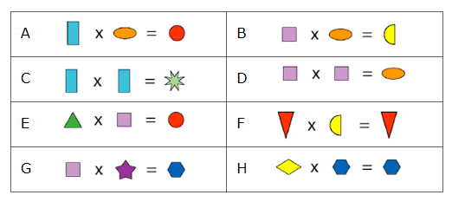
The coloured shapes stand for eleven of the numbers from 0 to 12. Each shape is a different number.
Can you work out what they are from the multiplications below?

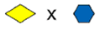
= 1 OR 0
Or

We know this because of question H. One of these has to be 1 or 0. It’s the only possible way for this to work. However I know that the red triangle is 0 because the answer is the same as one of the shapes we are multiplying. Now we can try and work these out. The HEXAGON is an answer for G which means it can’t be 1. Therefore the DIAMOND equals 1.

${}^{2}$=
${}^{3}$= x =

This information above is taken from D & B. I need to find a number from 2 – 12 which can be squared and cubed.

2 x 2 = 4 2 x 2 x 2 = 8
3 x 3 = 9 3 x 3 x 3 = 27

This means the SQUARE equals 2. The Oval equals 4 and the
SEMICIRCLE equals 8

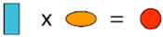

(4) (2)

This information comes from A & E. I know the OVAL and the SQUARE’S value from previous workings out. Because of their values I know that the TRIANGLE must be double the RECTANGLE. The only number the RECTANGLE can be is 3 because the maximum number for the CIRCLE or any other shape is 12. If the RECTANGLE is 3 then the TRIANGLE is 6.
3 x 4 = 12 = 6 x 2
This means the CIRCLE equals 12

Now we can work out the 8 POINT STAR. 3 x 3 = 9 meaning that the 8 POINT STAR equals 9.

There are 2 shapes remaining. The STAR and the HEXAGON. The STAR doubled equals the HEXAGON

(2) (?) ( x2)

The remaining numbers are 5, 7, 10, and 11

The only number which can be doubled to make a number less than 12 is 5. This means that the STAR equals 5 and the HEXAGON equals 10.

= 0 = 1
= 2 = 4
= 8 = 3
= 6 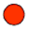= 12
= 9 = 5
=10

BY MATT, ANNA, BEN

