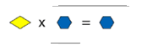
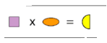
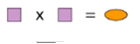
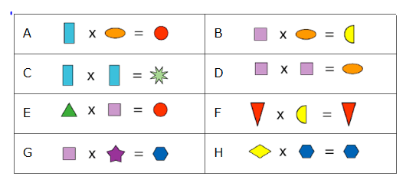
Shape Products Solution
The top sum shows 2 or 3 squared = the orange oval however the 2nd sum shows it has to be 2. Due to the fact that 3 x 9 is 27 and too big.
This shows that 1times x=x
These are the answers
Blue rectangle= 3 Green Star= 9 Yellow Diamond= 1 Yellow Semi-circle = 8
Orange oval= 4 Green Triangle= 6
Red Circle= 12 Red Triangle= 0
Purple Square= 2 Purple Star= 5
Yellow Semi Circle= 8 Blue Hexagonn= 10

This is the question

