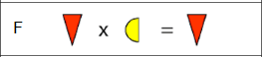
To work this out you need to start by finding zero, zero can be found in this problem in F, you can tell it is zero because the answer is the same as the first shape in the question demonstrating that zero multiplied by anything is always zero.
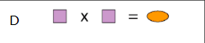
Next we looked at C and realised that the only other square number was nine which is in the correct range so the eight pointed star is nine and the rectangles are 3 because 3 x 3 = 9.
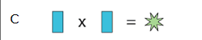
We then looked at D where it said that squre x square = oval and we already knew that square is 2 so oval is 4 because 2 x 2 = 4.
We then looked at question K because in question K thre was a Cubic sum. This was square x square x square = semi circle. The only cube that we hadn’t already found (that was between 0 and 12) was eight because we had found one because 3 x 3 x 3 = 27 and twenty seven isnt smaller than 13. 2 x 2 x 2 = 8 so the square is two and the semi sircle is eight.
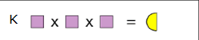
At first we thought that it was one but then we realised that the diamond was one. This is because anything times zero is always zero and anything times one is itself. We then looked at H and we realised that the hexagon x the diamond was the hexagon therefore the diamond must be one e.g. if the diamond was one and the hexagon was 10 then 1x10 is 10.
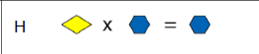

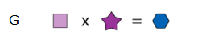
Finally we looked at G and we realised that the hexagon had to be an even number because anyh whole number x two = an even number. the final even number was ten so the hexagon was ten. Ten divided by two is five so the star is five
Next we looked at E and we worked out that the triangle is 6 because the square is two and the circle is twelve and twelve divided by 2 is 6.
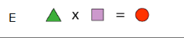
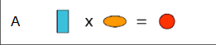
We then looked at A and we worked out that the circle was 12 because the rectangle is three and the oval is four so 3 x 4 = 12 so the circle is twelve.
0 | 
1
2
3
4
5 | 
6
7
8 | 
9
10 | 
11
12

