Challenge 1: Complete the spiral up to 144 and find the numbers that would be in the diagonal. We really enjoyed doing this (though some of us made mistakes first time).
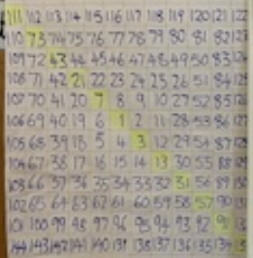
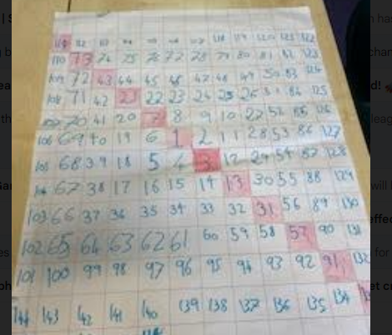

The numbers from top left to bottom right are:
111, 73, 43, 21, 7, 1, 3, 13, 31, 57, 91, 133.
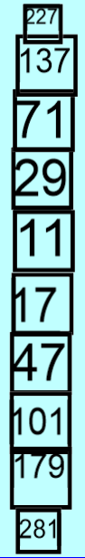
Challenge 2: Find the totals of the numbers in the diagonals in groups of 3.
We added the numbers systematically from top to bottom in groups of 3 and discovered there were ten totals.
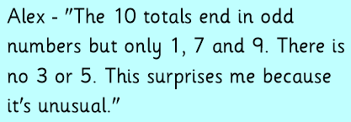
We noticed all the totals were odd numbers. Here are some of our other observations about the 10 numbers.
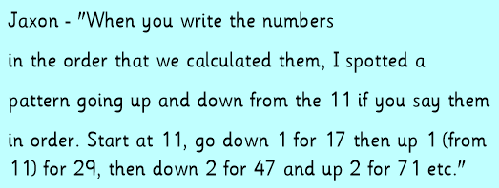

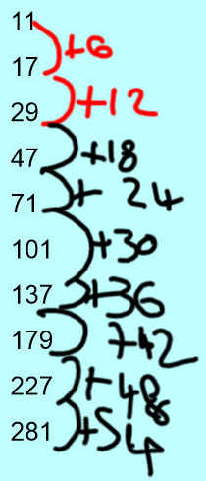
We then wrote the numbers out in ascending order and some of us noticed another pattern.
The difference between each pair of numbers when written in ascending order increases in multiples of 6.
This meant that we could predict what the next total would be if we extended the diagonal in the spiral. “It would be 341 because we would add 60 onto 281” said lots of the children.

Challenge 3a: Use the numbers to make new numbers with a total that has a 2 in the ones place.
We had so much fun with this and it generated lots of reasoning about adding even and odd numbers.
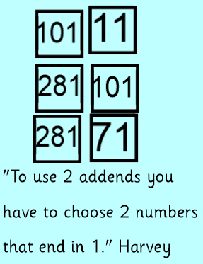
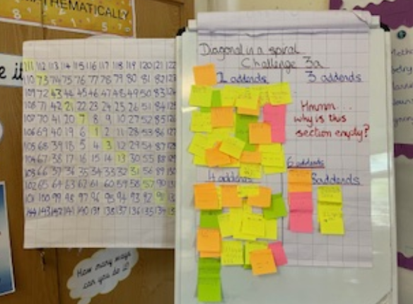
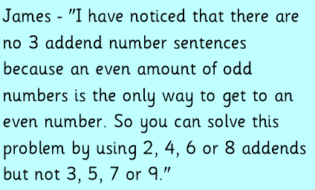

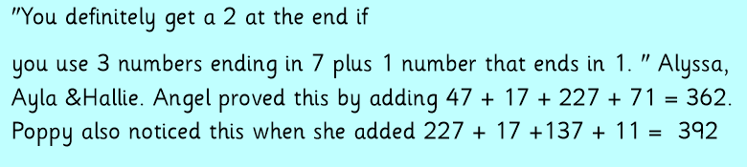
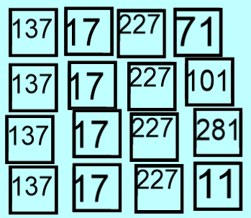

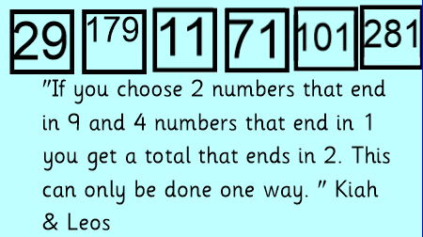
Tyler and Oliver noticed you could have the 2 numbers ending in 9 combined with 2 numbers that end in 7. They show some of the possible solutions here.
