Solution for Diagonal in a Spiral

Myself, Shubhangee, had worked in Ganit Kreeda, Vicharvatika, India with 15 kids, Viha, Abhiram, Eshann, Anirved, Arya, Rivaan, Miraya, Asma, Aprameya, Vibha, Rudraraj, Nithyashree, Adhrit, Kathir, Arnav, Arjun and Harshad of 4th and 5th grade worked on Diagonal in a Spiral.

CHALLENGE 1
Find the numbers that would be in this green upper-left to lower-right diagonal for a spiral going up to 144 instead of just 16.
Attaching the explanation given by Asma.

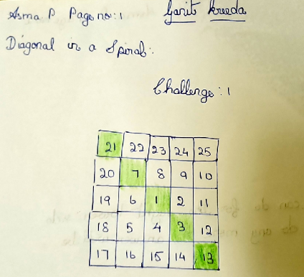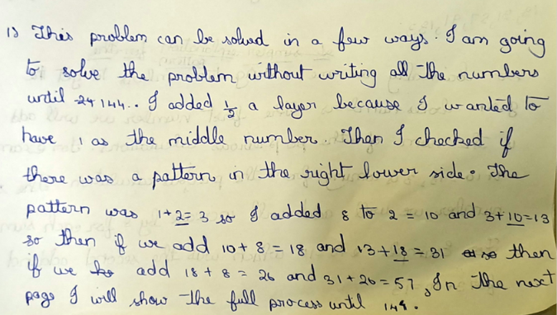
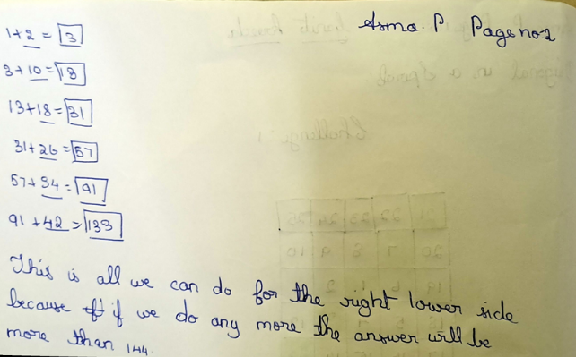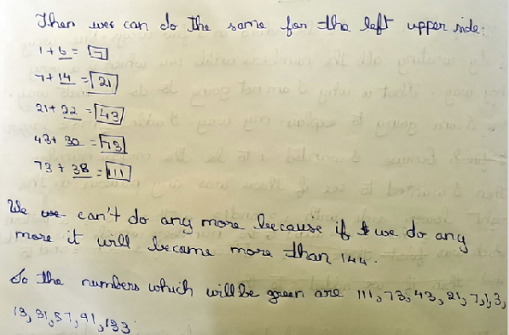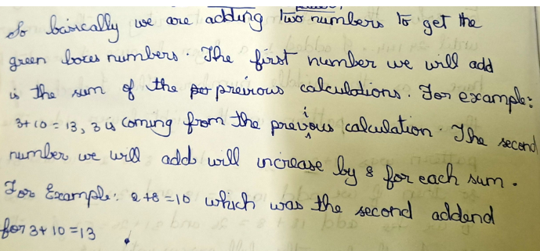
Similar explanation was given by Anirved.
He found out that 1+2=3, 3+ (2x2) =7, 7+(2x3) = 3, 13+(2x4) =21 and so on…using this logic Viha found out all the numbers in green diagonal (less than 144) without listing down any other numbers.
Aprameya found out all the numbers in a Spiral and then observed different patterns. 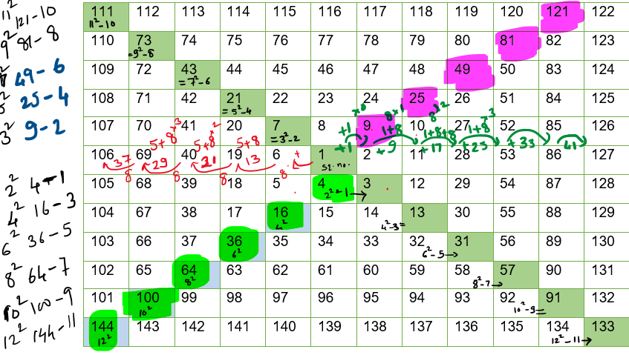
Kids spotted many different patterns by observing the grid.
Kids spotted that the numbers in the lower diagonal are related to sq of even numbers as shown. Every time they subtracted odd numbers in increasing order.
2^2 – 1 = 4-1 = 3
4^2 – 1 = 16-3 = 13
6^2 – 1 = 36-5 = 31
8^2 – 1 = 64-7 = 57
10^2 – 1 = 100-9 = 91
12^2 – 1 = 144-11= 133

Kids also spotted that the numbers in the upper diagonal are related to sq of odd numbers as shown. Every time they subtracted even numbers in increasing order.
3^2 – 1 = 9-2 = 7
5^2 – 1 = 25-4 = 21
7^2 – 1 = 49-6 = 43
9^2 – 1 = 81-8 = 73
11^2 – 1 = 121-10 =111
Challenge 2
The totals we got for each three are:

227, 137, 71, 29, 11, 17, 47, 101, 179, 281

Challenge 3a
You now need to use the numbers you got from adding the diagonal up in threes.
Use these numbers to make a total that has a 2 as the ones digit. You can only use a number once in any addition.
Do this in as many different ways as possible.
Kids shared different approaches about how they covered all the possibilities.
    - Asma thought in a systematic way with just 2 numbers that gives the sum ending in 2. Then she listed down all the possibilities with 3 no.s, 4 no.s, 5 no.s & so on.
    - Anirved, Eshaan and Adhrit systematically listed down all the ways they can get for sum ending in 2.
    - Harshad and Asma gave 5 logical steps to get sum ending in 2:
- A number which ends with 1 + another number which ends with 1.
- 3 X A number which ends with 7 + a number which ends with 1.
- 2 X A number which ends with 9 + 2 X a number which ends with 7.
- 3 X A number which ends with 7 + 2 X a number which ends with 1 + a number which ends with 9.
- 3 X A number which ends with 1 + a number that ends with 9.
- 4 X A number which ends with 7 + 4 x a number which ends with 1.
- 2 x A number which ends with 9 + 4 x a number which ends with 1.
We used counting techniques to calculate for each one as:
- As we have 4 numbers ending in 1 and we need to choose any 2 from this. We can do it in 3+2+1=6 ways.
- As we have 4 numbers ending in 7 and choosing any 3 from this can be done in 4 ways. And a number ending in 1 can be chosen in 4 ways. So, total number of ways = 4x4=16.
- 2 numbers ending in 9 can be chosen in 1 way and 2 numbers ending in 7 can be chosen in 6 ways. So, total number of ways = 1 x 6 = 6 ways.
- As explained earlier this can be done in 4 x 6 x 2 = 48 ways.
- As we have 4 numbers ending in 1 and choosing any 3 from this is same as leaving one number and it can be done in 4 ways and a number ending in 9 can be chosen in 2 ways. So, total no. of ways = 4x2=8 ways.
- This can be done in 1 way.
- This can also be done in only 1 way.
Total number of ways to get sum ending in 2 = 6+16+6+48+8+1+1 = 75 ways.

Adhrit shared one more way to see if all the answers are covered as:
Try to get 2 / 12 / 22/ 32/ 42.. as sum using units place digit. This was very powerful technique and we used this for cross checking the answers.
Finally, we got 75 solutions for challenge 3(a).
The task was very thoughtfully completed for challenge 3(a).

Challenge 3b
Do the same as in Challenge 3a but now the ones digit has to be an 8.
How many different ways are possible?
Here are the points kids have used for 3(b):
There are 5 ways to do this:
- A number ending in 7 + a number ending in 1.
4x4=16 ways.
- A number ending in 9 + a number ending in 7 + 2 X (a number ending in 1).
2 x 4 x 6 = 48 ways.
- 2 x (A number ending in 9).
1 way
- 2 x (A number ending in 7) + 4 X (a number ending in 1).
6 x 1 = 6 ways.
- 2 x (A number ending in 9) + 3 X (a number which ending in 1) + a number ending in 7.
1 x 4 x 4 = 16 ways.
- 4 x(A number ending in 7)
1 way
- 4 x (A number ending in 7) + A number ending in 9 + a number ending in 1.
1 x 2 x 4 = 8 ways.
- 4 x (A number ending in 7) + 2x (A number ending in 9) + 2x (a number ending in 1).
1 x 1 x 6 = 6 ways

Total number of ways to get sum ending in 8 = 16+48+1+6+16+1+8+6= 102 ways.

Here also we used the similar technique for cross checking as try to get 8 / 18 / 28/ 38/ 48.. as sum using units place digit.

Attaching Anirved work as it is:
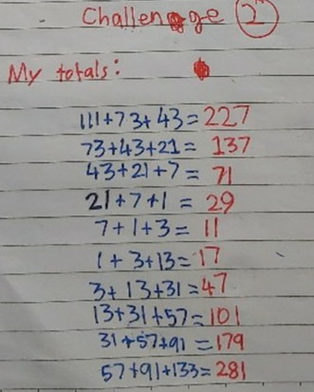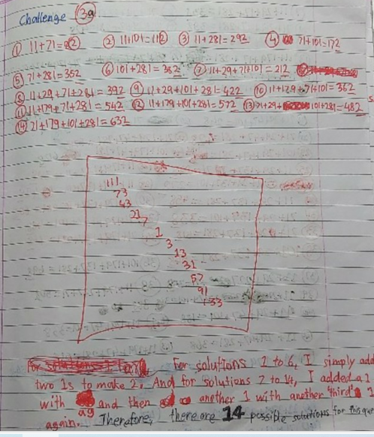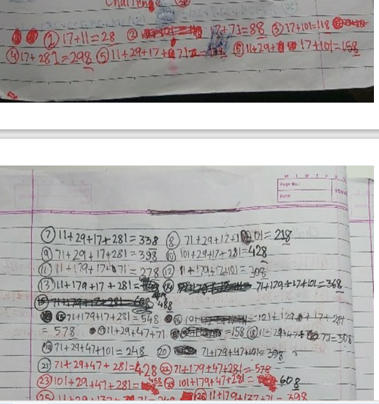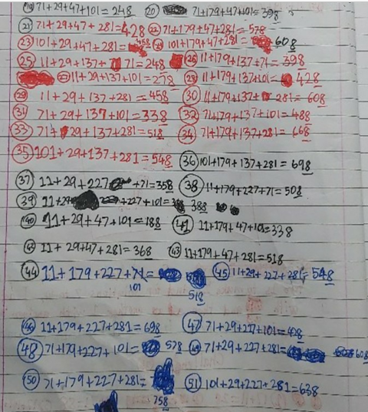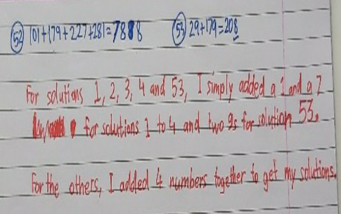

Attaching Adhrit’s work as it is:

