Challenge 1
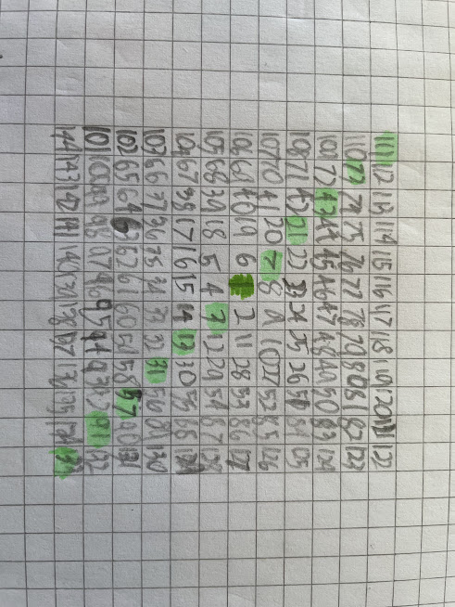

Challenge 2
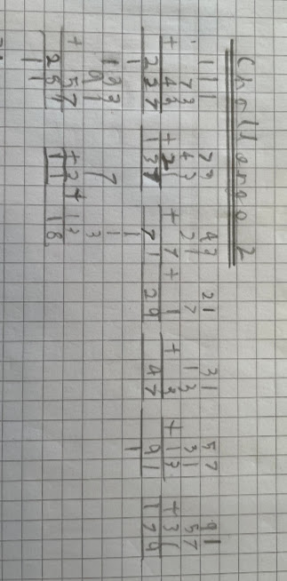
Challenge 3a
I have realised that to end up with a total that has a 2 in the ones column, the combined ones columns of the digits I am adding have to equal 2, 12, 22, 32, 42. I cannot make a total where the ones column adds up to 52 because it use all our numbers and all our numbers only equal 51.
Total of 2
I know that 1+1 = 2, so any two numbers that have a 1 in the ones column will equal a number with 2 in the ones column:
11+281
11+71
11+91
281+71
281+91
71+91
Total of 12
I also know that 9+1+1+1=12 so has a 2 in the ones column so that tells me that all these combinations end up with a 2 in the ones column:
29+71+281+11
29+71+281+91
29+71+91+11
29+281+11+91
179+71+281+11
179+71+281+91
179+71+91+11
179+281+11+91
Total of 22
I know that 7+7+8=22 and has a 2 as the ones digit.
All the numbers that are the product of three numbers ending in 7, 7 and 8 will always have a 2 in the ones digit. So that tells me that all these combinations end up with a 2 in the ones column:
227+137+18
227+47+18
137+47+18

Using my knowledge of number bonds I know that four numbers with 7, 7, 7 and 1 in the ones column will always equal a number with 2 in the ones column because 7+7+8 = 7+7+7+8
So that tells me that all these combinations end up with a 2 in the ones column:
227+137+47+11
227+137+47+91
227+137+47+71
227+137+47+281
Total of 32
I know that 9+9+7+7=32, so four numbers with these digits in the ones column will equal a number that has a 2 in the ones column:
29+179+47+137
29+179+47+227
29+179+227+137
I also know that I can switch one of the 9s for an 8 and a 1, so five numbers with digits 7+7+9+8+1 in the ones column will equal a number that has a 2 in the ones column:
18+91+179+47+137
18+91+179+47+227
18+91+179+227+137
18+91+29+47+137
18+91+29+47+227
18+91+29+227+137
18+11+179+47+137
18+11+179+47+227
18+11+179+227+137
18+11+29+47+137
18+11+29+47+227
18+11+29+227+137
18+281+179+47+137
18+281+179+47+227
18+281+179+227+137
18+281+29+47+137
18+281+29+47+227
18+281+29+227+137
18+71+179+47+137
18+71+179+47+227
18+71+179+227+137
18+71+29+47+137
18+71+29+47+227
18+71+29+227+137
Total of 42
I can make a digit where the ones column equals 42 so the total will have a 2 in the ones column using digits that end in 9+9+7+7+7+1+1+1:
179+29+137+227+47+281+91+71
179+29+137+227+47+281+11+71
179+29+137+227+47+281+11+91
179+29+137+227+47+11+91+71
3b
I have realised that to end up with a total that has an 8 in the ones column, the combined ones columns of the digits I am adding have to equal 8, 18, 28, 38, 48. I cannot make a total where the ones column adds up to 58 because it uses all our numbers and all our numbers only equal 51.
Total of 8
47+11
47+91
47+281
47+71
137+11
137+91
137+281
137+71
227+11
227+91
227+281
227+71

Total of 18
The simplest version will have 1+9+8 in the ones column:
18+29+11
18+29+91
18+29+71
18+29+281
18+179+11
18+179+91
18+179+71
18+179+281
The next is a bit harder because you have to use 7+1+9+1 in the ones column:
29+11+47+71
29+11+47+91
29+11+47+281
29+11+227+71
29+11+227+91
29+11+227+281
29+11+137+71
29+11+137+91
29+11+137+281
29+71+47+91
29+71+47+281
29+71+227+91
29+71+227+281
29+71+137+91
29+71+137+281
29+91+47+281
29+91+227+281
179+11+47+71
179+11+47+91
179+11+47+281
179+11+227+71
179+11+227+91
179+11+227+281
179+11+137+71
179+11+137+91
179+11+137+281
179+71+47+91
179+71+47+281
179+71+227+91
179+71+227+281
179+71+137+91
179+71+137+281
179+91+47+281
179+91+227+281
Once I had the full set using 29 as the digit with 9 in the ones column it was easy find the full set with 179 with 9 in the ones column as I just replaced 29 with 179 for every combination that I had already found.
Since I have four numbers with 1 in the ones column and at least two numbers with 7 in the ones column, the next combination will be 1+1+1+1+7+7.
11+281+71+91+227+137
11+281+71+91+227+47
11+281+71+91+137+47

Total of 28
The easiest way to make this is 8+9+9+1+1 in the ones column:
18+179+29+11+71
18+179+29+11+91
18+179+29+11+281
18+179+29+71+91
18+179+29+71+281
18+179+29+91+281
Next I will just change what I have done above to be 7+1 instead of 8, so the numbers I use will have 7+1+9+9+1+1 as I know 7+1=8:
47+91+179+29+11+71
47+281+179+29+11+71
47+11+179+29+281+91
137+91+179+29+11+71
137+281+179+29+11+71
137+11+179+29+281+91
227+91+179+29+11+71
227+281+179+29+11+71
227+11+179+29+281+91
I will now change what I have done to make 28 by changing 9 to 7+1+1, so the numbers I will use in the ones column are 8+9+7+1+1+1+1:
18+29+47+11+71+91+281
18+29+137+11+71+91+281
18+29+227+11+71+91+281
18+179+47+11+71+91+281
18+179+137+11+71+91+281
18+179+227+11+71+91+281
Total of 38
To make 38 I can use the following numbers in the ones column, 7+7+7+9+8 (I chose these numbers as I know that 3x7= 21, plus 9=30, plus 8=38)
227+137+47+29+18
227+137+47+179+18
I cannot find any other ways of making 38 because I have used all of the 7s which is what I would usually replace 9 or 8 with (by adding 1s).
Total of 48
If I use all the numbers it totals 51, so if I minus 3 of the numbers ending in 1 I will have a total of 48 in the ones column. For the numbers that I will add together, in the ones column I need 9+9+8+7+7+7+1:
179+29+18+227+137+47+11
179+29+18+227+137+47+71
179+29+18+227+137+47+91
179+29+18+227+137+47+281

