Making Pathways Solution :

Myself, Shubhangee, had worked in Ganit Kreeda, Vicharvatika, India with 15 kids, Hiren, Vansh, Eshaan, Rishaan, Samaira, Renah, Udit, Uday, Viha, Gowri, Arya, Vishnu, Krishna, Rivaan, Miraya of 2nd to 4th grades on Making Pathways.

Initially, kids used trial and improvement method to find one solution for first challenge. Slowly, they worked together to find all possible solutions for challenge 1.

Challenge 1

Can you make three paths of 22,40 and 64 one in each of the three colours?

22 - 9+9+1+1+1+1 7+7+7+1 5+5+5+5+1+1
40- 9+9+9+9+1+1+1+1 25+7+7+1 29+1+5+5
64- 9+9+9+9+24+1+1+1+1 25+25+7+7 29+29+5+1
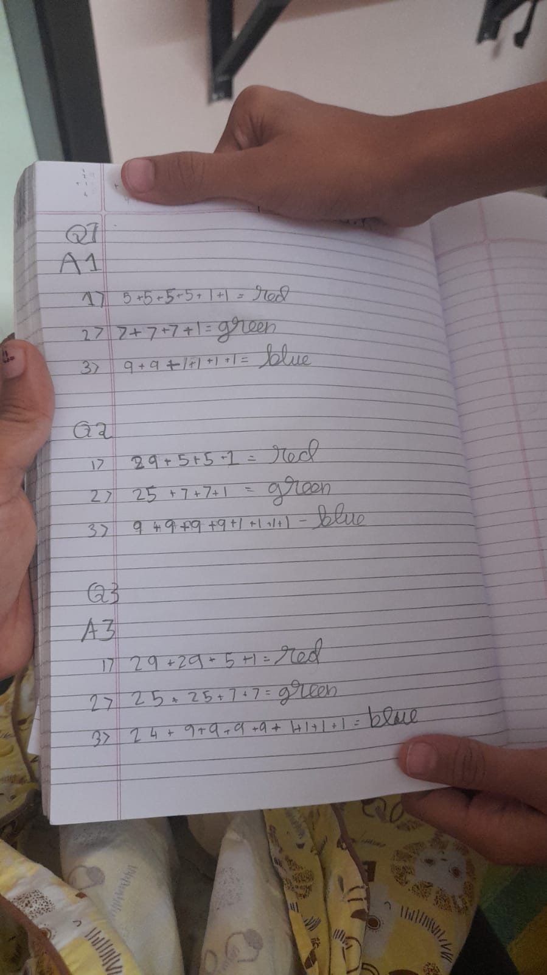

Challenge 2
How many different ways can you make 75? You cannot mix the colours that are in one path. We tried systematically starting with the smallest length size and if doesn’t work we used bigger length. Here are our solutions. Together we got 2 for Blue, 2 with green and 1 with red.
24+24+9+9+9 , 24+24+24+1+1+1
25+25+7+7+7+1+1+1+1, 25+25+25
29+29+1+1+5+5+5

Challenge 3
Try to make eight consecutive lengths of paths that can be made out the blue, green and red - but each separately?

blue=72, 73, 74, 75, 76, 77, 78, 79.
red=29,30,31,32,33,34,35,36.
green=21,22,23,24,25,26,27,28.

