A4 Fraction Addition

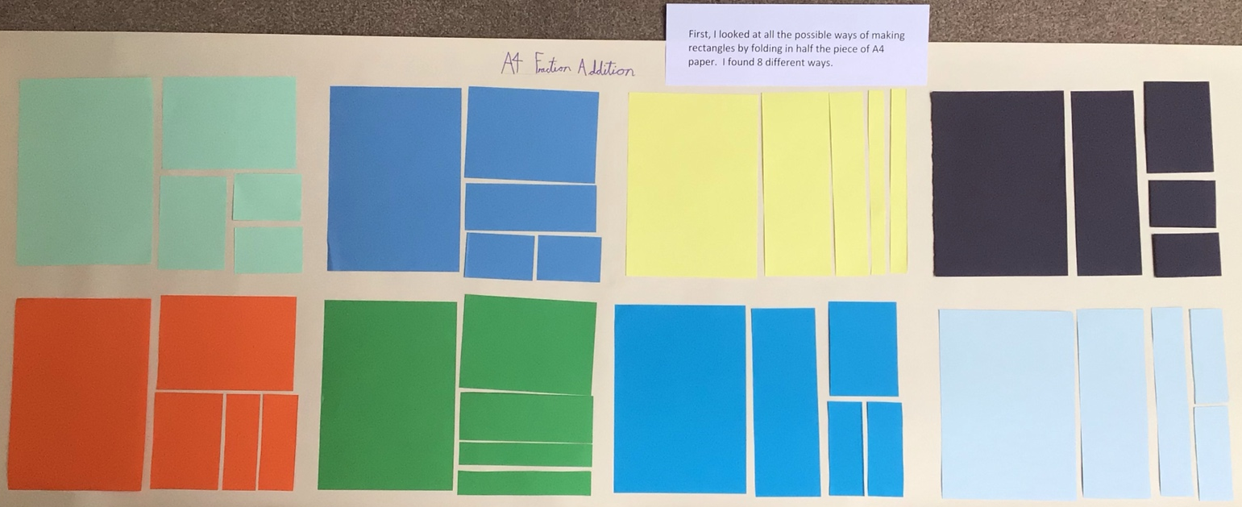
The first part of this challenge involved thinking about the different ways to fold and cut a piece of paper in half to show a half, a quarter, an eighth and two sixteenths.
I liked working in different colours and laying them out to clearly see the different combinations that could be made. It is interesting to see the different shapes that still represent the same fraction amount. I found 8 combinations.

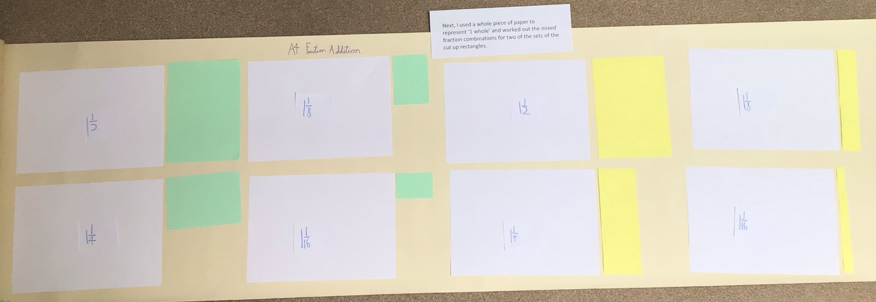
The next part involved using just two of the combinations and making mixed fractions using a whole piece of paper and a fraction. I had to identify the value of each combination.
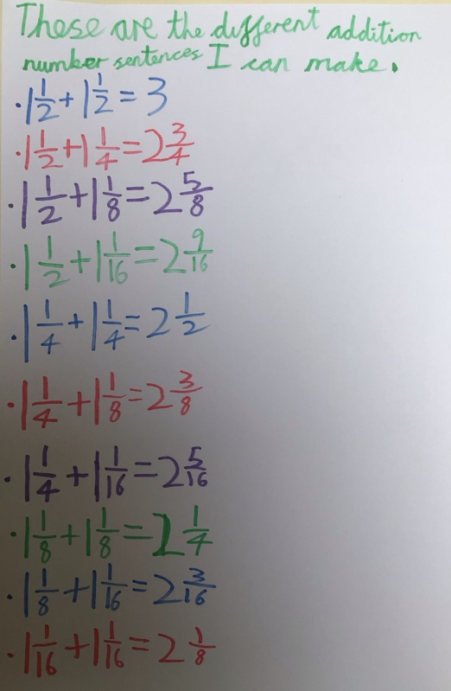
Next, I made a list of all the different addition number sentences that are possible from adding one from each combination.

