Nrich Solution for Got It

This task of Got It was taken for 2 sessions with a group of 16 students in Ganit Kreeda, Vicharvatika, India by Shubhangee (facilitator).

The names of the students are:
Kanaa, Ruhi, Kimaya, Ananya, Aarav, Shravani, Pushan, Ishan, Adithya, Avyukth, Mrunmayee, Shreehari, Aniket, Anirudh and Vikrant.

Kids played this game multiple times in the session and then at home.

They first observed that when target is 23 and you are allowed to take 1/2/3/4, if you reach 18, you can win. Slowly, kids went backwards to find 13, 8 and 3 as winning positions.

Kanaa beautifully explained the winning strategy here in this video.
https://youtu.be/VNj3bAEzl6M

Kanaa explained it here as well.
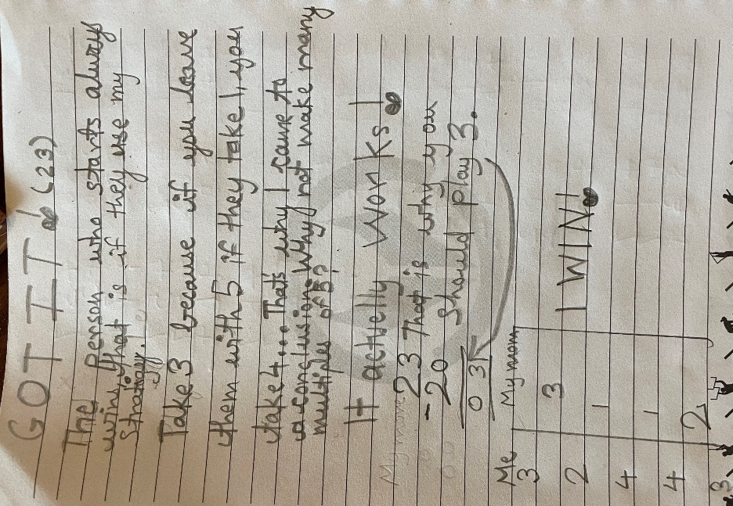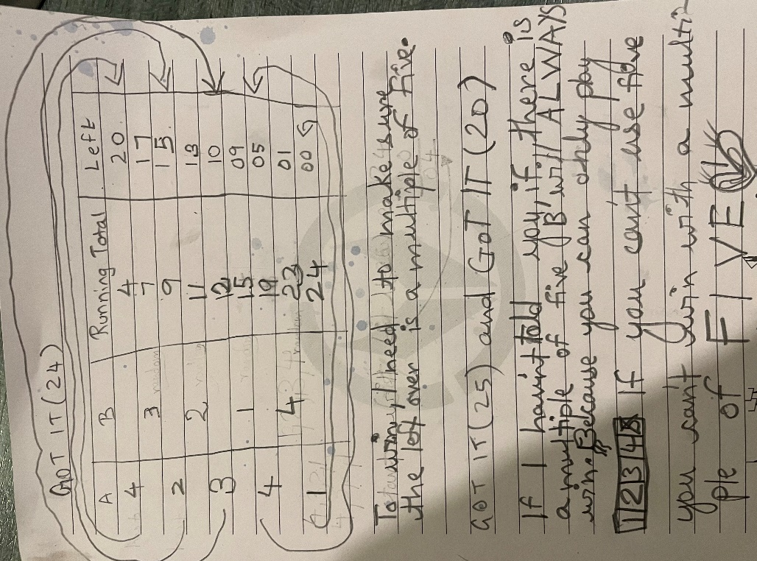

Kids collaboratively discovered that when target is 23 and numbers to be added are either 1/2/3 or 4:
1st player will always win.
He must take 3 in the beginning.
Then play to take 8, 13 18 and 23.

Kids also figured out how this strategy will change for different target and different addends.
They realised that they will get all the winning positions by subtracting one number bigger than the biggest number of the addend from the target.

