Nrich Solution for Got It (Tue 31)

This task of Got It was taken for 2 sessions with a group of 14 students in Ganit Kreeda, Vicharvatika, India by Shubhangee (facilitator).

The names of the students are:
Valerie, Kabir, Mithravinda, Devasena, Sanat, Tejas, Anant, Samvit, Prapthi, Pranitha, Viaan, Vibha, Garima, Shyam.

Kids played this game multiple times in the session and then at home.

Devasena played several times and found out that when target is 23 and you are allowed to take 1/2/3/4…..18, 13, 8 and 3 are our in between goals. Kids tested it by playing several times.
Garima, Valerie, Kabir, Anant, Shyam and Samvit had also found similar strategy. They had subtracted 5 from 23.
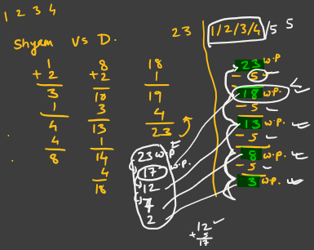

Shyam explained why to subtract 5 to get different winning positions.
He said that as opponent can add maximum 4, so if we give him 18, the max he can reach is 18 + 4 = 22 and we can add 1 and win the game.
This strategy was then adapted and tested with different target and different addends and kids discovered that
If addends are 1,2,3…n and target is T then winning positions are found using T- (n+1) continuously.
If you are left with remainder as 0, then 2nd person will win and if you are left with nonzero remainder then 1st person will win by starting with the remainder.
For example, Target = 31 and addends = 1/2/3/4/5 then
5+1=6
31- 6 = 25 – 6 = 19 – 6 = 13 – 6 = 7 – 6 =1.
So, start with 1 and 1st player will win.
Kids also discovered that if target number is a multiple of 6 (in this case), then 2nd player will win.
For example, when target is 100 and you are allowed to add 1/2/3 then as 100 is a multiple of 4 (3+1), second player can win.

