Always, Sometimes, Never (Number)

Solutions from Y5 and Y6 children at Tanglin Trust School, Singapore

Original statements

- The sum of three numbers is odd.
Sometimes. Because for example you could do 3+3+3 which is 9 but you could also do 4+4+4 which is 12. (Daniel Y6)

Sometimes because if you add 3 even numbers, you end up with an even number. If you add 3 odd numbers together, you get an odd number. (Soyun Y5)

- Multiples of 5 end in a 5.
Sometimes because you could do 5 times 2 which is 10 but you could also do 5 times 3 which would be 15. (Daniel Y6)

Sometimes because 10 is a multiple of 5 but it ends in a zero but 15 ends in 5. (Gracie Y5)

Sometimes because multiples of 5 can also end in 0
e.g. 5 x 5 = 25 5x8=40 (Medina Y5)

- If you add a multiple of 10 to a multiple of 5, the answer is a multiple of 5.
Always because 10 is a multiple of 5. (Gracie Y5)

- If you add 1 to an odd number you get an even number.
Always true because the number pattern goes odd, even, odd, even, odd, even etc. This means that if you add 1 to an odd number it will always be even. (Soyun Y5)

- If you add two odd numbers you get an odd number.
Never because if you add an odd number to an odd number, the answer is always even. (Soyun Y5)

More complex statements

Video here by Aaryan Y5: https://padlet.com/simone_dixon/chg4siw9t32vxcla

Advika Y5:
Statement | Answer
When you multiply two numbers, you will always get a bigger number | Sometimes:  Because 2x3=6 which is greater than 2 or 3 but 1x3 = 3 which is greater than 1 but not greater than 3. Also if we multiply 2 x -3 = -6 this is less than both 2 and -3.
If you add 5 to a number, the answer will be bigger than 5 | Sometimes  Because 5 + 1 = 6 which is greater than 5, but 5 +-1 = 4.
A square number has an even number of factors | Never  For example, let’s take 9 - it has an odd number of factors since in 3 x 3, 3 will be counted only once. This is true for all square numbers.
The sum of 3 consecutive numbers is divisible by 3 | Always  Because the sum of 3 consecutive numbers is triple the middle number. Triple any number is always divisible by 3.
Dividing a number by half makes it twice as big | Sometimes  If it is a positive number, this is always true since if you divide by half, you actually get double the quantity that you started with, eg. 1/(½) = 1 x 2 = 2 . However, if the number is negative, while we get double the quantity, the answer is smaller than the original number. E.g. -1/(½) = -1 x 2 = -2. -2 is smaller than -1.

- When you multiply two numbers, you will always get a bigger number

This is sometimes true. In the following instances, this is not true -
a) when you multiply any number by 1 you get the same number, for example, multiplying 5 and 1 gives 5;
b) when you multiply any number with 0 you will get 0, for example multiplying 5 and 0 gives 0
c) when you multiply any positive number with a negative number you will get a negative number, for example multiplying 5 with -1 gives -5.
However, in other instances, such as multiplying two whole numbers greater than zero or both less than 0, then the result will be a bigger number. (Kabir Y6)

I think this is sometimes true as it will work when you multiply any two numbers together unless you multiply with a 0. (Serena Y5)

The answer is sometimes true because when you multiply 6 by 2 you will get a bigger number which is 12 but if you multiply 0 by 2 the number won’t get bigger and it will be the same. (Maxim Y6)

This is sometimes true because if you multiply anything by 1 it will always be the same number like: 1709 x 1 = 1709 and 1x1,111,111 = 1,111,111. (Dylan Y6)

This is sometimes true because 6x6= 36 but 0x1,000,000= 0 and even 1x1=1 (Thomas Y5)

Sometimes, because if you do 2x1, you get 2 and 2 is the same number as 2. (Nathalie Y6)

- If you add 5 to a number, the answer will be bigger than 5

This is sometimes true. For example, if you add 0 to 5 the answer wouldn’t be greater than 5. Similarly, if you add a negative number like -1 to 5 your answer would be smaller. On the other hand, if you add a positive number greater than 0 then your answer would be greater than 5. (Kabir Y6)

Sometimes as if the number is ≤0, the answer will be <5. (Prisha Y5)

This is sometimes true because you can add 5 to 0 and it will become 5 still. Also if you add 5 to -1 it will become 4. (Dylan Y6)

This is sometimes true because 19+5=24 but if you add 0 to 5 it will equal 5. (Thomas Y5)

- A square number has an even number of factors

This is false as all the other factors are paired but since one of the factors will be e.g. 5 * 5, the number 5 is repeated so it will be odd and not even. (Prisha Y5)

This is never true. For example 3x3=9 and 9 has 3 factors, 1, 3 and itself. (Vedant Y5)

- The sum of 3 consecutive numbers is divisible by 3

This is always true. Consecutive numbers go up by 1, therefore, the sum of 3 consecutive numbers goes up by 3 which will always be divisible by 3. For example, adding 4, 5 and 6 would give us 15 which is divisible by 3. (Kabir Y6)

Always true. 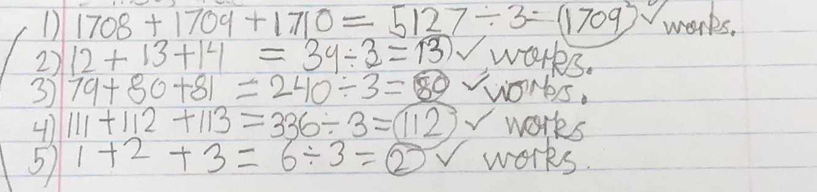
1708 + 1708 + 1708 - 1708 x 3 so it is divisible by 3. To make it consecutive you must add 1 to the second number and 2 to the 3rd number which means you have added 3 which is divisible by 3. (Dylan Y6)

This is always true for example 4+5+6=15 and 15 divided by 3= 5. (Vedant Y5)

