Always, Sometimes, Never
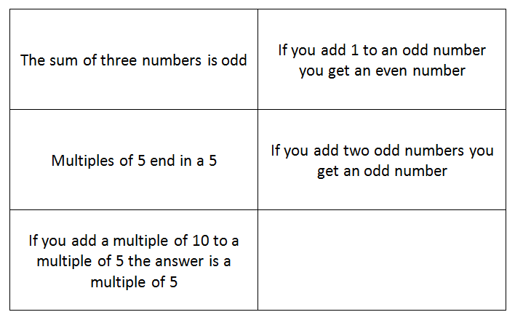
Are the following statements always true, sometimes true or never true?
How do you know?

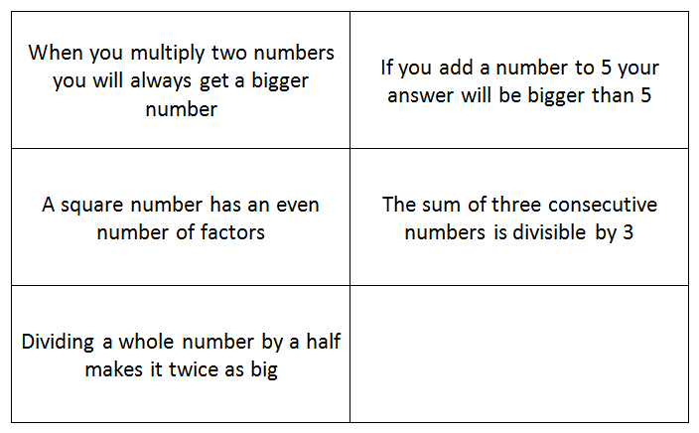
Challenge 2:

Solution
Sometimes – depends if the numbers are odd or even. | Always – you will get the next consecutive number.
Sometimes-they can also end in zero. | Never – adding two odd numbers is really adding an even number +1 to another even number +1, so the two extra +1s make 2. So you are really adding 2 which is even.
Always -10 is double 5, so all of the factors of 5 will also be factors of 10. All of the answers to the 10 times table will also be in the 5 times table.

Challenge 2:

Sometimes – you do always get a larger number if you are multiplying whole numbers. If you multiply 2 decimal numbers together, the answer will be smaller (0.5 x 0.5 =0.25) | Sometimes - if you add a zero or a negative number, the answer will be the same or smaller.
Never – a square has an odd number of factors. Factors usually come in pairs, but one of the factors of a square number is a factor times by itself. | Always – the first number you start with (e.g.: 2) then has 1 added to get to the next number (3), then has 2 added to get to the next number (4) so 2+3+4 = 9.
Always – dividing a number by a half (0.5) is the same as x2. So the number will be twice as big (double). It is not the same as dividing a number in half, which is splitting it in two.

