Always, Sometimes or Never? Solution

Myself Shubhangee (Facilitator) had worked collaboratively on Always, Sometimes or Never?
with a group of 13 students of 2nd to 3rd grade, in online mode, in ‘Ganit Kreeda’, Vicharvatika, India. The names of the students are:
Ananya, Shivashree, Swara N., Kanaa, Ruhi, Mrunmayee, Aarav, Swara S., Kimaya, Atharva, Shruti, Amey, Avyuktth.

I had conducted this task in 3 sessions and kids had worked both collaboratively and individually through homework submissions. We had an insightful discussion during the sessions. Kids unanimously categorised these number statements as:
Always True | Sometimes True | Never True
When you add two numbers you  can change the order and the  answer will be the same | When you add 10 to a number,  the answer is a multiple of 10
If you add 10 and take away 1,  it is the same as adding 9 | When you subtract one number  from another number you can  change the order and the answer  will be the same

First kids tried to explain the reasons by giving examples. But, when I asked them if they can check each and every example, they tried to think differently.

Here is the explanation of every statements:
- When you add two numbers you can change the order and the answer will be the same
To add means to mix. When we add 4 and 5 marbles, why it is same as adding 5 marbles to 4 marbles?
Kids explained it using diagram as:

As numbers are same in both the cases, we will get same answer even if we change the order of numbers in an addition problem.
- If you add 10 and take away 1, it is the same as adding 9.
Kids again drew picture for this. They added 10 marbles to the existing marbles in the box and removed one from this newly added 10 marbles, which is same as adding new 9 marbles to the existing marbles.

- When you add 10 to a number, the answer is a multiple of 10.
Examples:
20 + 10 = 30…is a multiple of 10
80 + 10 = 90…is a multiple of 10
Counter Examples:
12 + 10 = 22…is not a multiple of 10
43 + 10 = 53…is not a multiple of 10
Kids corrected it as when you add 10 to a multiple of 10 (or the number that contains 0 in its units place), the answer is a multiple of 10 , which is always true.
- When you subtract one number from another number you can change the order and the answer will be the same.
Examples:
8 – 8 = 0
67 – 67 = 0
Counter Examples:
18 – 10 = 8
10 – 18 = is not possible as 18 is bigger than 10.

Kids then worked on these little difficult statements.

Always True | Sometimes True | Never True
When you add two even numbers together the answer is even | When you multiply by an odd number the answer is odd | When you add two odd numbers together the answer is odd
When you multiply by an even number the answer is even | When you multiply a number by itself the answer is even | If you add an even number to an odd number the answer is even
Doubling a number results in an even number | The sum of four even numbers is divisible by four
 | Adding three consecutive numbers results in an even number
- When you add two even numbers together the answer is even…always true.
Shruti and Aarav explained it as even numbers can be divided into 2 equal parts.
They used this fact and explained it using an example.
Add 2 even numbers… 6 marbles and 4 marbles.
Now both 6 and 4 marbles being even can be equally divided among two people. That means there is no leftover. This means the total is even number.

- When you add two odd numbers together the answer is odd….Never True.
Kids used 10 number Frame to explain this with an example as:
E.g. 7 + 9 = 16 or 7 + 11 = 18

As any odd number when arranged in groups of 2, there is always 1 leftover and when you add or mix two odd numbers 1 left over from these two numbers will make a pair. That’s why the answer is always even.
- If you add an even number to an odd number the answer is even….Never True.

Aarav explained it as:
Even number can be paired equally and odd number can’t be paired. There will always be 1 leftover. That’s why on adding one even number to one odd number, we will always have 1 leftover. So, the answer is always odd.
- When you multiply by an odd number the answer is odd …Sometimes True.
Swara S explained it by giving examples as
7 x 2 = 14, which is even and
7 x 3 = 21, which is odd.
Kids changed it to When you multiply an odd number by an odd number the answer is odd, so that the statement is always true.

- When you multiply by an even number the answer is even…. Always True.
Aarav explained it as:
Even number is a multiple of 2 that means even number = 2 x some number(s).
So, any number(n) x even number = any number(n) x 2 x some number(s)
i.e. any number(n) x even number = 2 x (n x s), which is multiple of 2 and so even.

- When you multiply a number by itself the answer is even…Sometimes true.
Kids came up with different examples as:
Examples:
2x2=4, even 8x8=64 even
Counter examples:
5x5 = 25…odd 7x7=49 odd

- Doubling a number results in an even number…Always true.
All the kids collaboratively explained this using 2 ways.
Doubling means adding same number twice or multiplying a number by 2.
As we know from above multiplying any number by 2 is a multiple of 2 and so even.
Secondly, if you add two same numbers, we will either have
Odd + odd = Even OR Even + Even = Even

- The sum of four even numbers is divisible by four…Sometimes true
Examples:
8+4+6+10 = 28…divisible by 4
2+14+6+10 = 32…divisible by 4

Counter examples:
4+8+4+2=18…not a multiple of 4.
6+10+4+2=22…not a multiple of 4.

- Adding three consecutive numbers results in an even number…Sometimes true
Examples:
1+2+3=6, even
5+6+7=18, even
Counter examples:
4+5+6=15, odd
8+9+10=27, odd
Kids then worked on Shapes related statements.
Always True | Sometimes True | Never True
Three sided shapes are called triangles.  (we considered the shapes are closed.) | 3D shapes have more than  four faces.  Cube or cuboid has 6 faces. But, sphere, cone have less number of faces. Pyramid also has exactly 4 faces.
If you put two squares together
you get a rectangle.

Two same sized squares joined side to side will give a rectangle.
But, 2 different sized square or 2 same sized squares joined at corner won’t give a rectangle.

 | Four sided shapes are called squares
When you cut a square in half
you get a triangle

Here is Aarav’s solution:
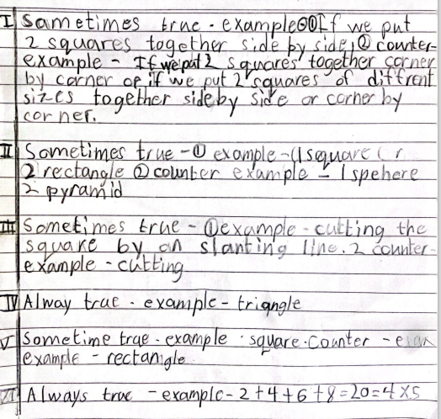
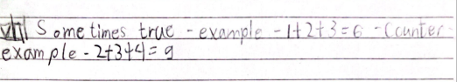
Kanaa’s solution:
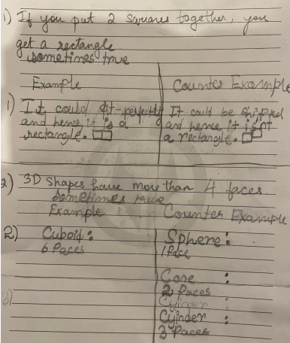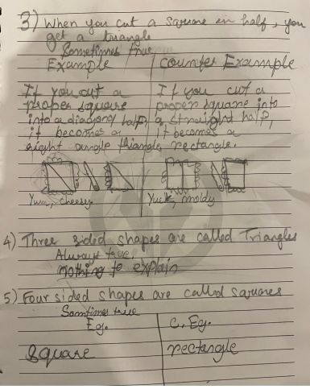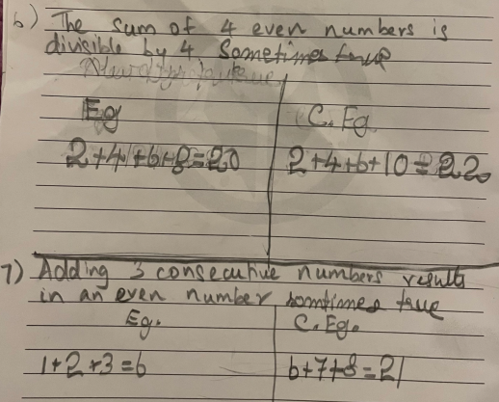

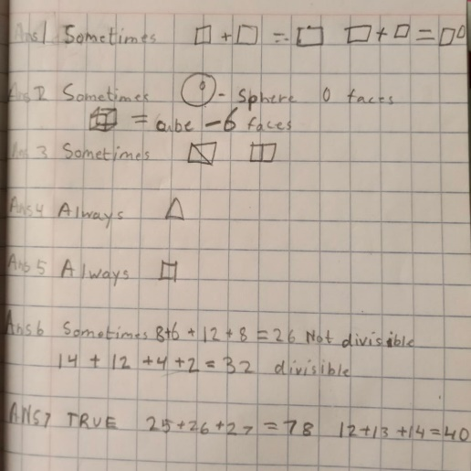 This is Mrunmayee’s solution.

