Live nRich Solution for Always Sometimes Never
(https://nrich.maths.org/12671)

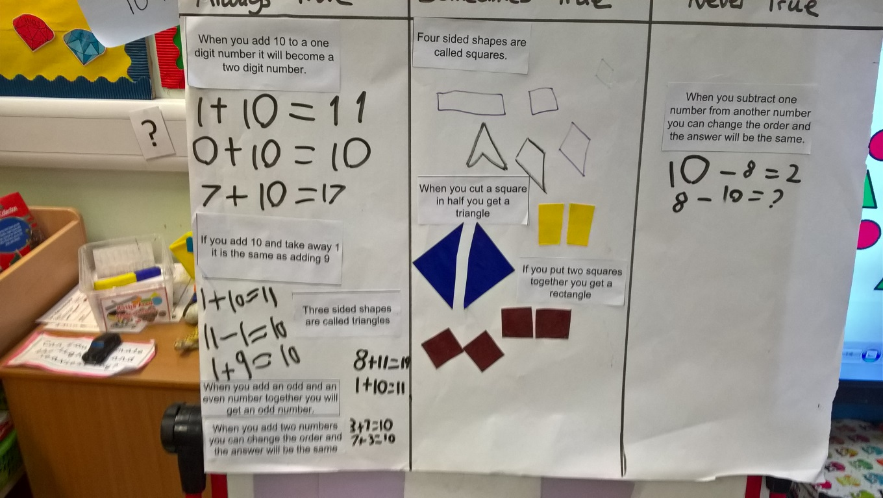
nRich asks: When you cut a square in half you get a triangle…
Maja said, “When I cut my blue square in half, it made 2 triangles.”
Endrikas said, “I cut my yellow square in half, but it made 2 rectangles.”
We decided that maybe nRich are right. But then, Das cut his brown square into 4 quarters! He put 2 quarters together and said that it made a different half. So, because we found examples that worked and some that didn’t work, we eventually agreed that it was sometimes true.

