Orchards Primary School, Wisbech Year 2
Live Solution for Always Sometimes Never
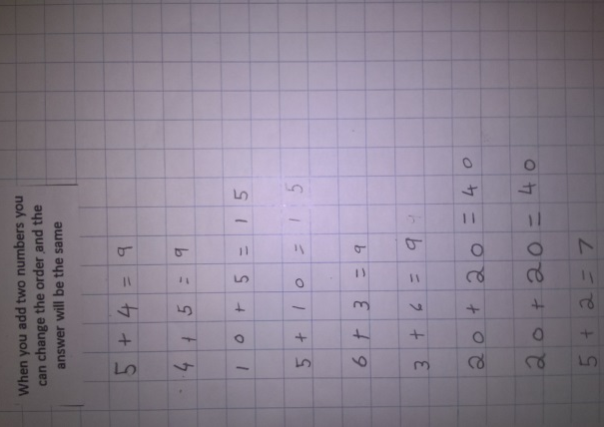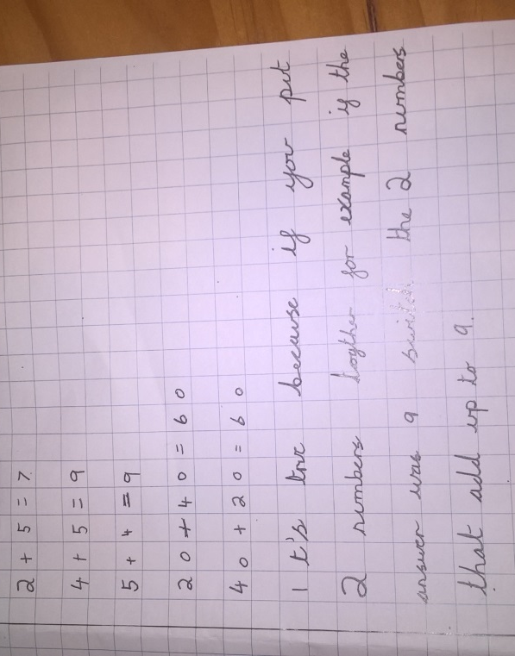
In Beech and Maple Classes, the children looked at pairs of numbers and decided it is true that when you add two numbers you can change the order and the answer will be the same. They didn’t say whether it was always or sometimes true though.
Some children noticed this in Maths Week when they were working with Pascal’s triangle. See below, where they coloured in red all the multiples of 3. We noticed that 6 + 15 and 15 + 6 both get the same answer, (21). We also noticed how the triangle is symmetrical.
