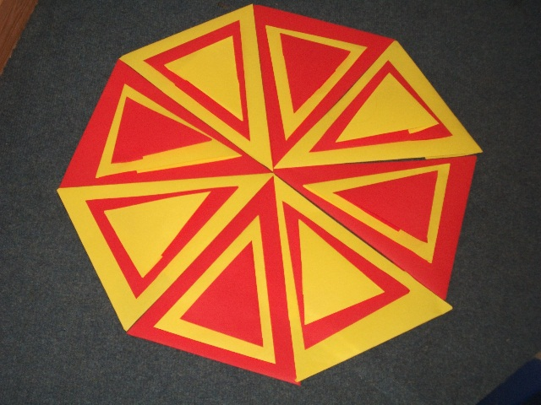
First we made the shapes out of the different coloured paper and then we sorted them into the groups of three. Large yellow, medium red, small yellow or the opposite way round. We sorted the groups so that you can see every shape by putting them in the middle of the larger shape. After that we sorted the groups into a flower. The groups are petals and we used the original pattern (see second line) 4 times.

