Nrich Soln for Domino Magic Rectangle (2)
This task was given as homework in Ganit Kreeda, Vicharvatika, India and sharing the solutions submitted by Ruhi and Aarav.
Ruhi’s Solution.

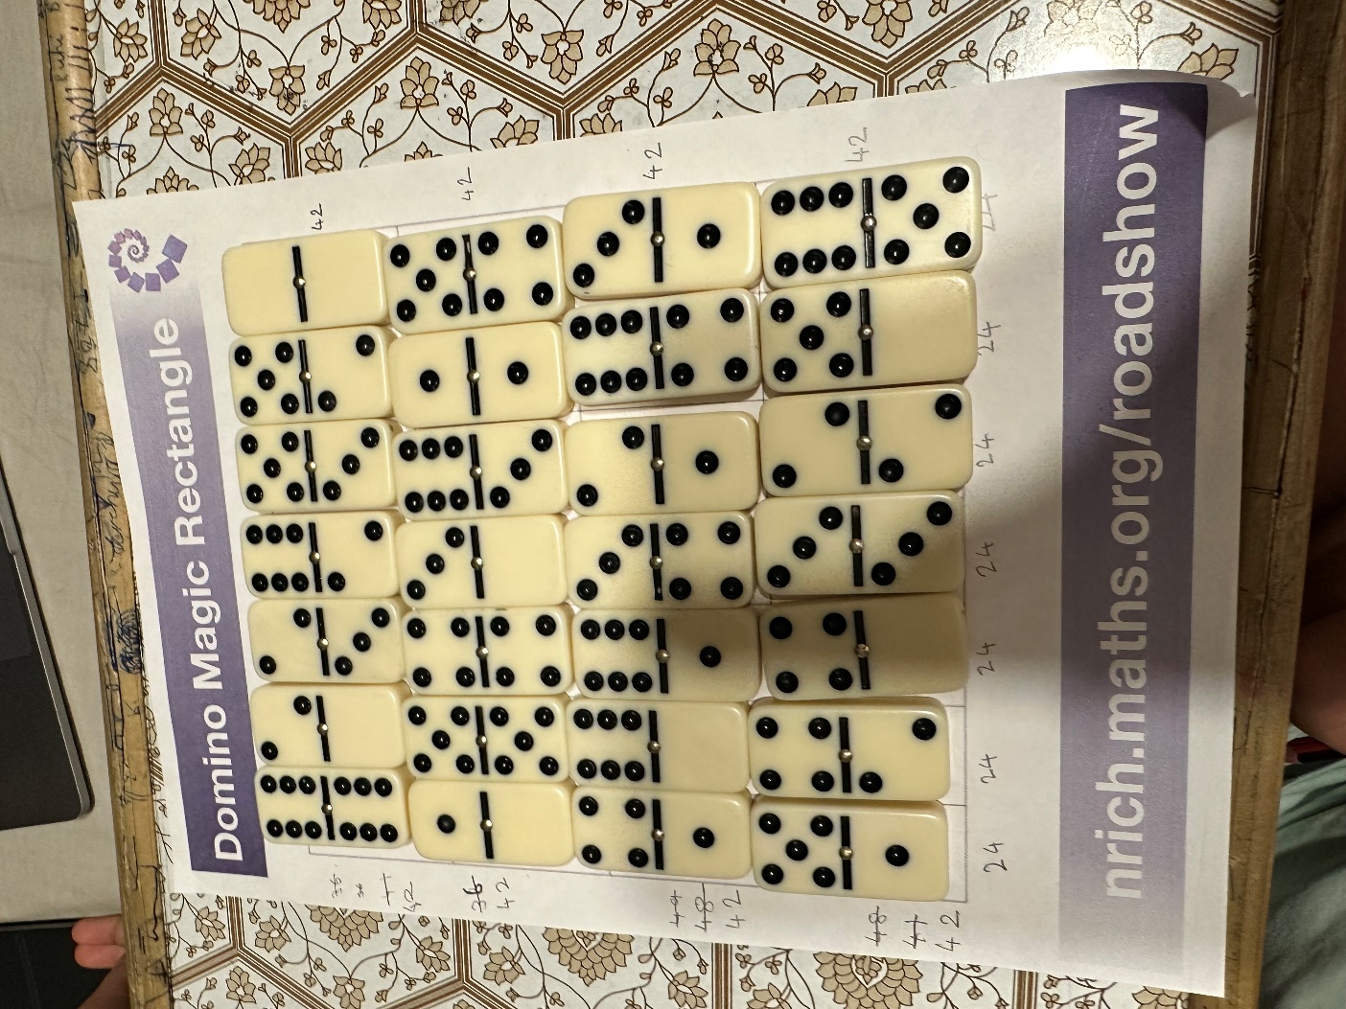
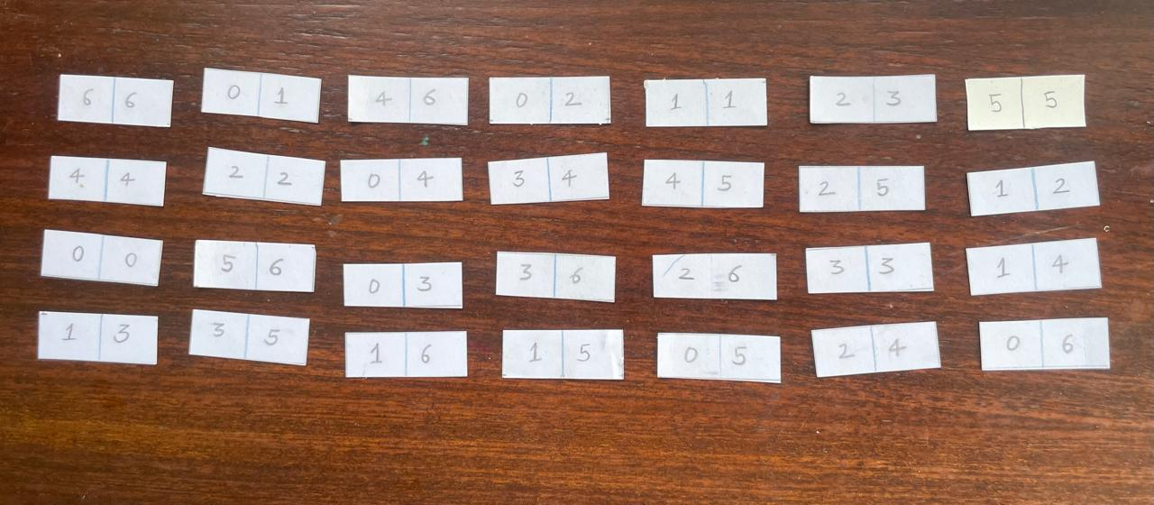
Aarav’s Solution.

