Domino magic Rectangle

An ordinary set of 28 dominoes can be laid out as a 7 by 4 magic rectangle in which the spots in all the columns total 24 while the spots in all the rows total 42. Try it!

Ans: I could make a Magic Rectangle. Here is the solution:

(3, 5), (1, 2), (4, 6), (1, 3), (5, 5), (0, 6), (0, 1)
(3, 4), (2, 6), (1, 1), (1, 4), (6, 6), (0, 5), (0, 3)
(2, 3), (1, 5), (3, 3), (2, 5), (0, 0), (4, 5), (3, 6)
(0, 4), (1, 6), (2, 4), (4, 4), (0, 2), (2, 2), (5, 6)

Above, the numbers (dots) in each row add up to 42, and the numbers in each column add up to 24.

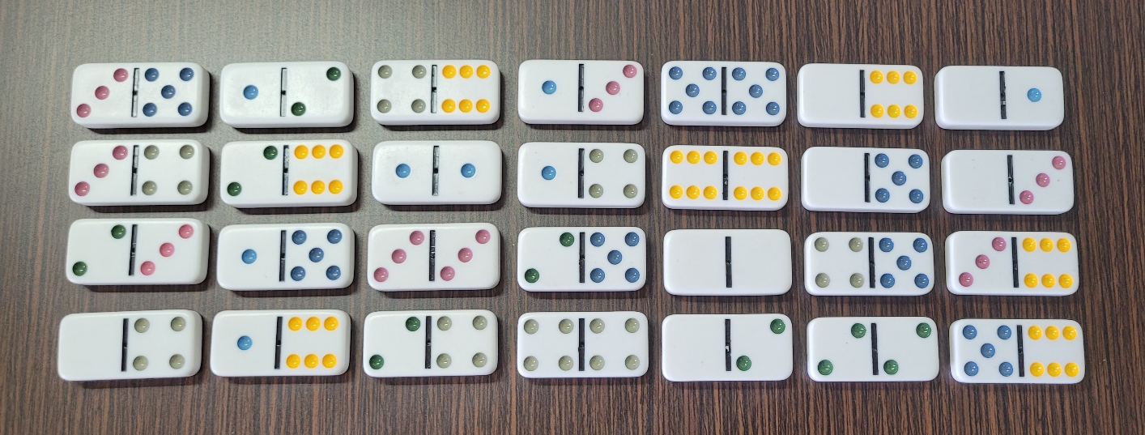

I have tried to make a game involving dominoes and magic squares:

This is a 2 - 4 player game.

Setup:

All the dominoes except (0, 6), (0, 5), (1, 6) have to be kept in a pile beside a playing area (which is really just some space between the players). First, get a sheet of paper. Place 25 dominoes in a 5 x 5 grid and draw a rectangle on each of the dominoes’ borders. Spacing between dominoes is optional, and if there is too little space to draw 25 domino sized rectangles, you can draw them on two sheets of paper. Now, you should have 25 rectangles in a 5 x 5 grid. Call this sheet of paper the playing mat.

Rules:

The youngest player starts. Every player can either take a domino and place it in one of the rectangles on the playing mat or remove an already placed domino. If the dots on the dominoes have a sum of 30 in a row or column of 5 dominoes, the player who completes the row or column earns 10 points. If the dots on the dominoes have a sum of 30 in a diagonal of 5 dominoes, the player who completes the diagonal earns 20 points. If a domino is removed from a row, column or a diagonal and the row, column or diagonal remains incomplete, the points will not be deducted from the person who got points for it.

After a player makes a move that makes the sum of dots on each of the dominoes in all rows, columns and diagonals 30, that player earns 50 points and ends the game. Each player will count how many points they have earned. The player with the most points wins!

My Video Link for Domino Magic Rectangle Game:

https://youtu.be/ygULrnnMjFU

