Which Fraction Is Bigger?
Warm-up
Which is bigger: 2/5 or 1/3
There are a few ways which you can use to convince yourself that one is fraction is bigger than the other:
- The lowest common denominator for 2/5 and 1/3 is 15 (5*3) and hence 2/5 can be written as 6/15 and 1/3 can be written as 5/15. It can now be seen that 2/5 > 1/3 because when the denominator is 15 for both fractions, the numerator is 1 number larger for the fraction equivalent to 2/5 which is 6/15
- If you were to simply do the division for both fractions, you would get 2/5= 0.4 and 1/3= 0.3333…. since the number in the tenths place for 2/5 is 4 and for 1/3 it is 3, this again shows that 2/5> 1/3 as 4 is bigger than 3
- Imagine you got a string which has a length of 15cm. If you cut 2/5 of this string, then you would a length of 6cm. If you cut 1/3 of this string then you would get a length of 5cm. This also shows that 2/5> 1/3 as 2/5 of 15 is larger than 1/3 of 15. You can use this idea with any length or any other instance (e.g. time)
What if you had the fractions 2x/5 and x/3? Would your answer be the same?
The answer would only be the same if x is some positive number which is not 0. You can think of 2x/5 as (x)( 2/5) and you can think of x/3 as (x)(1/3). We have already established that 2/5> 1/3 and hence if x is some positive constant which is not zero, the fractions are just getting multiplied by a fixed value and hence they are only getting scaled up or down at the same rate. You can also think of this as the xs cancelling out on both sides of the inequality which results in 2/5> 1/3 which is true. If x=0, then 2x/5=x/3 because you end up with a 0 on the numerator for both fractions and 0 divided 5 or 3 is just 0. It gets interesting when x is negative. If x is negative, then x/3> 2x/5. Because 2/5 is bigger than 1/3, this means if you multiply 2/5 by a negative number, then the number is larger on the negative side (it is further down the number line on the negative side than x/3). What this consequently means is that 2x/5 is smaller than x/3 as x/3 would be closer to 0. An alternative way to arrive to the same conclusion is if you get the same denominator for the fractions- so 2x/5= 6x/15 and x/3= 5x/15. The fractions are the same if 6x=5x or x=0, 2x/5> x/3 if 6x>5x or x>0 (meaning a positive number). And x/3> 2x/5 if 5x>6x or x<0 (negative number)

Main Problem
4x/7 or 9/14 - 4x/7 can be written as 8x/14; this makes the denominators for both fractions the same and we only need to focus on the numerators. The only time these fractions are equal is when 8x=9 and so when x=9/8 or 1.125 then the fractions are equal. If x is greater than 9/8, then this means that 4x/7> 9/14. However if x< 1.125 then 9/14> 4x/7.

5/9 or 2x/12 - again we should try to get the lowest common denominator. In this case it is 36 and so 5/9= 20/36 and 2x/12= 6x/36. Same like last time, the only time the fractions are the same is if the numerators are equal. So when 6x=20 and x= 10/3, then 5/9= 2x/12. If x is greater than 10/3, then 2x/12> 5/9 but if x is less than 10/3 then 5/9> 2x/12.

(3x/4)+1 or (x/4)+3 - (3x/4)+1= (3x/4)+(4/4)= (3x+4)/4
(x/4)+3= (x/4)+(12/4)= (x+12)/4. Both of the fractions have already got a common denominator and so when 3x+4=x+12 or x=4, then the fractions are the same as they got the same numerator (this is solving both linear expressions simultaneously). For (3x/4)+1 to be greater than (x/4)+3, then this means that 3x+4 must be greater than x+12- in other words x must be greater than 4. Conversely, if x<4, then (x/4)+3 > (3x/4)+1.

(8(1-x))/5 or x/6 - (8(1-x))/5= (8-8x)/5= (48-48x)/30 and x/6=5x/30. The denominators are now the same so when the numerators are the same- when 48-48x=5x or x=48/53, then the fractions are the same so (8(1-x))/5= x/6. If 5x> 48-48x or x> 48/53, then x/6> (8(1-x))/5. Conversely if 48-48x> 5x or x< 48/53, then (8(1-x))/5> x/6.

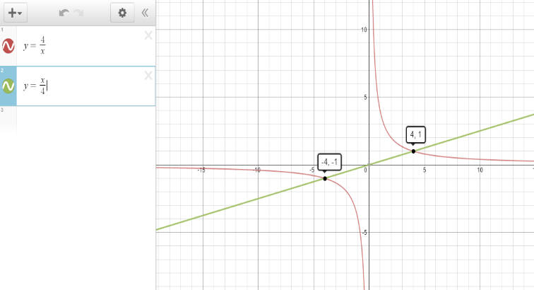
8/2x or 4x/16 - 8/2x= 4/x and 4x/16= x/4 - so it can be seen that we are comparing the reciprocals of one another where y=8/2x is a reciprocal graph and y=4x/16 is a linear graph with a gradient of 1/4. For the two fractions to be equal, then 4/x must be equal to x/4. This means x²=16 and so x=4 or x=-4. This makes sense as 4/-4= -4/4=-1 and 4/4=4/4=1 (you get this by substituting x=4 or -4 into the functions).
For 4x/16> 8/2x, then if -4<x<0 but also if x>4, the inequality will be true (this can be seen by looking at the graphs to thee right). For 8/2x> 4x/16, then 0<x<4 or x<-4 as can be seen on the graph to the right. When x=0 the fraction 4x/16=0 but the fraction 8/2x is undefined as 8 is getting divided by 0. Arguably, it could be said that when x=0 then 8/2x> 4x/16 as 8/2x is heading towards infinite which is larger than 0 (the reciprocal graph never actually crosses the y axis)

