Name that graph

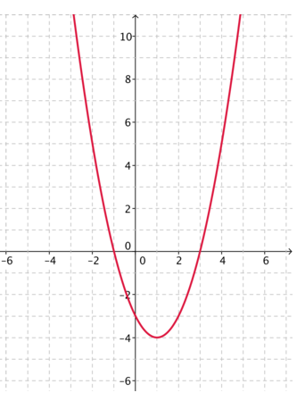
Just from looking at the graph I know it is a quadratic graph, this means it contains and x squared.
The two forms of this graph are expanded and factorised.

An expanded formula looks like this:
x² + 7x + 12 = 0

However solving a quadratic graph requires the factorised formula,

In order to factorise an equation, you need to look for two numbers,

In the formula x² -3x - 4 = 0, the two numbers must add together to form -3 and multiply together to form -4. These numbers are 1 and
-4.

The equation will look like this: (x+1)(x-4) = 0.
It has two solutions, this is because one of the brackets must equal 0.

x + 1 = 0 or x - 4 =0

If we subtract the numbers we end up with x = -1 or x = 4

A graph would look like this:
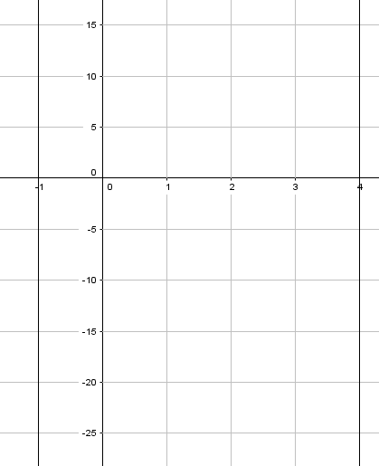
Notice that the graph passes through -1 and 4 on the x axis. These are the roots and the values of x.

In this graph, the line passes through -1 and 3. Here is the math for that.

x = -1 or x = 3
x+1=0 or x-3=0
(x+1)(x-3)=0

The factorised form of the equation is (x+1)(x-3)=0

If we expand that we get:

(x*x)+(x*+1)+(x*-3)+(+1*-3) = 0
x² + x + -3x + -3 = 0
x² + -2x + -3 = 0
The expanded equation is x² - 2x - 3 = 0
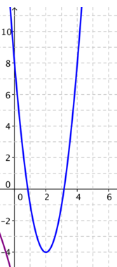
This graph is also quadratic, the roots are 1 and 3.

x = 3 or x = 1
x – 3 = 0 or x – 1 = 0
(x-3)(x-1) = 0

The factorised equation is (x-3)(x-1) = 0

(x*x)+(x*-1)+(x*-3)+(-1*-3) = 0
x² + -x + -3x + 3 = 0
x² + -4x + 3 = 0

The expanded equation is x² - 4x + 3 = 0

This factor which is the same in the two graphs is the x². This is different for the next graph.
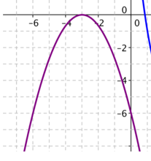

In this graph, the line is upside down compared to the others; this is because the x² is negative. The root is -3, so the only solution is -3.

x = -3 or x = -3
x + 3 = 0 or x + 3 = 0
(x+3)(x+3) = 0

However, the x² is negative so one x needs to be negative. This has to be the x in the bracket with a 3 so that the 3 also becomes negative.
-(x+3)(x+3) = 0.
The expanded form is -x² -6x -9

