For every triangle with at least two whole number sides, you can always form a parallelogram by putting 2 triangles together.
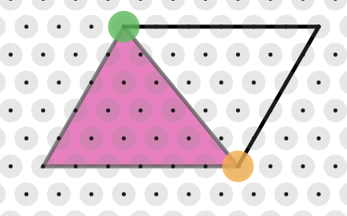

Then, from the task, “Isometric Areas”, we know that the area of a parallelogram in “T” is
$$\left(Base ×Height\right)× 2$$
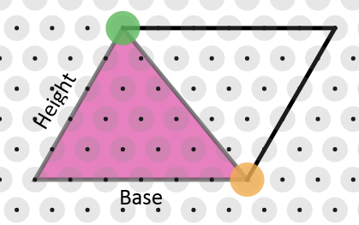

For the area of a triangle, we can divide this by 2
So the formula is: $Base ×Height$

