ANGLES IN THREE SQUARES

1. The angle c=45$°$, because it is the angle between the diagonal and the side of square.

2. I mark points on the diagram, which in essentally to name angles.

3. a) The angle $∠$ CAE is a, $∠$BDA is b.
b) The angle$∠$DCA is symmetric with the angle $∠CAE$(alternate angles), so $∠DCA=a.$
c) The angle $∠BCD=b.$
d) The angle $∠ABF≅ ∠CBG=b$
e) $△BHC is right-angled, so ∠CBH=90°-b$
4. $∠$BCA = a+b
We have to prove, that a + b= c = 45$°$
5. In $△$ ABC the line segments AB and BC are symmetric. AB$≅$ BC, this is why $△$ ABC is isosceles, so is $∠$BAC $≅∠$BCA. $∠$BAC= a + b.
6. The equation for angles in $△$ ABC:

180$°=∠$ABC + $∠$BAC + $∠ACB$
$$180°=(\left(90°-b)+b\right)+\left(a+b\right)+\left(a+b\right)$$
$180 =$ 90$°$ + (a+b)+ (a+b)
$180°=$ 90$°$ + 2 $⋅$ (a+b)
180$°-90°=2⋅(a+b)$
90$°$ = 2 $⋅(a+b)$
90$°$$:2=a+b$
45$°=a+b$

The sum of angles a and b in 45$°.$ And angle c is 45$° too.$
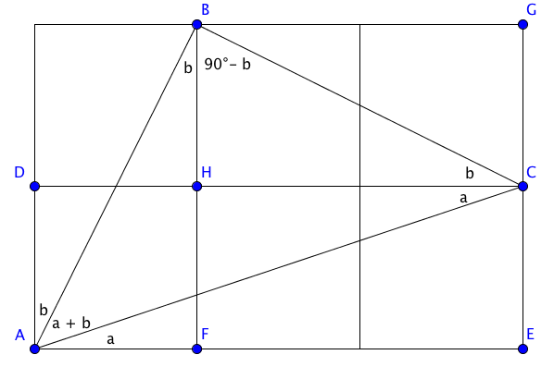
$a+b=c$

