Pentagon construction
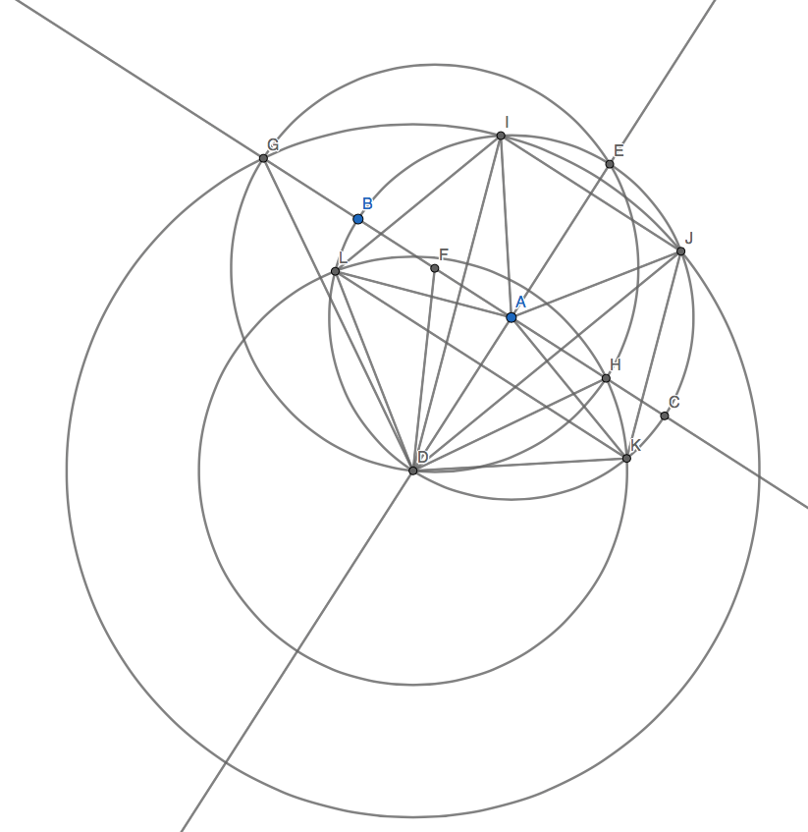

The above is the construction of a regular pentagon. Let the radius of the circle $C_{1}$ with centre at point $A$ passing through point $B$ be 1.

The right angled triangle $FAD$ was apparent to me when I completed the construction. By Pythagoras’ theorem,

$$DF^{2}=FA^{2}+DA^{2}$$

Since point $F$ is the midpoint of the radius $AB$, $FA=\frac{1}{2}$. Since $DA$ is a radius, $DA=1$. Substituting these values into the above equation gives

$$DF=\frac{\sqrt{5}}{2}$$

Then, I saw the right angled triangle $ADG$. By Pythagoras’ theorem,

$$DG^{2}=DA^{2}+AG^{2}$$

But

$$AG=GF+FA$$

And, since $DF$ and $GF$ are both radii of the circle with centre $F$ passing through the point $D$, $GF=DF=\frac{\sqrt{5}}{2}$, so $AG=\frac{\sqrt{5}}{2}+\frac{1}{2}=\frac{\sqrt{5}+1}{2}$. $DA$ is again equal to 1. Substituting these values into the above equation, we obtain

$$DG=\frac{\sqrt{10+2\sqrt{5}}}{2}$$

$DI=DJ=DG$, since these line segments are all radii of the circle with centre $D$ passing through $G$.

The next right angled triangle I observed was triangle $AHD$. By Pythagoras’ theorem,

$$DH^{2}=AH^{2}+DA^{2}$$

But

$$AH=HF-FA$$

And $HF=DF=\frac{\sqrt{5}}{2}$, since they are both radii of the circle with centre $F$ that passes through $D$. So $AH=\frac{\sqrt{5}}{2}-\frac{1}{2}=\frac{\sqrt{5}-1 }{2}$. $DA$ is again equal to 1. Substituting these values into the above equation, we obtain

$$DH=\frac{\sqrt{10-2\sqrt{5}}}{2}$$

$DL=DK=DH$, since these line segments are all radii of the circle with centre $D$ passing through $H$.

We can now find the size of $∠DAL$ using the cosine rule:

$$∠DAL=\arccos{\frac{LA^{2}+DA^{2}-DL^{2}}{2\left(LA\right)\left(DA\right)}}$$

$LA=DA=1$, since these line segments are both radii of the circle $C_{1}$, and it was deduced above that $DL=DH=\frac{\sqrt{10-2\sqrt{5}}}{2}$. Substituting these values into the above equation, we obtain

$$∠DAL=\arccos{\frac{\sqrt{5}-1}{4}}=72°$$

Now, triangles $LAD$ and $DAK$ are congruent. This is because $LA=DA$ (radii of one circle), $AD=DA$ (common side of both triangles) and $DL=DK$ (deduced above), so the triangles are congruent by the SSS theorem. In particular, this means that

$$∠DAK=∠DAL=72°$$

I then considered triangle $ALK$.

$$∠LAK=∠DAL+∠DAK=144°$$

From the cosine rule, we can find the length of $LK$:

$$LK=\sqrt{LA^{2}+KA^{2}-2\left(LA\right)\left(KA\right)\cos{∠LAK}}$$

$LA=KA=1$, since they are the radii of the circle $C_{1}$, and we know that $\cos{∠LAK=\cos{144°=-\frac{1+\sqrt{5}}{2}}}$. Substituting these values into the above equation, we obtain

$$LK=\frac{\sqrt{10+2\sqrt{5}}}{2}$$

So $LK=DI=DJ$. We see then that triangle $ALK$ is congruent to triangles $DAI$ and $DAJ$ by the SSS theorem, since one side of one triangle is equal to another side of the other two triangles ($LK=DI=DJ)$, and the other two sides of one triangle are equal to the other two sides of the other two triangles, because they are all radii of the circle $C_{1}$.

In particular then, $∠DAJ=∠DAI=144°$. Also,

$$∠JAI=360°-\left(∠DAJ+∠DAI\right)$$

So $∠JAI=72°$.

Now, $∠LAI=∠DAI-∠DAL=72°$. Therefore, $∠KAJ=360°-\left(∠DAK+∠DAL+∠LAI+∠JAI\right)=72°$.

Therefore, by the SAS congruence axiom, the triangles $AIJ, AJK,AKD,ADL,ALI$ are all congruent to each other and, in particular, $IJ=JK=KD=DL=LI$ and all the angles in one of the above triangles are equal to the angles in the corresponding four triangles, therefore $∠I=∠J=∠K=∠D=∠L$, where these angles are the interior angles of the shape $IJKDL$, making this shape a regular pentagon

