Problem 1
Alan has 3 friends, Barney, Charlie, and Daniel.
Barney and Ed are both friends with Charlie.
Ed is Frank's only friend.

For the first problem, I started off by working out how many friends each boy has:
To help, I put Alan as A, Barney as B, Ed as E etc.
A: 3 (B, C, D)
B: 2 (A, C)
C: 3 (B, E, A)
D: 1 (A)
E: 2 (F, C)
F: 1 (E)
After this I knew that Frank had to go in the last circle with Ed next to him, as this is the only way that Ed is connected to just two people, whereas, if I put Frank in the first circle, Ed would be connected to three people. Then, I Charlie next to Ed as they are both friends. After that, I put Alan in the topmost circle as that is the only circle out of all of the ones left that are connected to three friends.
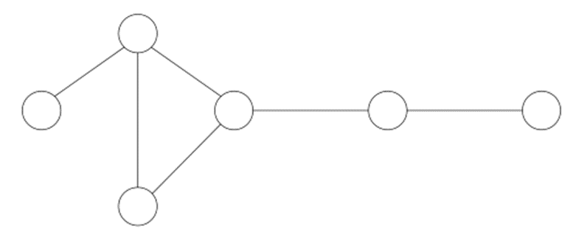
Once I worked that out, I knew that Daniel had to go in the first circle as he only has one friend. Then, I put Barney in the last circle left.
B
D
F
E
C
A

Problem 2

Bella and Ciara are friends
Emily and Ciara are not friends
Bella is Fiona's only friend
Anna has more friends than anyone else
Daphne has three friends
Gill and Daphne are not friends
Emily has two friends
For problem 2, I couldn’t work how many and who were each girls friends, so instead I looked at each circle and wrote down how many circles were connected to each other.

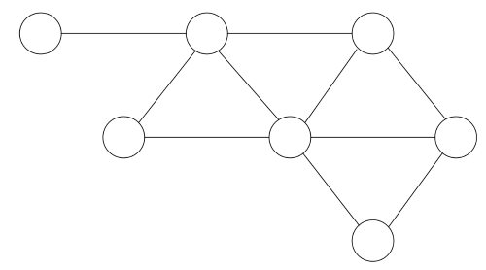
3
4
1

Because of this, I knew that Anna had to go where the 5 is as the question states that she has the most friends. Also, I could deduce that Fiona goes where the 1 is and Bella goes where the 4 is as Bella is Fiona’s only friend and there is only one circle that is connected to only one other. After that, I had to experiment a bit with the positioning. I knew that there were 2 possible places for Daphne to be put so I tried them out in both positions.
3
2
5
2
Here is one possibility:
C
E
G
D
A
B
F
However, it doesn’t work
as Cierra and Bella aren’t
friends but they are next
to each other so I tried the
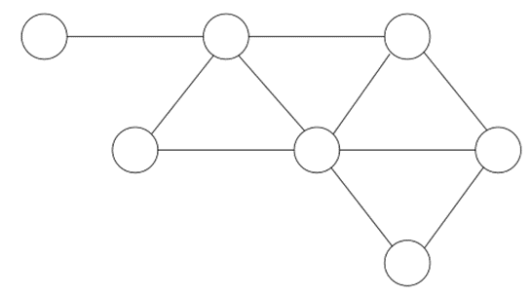
other way:
E
G
C
F
B
A

D

This was the correct method. I knew Daphne had to go where she is because there were only two possibilities and the first one didn’t work. Then, I knew that if I put Cierra where Emily is, she would be next to Bella and if I put her were Gill is then Gill would be next to Daphne so she had to go where she is. After that, I knew I had to put Emily where she is because if I put her where Gill is, she would be next to Cierra who she isn’t friends with. It left Gill with the one spot. I checked it and it all worked out.

With these problems, I found it easier to work more systematically, slower and to make more jottings than usual as you can get muddled up and confused.

