Equation for the cubic curve
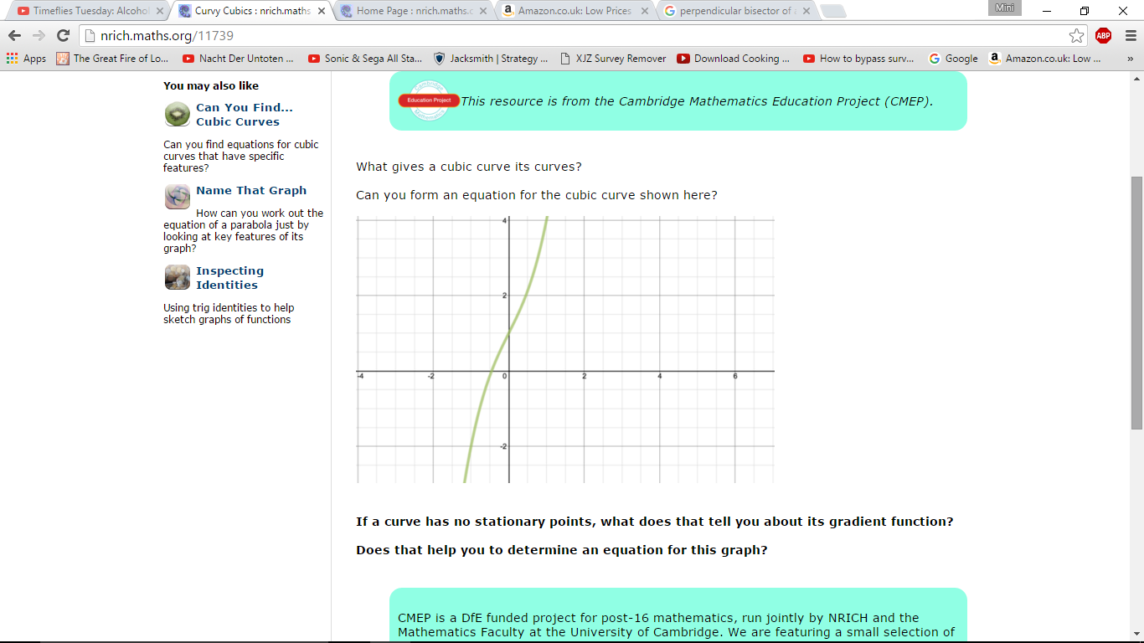

A cubic function is one in the form f(x) = ax³ + bx² + cx + d.
Looking at the graph above, it can be seen that there are no stationary points. ∴ for this graph, f ’(x) ≠ 0
Since the y intercept for this cubic graph is when y=1, we know the equation will be y= ax³ + bx² + cx + 1
Differentiating the function would give dy/dx= 3ax² + 2bx + c
I figured out that if c=0, a graph such as this cannot exist as you would end up with dy/dx= 3ax² + 2bx and if you set the differential function equal to zero, 3ax² + 2bx is factorisable ------> x(3ax + 2b) and hence you would always have two stationary points, when x=0 and when x= -2b/3a .
There must be a value of a other than 0 otherwise the graph obviously wouldn’t be cubic.
I realised that if the value of b was zero then dy/dx would be 3ax² + c. This could be a possible option for this graph but only if the value of c is positive and if the value of a is positive (from looking at the graph, I can tell the graph is a positive cubic so a>0). The reason for this is if the value of c is positive, then when dy/dx = 0, x= (-c/3a)^{1/2} and hence there would be no real values for x as you cannot take the square root of (-c/3a) because you are taking the square root of a negative number. In other words, there would be no stationary points in this case and this graph doesn’t have any stationary points.
From simple substitution, I shall demonstrate how I found out that the value of b=0:
Looking at the graph, I can see when x=1, y=4. So substituting x=1 in the general cubic form gives a+b+c+1=4 or a+b+c= 3
I can see that when x=-1, y=-2. So substituting x=-1 in the general cubic form gives –a+b-c+1=-2 or -a+b-c=-3
So now I have got two equations: a+b+c= 3 and -a+b-c=-3 If I take the second equation and multiply it by -1, then I get -1(-a+b-c)= 3 or a-b+c=3
The strange thing is a+c+b=3 but also a+c-b=3. So from this we can conclude that b has to equal to zero or else the above equations wouldn’t work.
Now we know that y= ax³ + cx + 1 and we need to find out the values for a and c.
I made an attempt to find the value of c: when x=0, then dy/dx= 3a(0)² +c= c
I then saw the point on the graph when x=0 and y=1.

I then proceeded and attempted to draw an approximate tangent line for the coordinate (0,1) (the tangent line is the black line on the graph above. Looking at the black line it looks like it would have an equation y=2x so would have a gradient of 2. That consequently means that if the tangent line has a gradient of 2, then the point (0,1) must also have this. And since when x=0, dy/dx=c , this means that c must be two as that is the gradient.
Now of course, the method above is extremely inaccurate and to increase the accuracy I also did a few simultaneous equations:
We already established that a+c=3 (as b=0)
I then looked at the graph and then took an estimated value for what y would be when x=0.5. It looks like y is around 2.1.
So then I also constructed another equation using the estimation of when x=0.5, y=2.1:
a(0.5)²+0.5c+1=2.1 or 0.125a+0.5c=1.1

So now I have two equations: a+c=3 and 0.125a+ 0.5c = 1.1

Therefore, 3-c = 8.8-4c or 3c= 5.8
a= 8.8- 4c
a=3-c
c= 5.8/3 ≈ 2 - I assumed the value of y was 2.1 when x=0 so I didn’t get the perfect answer for c being 2. It looks like the value of y when x=0 is slightly higher than 2.1.

If c=2 then a must be 1 as a+c=3

So my answer for the equation for the cubic graph is y= x³+2x+1

