Cubic Curves

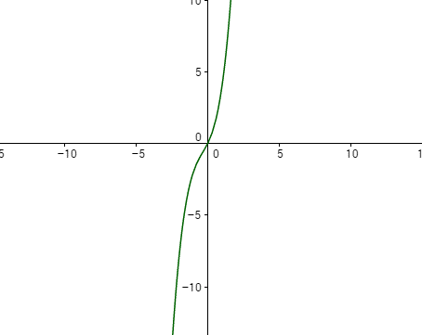
a. If the cubic curve can’t have stationary points, the gradient of the curve at any point can't be 0. This means you can't have maximum or minimum points which must have a gradient of 0, so the closest thing we have is a point of inflection. If you slant this point of inflection a bit, you can end up with no stationary point:

To find out the equation of a graph like this, its gradient function must have no solutions (so that there are no stationary points on the cubic). The derivative of a cubic curve will be a quadratic equation ax^2 + bx + c.
You could find a quadratic with no solutions using trial and error by changing its y-intercept, but you can do it methodically using the discriminant, b^2-4ac. If b^2-4ac < 0, the equation will have no real solutions.
$When a=1, b=2, c=2:$
$b^{2}-4ac=4-8= -4$
$-4<0$
So ${\frac{dy}{dx} = x}^{2}+2x+2$
This is the gradient function of a curve with no stationary points. To get the original curve, we can use integration:
$\int{\left(x^{2}+2x+2\right)dx=\frac{1}{3}x^{3}+x^{2}+2x+c}$
To find a value for c, we could set the equation equal to 0 and plug in a random x-value to find the value of c. But we don't actually need to find c, since it doesn’t affect the stationary points. So a curve with no stationary points is:
$y=\frac{1}{3}x^{3}+x^{2}+2x$
(Also, you can change the slant of the 'wavy part' of the curve by changing the y-intercept of the gradient function: a large y-intercept might move f’(x) really far away from the x-axis which makes the wavy part of the cubic steeper, a smaller y-intercept does the opposite. This might be because the closer f’(x) gets to the x-axis, the closer it is to having solutions, so the closer the cubic curve is to having a gradient of 0)

b.
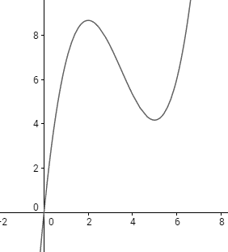

$\frac{dy}{dx}=0 when x=2 and x=5$
$\frac{dy}{dx}=\left(x-2\right)\left(x-5\right)=x^{2}-7x+10$
To find the original equation:
$\int{\left(x^{2}-7x+10\right)dx=\frac{1}{3}x^{3}-\frac{7}{2}x^{2}+10x+c}$
Again c doesn't change the stationary points so it can equal 0:
$y=\frac{1}{3}x^{3}-\frac{7}{2}x^{2}+10x$
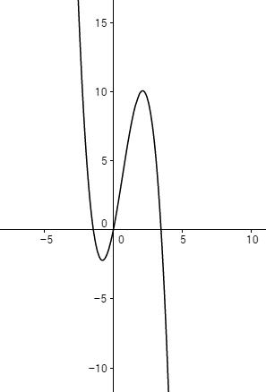
c.

$\frac{dy}{dx}=0 when x=-1$, but it must be a local minimum - has to be decreasing before x = -1 and increasing after x = -1.
You could check this using 2nd derivative of $f(x)$ but this would involve working backwards and it's easier to use if you have the curve and you're looking for stationary points, rather than the other way round.
A better way is to take values either side of x = -1 and check if it decreases before and increases after.
If we put $\frac{dy}{dx}=x+1, when x=-1, \frac{dy}{dx}=0$
$when x=-2,\frac{dy}{dx}<0$ which is a decreasing function
$when x=0,\frac{dy}{dx}>0$ which is an increasing function
So $\frac{dy}{dx}=x-1$ will give us a local minimum of -1.
We can just pick a random value for the other stationary point, since this doesn't make a difference.
e.g. local maximum at x = 5
$\frac{dy}{dx}=x-5$
To check if it's a local maximum:
$x=4, \frac{dy}{dx}=-1, -1<0$ - this is wrong because the function should be increasing at x = 4. So we should try the negative of x-5, -x+5:
$$\frac{dy}{dx}= -x+5$$
$when x= 4,\frac{dy}{dx}>0$ which is increasing
$when x=6,\frac{dy}{dx}<0$ which is decreasing
Now we need to put the local maximum and minimum together in the full dy/dx:
$\frac{dy}{dx}=\left(x+1\right)\left(-x+5\right)$
$$= -x^{2}+4x+5$$
Now integrate to find the original function:
$\int{\left(-x^{2}+4x+5\right)dx= -\frac{1}{3}x^{3}+2x^{2}+5x+c}$
Constant doesn't matter, so$y=-\frac{1}{3}x^{3}+2x^{2}+5x$
d.
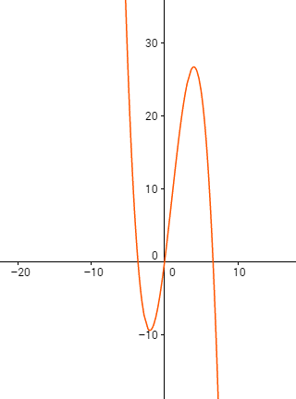
f(x) needs to be increasing before x = 4 and decreasing after it, and the opposite for x = -2.
$\frac{dy}{dx}=0 when x=-2 and x=4$
$\frac{dy}{dx}=x+2$
$\frac{dy}{dx}=-x+4$ (checking either side of x, these equations match the increasing/decreasing functions)
$\frac{dy}{dx}=\left(x+2\right)\left(-x+4\right)$
$$=-x^{2}+2x+8$$
$\int{\left(-x^{2}+2x+8\right)dx= -\frac{1}{3}x^{3}+x^{2}+8x+c}$
The c doesn't matter so $y=-\frac{1}{3}x^{3}+x^{2}+8x$

