

'The Mathemagician's Spells'
Tell me the next two numbers in each of these seven minor spells, chanted the Mathemagician, and the great spell will crumble away!
Next Numbers: 16, 32 , 64
The Rule is to double the number each time.
Spell the first: | 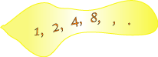
Spell the second: | 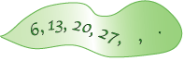  Next Numbers: 7, 3  Well for the first one you take away 64 then you keep taking away half of that.  Next Number3: 34, 41  The Rule is to plus seven each time.
Spell the third: | 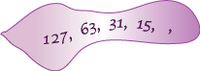
Spell the fourth: | 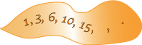  Next Numbers: 21, 28  The Rule is to add on 2 then 3, 4, 5, 6, 7 so you just add 1 more each time.
Spell the fifth: | 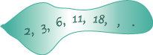  Next Numbers: 27, 38  The Rule is to add on 1 then 3 then 5 and keep adding on the next highest odd number.
Spell the sixth:
Next Numbers: 125, 216
This one was hard! We had to check out the hint – which was “cubes” and then Rory figured out that if you make cubes that increase in size up and out, it worked. Therefore the rule is that each time you are cubing a number (eg you times the number by itself twice) starting with 1 x 1 x 1, then 2x 2x2. This means the 5th number in the sequence would be 5 cubed (125)

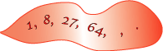
Spell the seventh:

Next Numbers: 18, 12
The rule is taking off the multiples of 6 backwards beginning with 48.
