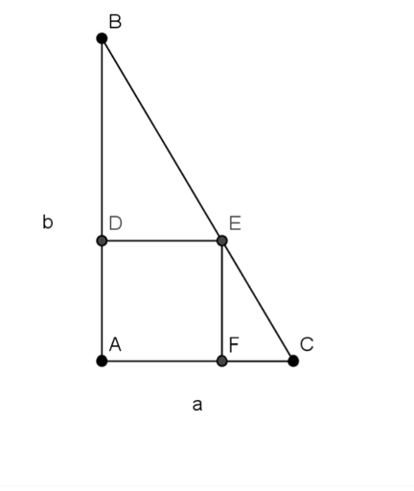
Method 1: I first figured out how to use method 1 to solve for $x$ in the triangle with the height of 6 units and a base of 3 units. First I noticed where the similar triangles are. I saw two similar triangles, triangle CFE and triangle CAB, these are similar triangles by the AA similarity theorem. Both triangles are right angle triangles and angle C is shared by both triangles. Now I made a similarity ratio so I did $\frac{CF}{EF}=\frac{CA}{BA}$
Now CF=3-x, EF=x, CA=3, BA=6, so now we have $\frac{3-x}{x}=\frac{3}{6}$to solve for x we can use cross multiplication…
$6\left(3-x\right)=3x$
$18-6x=3x$
$18=9x$
$2=x$
Now I thought if I went through the same process but using a and b, I could make a general formula for $x$so that is what I did, I used the same process and I got $\frac{a-x}{x}=\frac{a}{b}$Now I used cross multiplication to get..
$b\left(a-x\right)=ax$
$ba-bx=ax$
$ba=ax+bx$
$ba=x\left(a+b\right)$
$\frac{ba}{a+b}=x$

Method 2:
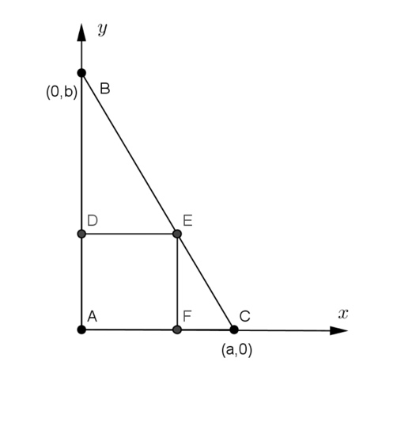
To use method 2 I first started by labeling point F to be (k,0)
Because point F is an unknown distance from the origin but point F lies on the x-axis. Now I know point E has the same x-coordinate but I also know point E is $k$ units from the x-axis because since we are dealing with a square and we see the distance from point A to F is k units, so that means the distance from point F to E should be k units. So point E would have the coordinates $\left(k,k\right)$ now I decided to find the equation of line BC, so first I found the slope to be $-\frac{b}{a}$ And then I found the y-intercept to be $\left(0,b\right)$
Now I wrote my equation of the line in slope-intercept form so now I have $y=-\frac{b}{a}x+b$
Now I plugged in point E into the equation I did this because the x and y coordinates of Point E are actually the measure of the side length of the square so now I have $k=-\frac{b}{a}k+b$
Now since $k$ represents the side length of the square I am going to solve the equation for $k$
$k+\frac{b}{a}k=b$
$k\left(1+\frac{b}{a}\right)=b$
$k=\frac{b}{1+\frac{b}{a}}$
$k=\frac{\frac{b}{a+b}}{a}$
$k=b*\frac{a}{a+b}$
$k=\frac{ba}{a+b}$
And now we have the same formula we got using method 1 for solving for the side length of the square.
Method 3:
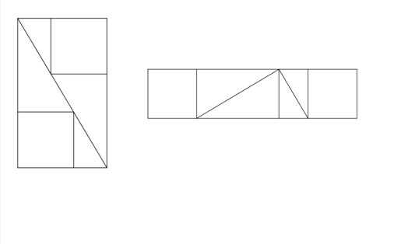
To use method 3 first I found out how rectangle 1 became rectangle 2. To make rectangle 2 we pretty much just rearrange all the separate geometric shapes from rectangle 1 and we will result in a figure with the same area as rectangle 1, and the reason for this is because if I were to find the area of rectangle 1 I can take the sum of all the areas of the separate geometric figures(so the 2 squares and the 4 triangles. Now since I am just taking the same separate geometric shapes and just rearranging them so now I will just add the areas of each separate geometric figure and since the same figures are used in both rectangles I will have the sum of figures with the same area as before so both rectangle 1 and rectangle 2 will have the same area. Now first I tried to use this method with right triangles of height 6 units and base 3 units. I decided to find the areas of both rectangles in terms of $x$ (the side length of the square) so first I found the area of rectangle 1 and I got the area to be 18 units², now to find the area of rectangle 2 I first found the length and the length was 9, after that I found the width to be $x$ so the area of rectangle 2 is $9x u^{2}$
Since I already showed both rectangles are equivalent in area I got $18=9x$ and I got $x=2$
Now I wanted to generalize this for any height and width. So instead of using 6 and 3 I used a and b, I used the same method I used for 6 and 3 and ended up getting the equation of the areas of rectangle 1 and rectangle 2 to be $x\left(a+b\right)=ab$
Now I have the general formula $x=\frac{ab}{a+b}$

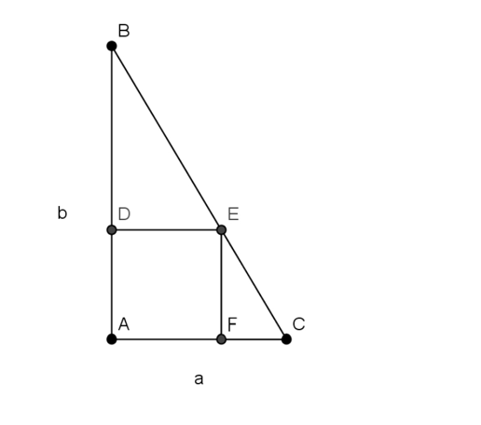
The first time I saw this question, because I saw right triangles I thought if I could use trigonometry to solve for the side length of the square. I then started to generalize the trigonometry method I used into a formula for $a$and $b$ so….
First I saw that both triangle BAC and EFC are right triangles, so I decided to find for the measure of BCA and then use the measure of angle BCA to use more trigonometry to solve for the side length of the square. So I am going to call BCA angle $z$ now since I have a right triangle I can say $\tan\left(z\right)=\frac{b}{a}$ now to solve for $z$ I am going to take the arctangent of $\frac{b}{a}$ so now I have $z=\tan^{-1}\left(\frac{b}{a}\right)$ now I will call the side length of the square $x$. I also know that $\tan\left(z\right)=\frac{x}{a-x}$ Where x is the side length of the square(This tangent is taken from angle $z$ being in triangle CFE) now I know $tan⁡(\tan^{-1}\left(\frac{b}{a}\right))=\frac{x}{a-x}$ now I will multiply by $a-x$ on both sides to get $tan⁡(\tan^{-1}\left(\frac{b}{a}\right))(a-x)=x$ now I am going to distribute so I get $a*tan⁡(\tan^{-1}\left(\frac{b}{a}\right))-x*tan⁡(\tan^{-1}\left(\frac{b}{a}\right))=x$ now I am going to add $x*tan⁡(\tan^{-1}\left(\frac{b}{a}\right))$ to both sides so now I have $a*tan(⁡\tan^{-1}\left(\frac{b}{a}\right))=x+x*tan⁡(\tan^{-1}\left(\frac{b}{a}\right))$ now I divided the whole right side of the equation by $x$ to get $a*tan⁡(\tan^{-1}\left(\frac{b}{a}\right))=x(1+tan⁡(\tan^{-1}\left(\frac{b}{a}\right))$ so once I solved for $x$ I got $x=a*tan⁡(\tan^{-1}\left(\frac{b}{a}\right))/(1+tan⁡(\tan^{-1}\left(\frac{b}{a}\right))$ where $b≥a$.

