The Square Under the Hypotenuse
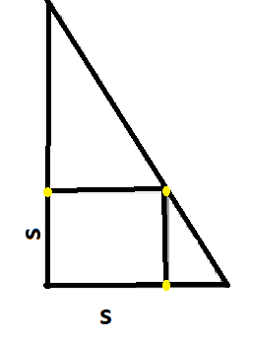
Constructing the Square
To construct the square, I would first work out the length of the square and mark the measure on the sides adjacent to the hypotenuse. I would then extend the point made on the base of the triangle to a point on the hypotenuse using a line perpendicular to the base. Lastly, I would extend the point on the other side of the triangle to the point made on the hypotenuse to form the square.

Solution 1
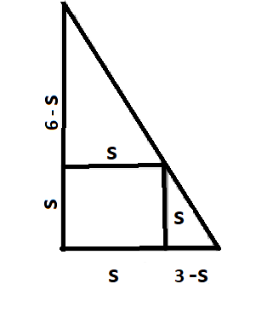
I first assumed that the side of the square measured ‘S’. So the length of the left over part of the base was 3 – S.
Similarly, the left over part of the height of the triangle was 6 – S.
I proceeded to use the Pythagoras theorem to find out the length of the hypotenuse using the length of the other two sides. This turned out to be $√45$.
I noticed that the sum of the hypotenuse of the 2 smaller triangles added up to the hypotenuse of the larger triangle.
So, $\sqrt{s^{2} +{\left(6-s\right)}^{2}}$ + $\sqrt{s^{2}+{(3-s)}^{2}}$ = $√45$
$\sqrt{{2s}^{2}-12s+36}$ + $\sqrt{2s^{2}-6s+9}$ =$\sqrt{45}$
Squaring both sides gave me the following equation:
$${4s}^{2}-18s=-2\sqrt{{4s}^{4}-36s^{3}+162s^{2}-324s+324}$$
After squaring the above equation and manipulating it a bit, I got the following:
$$s^{2}-4s+4=0$$
$$→\left(s-2\right)\left(s-2\right)=0$$
$$∴s=2$$

Solution 2
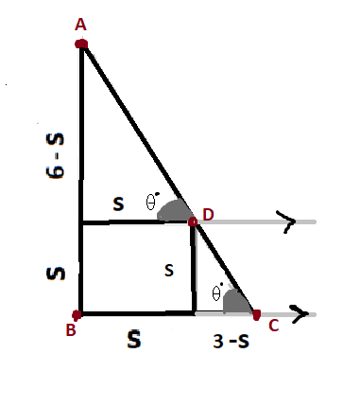
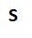
I started by equating angle C to theta and then extended the set of parallel lines that made up the square. I noticed was a transversal and therefore, angle C would equal angle D as they were corresponding angles.
Tan θ= $\frac{Opposite}{Adjacent}$
$∴$Tan θ= $\frac{6-S}{S}$
$∴$Tan θ= $\frac{S}{3-S}$
$$→\frac{6-S}{S}=\frac{S}{3-S}$$
$→\left(6-s\right)\left(3-s\right)=s^{2}$
$$→s=2$$

The General Formula
Let the sides adjacent to the hypotenuse be a and b.
Using ‘Method 2’, we can say that
$$\frac{a-S}{S}=\frac{S}{b-S}$$
$$\left(a-s\right)\left(b-s\right)=s^{2}$$
$$ab-sa-sb+s^{2}=s^{2}$$
$$ab-s\left(a+b\right)=0$$
$$ab=s(a+b)$$
$$→\frac{ab}{a+b}=S$$

METHOD 1
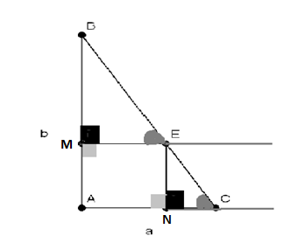

Since lines ME and AC are parallel and EC is a transversal of these lines, angle BEM = angle C.
Angles of a square are all 90$°$. Therefore,
Angle BME = ENC = 90$°$
Therefore Angle B must equal Angle CEN. ( As angles in a triangle add up to 180$°$)

$∴$As all the angles are equal, BME and ENC are similar triangles
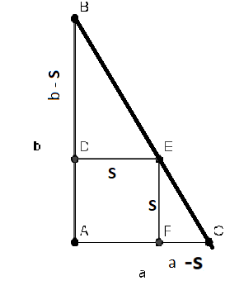
Since, they are similar we can say that the corresponding sides of the 2 triangles will be in the same ratio.
So, the following will hold true:
$$x=\frac{S}{a-S}$$
$$x= \frac{b-S}{S}$$
$$∴\frac{S}{a-S}=\frac{b-S}{S}$$
$$\left(a-s\right)\left(b-s\right)=s^{2}$$
$$ab-sa-sb+s^{2}=s^{2}$$
$$ab-s\left(a+b\right)=0$$
$$ab=s(a+b)$$
$→\frac{ab}{a+b}=S$

Method 2
The equation for a straight line is$y=mx+c$, where ‘$c$’ is the $y$-intercept, which in this case is ‘b’, and $m$ is the gradient which equals$\frac{y_{2 }{-y}_{1} }{x_{2}{-x}_{1}}$. To find the gradient I took the points (0, b) and (a, 0). Substituting these into the equation gave me $m=–b/a.$
$$→y=\left(-\frac{b}{a}\right)x+b$$
I then noticed that point ‘E’ would have the same values for the x and y coordinates as the lines connecting the point to the coordinate axes were the sides of the square and they are all equal. Therefore the x and y coordinates of ‘E’ would also equal the length of the square.
$$x=y=s (where s is the length of the square)$$
Substituting in ‘s’ for all ‘x’ and ‘y’ in the equation of the line gave me
$s=(-b/a)s+b$ . This when rearranged, gave me $s=\frac{ab}{a+b}$
Method 3
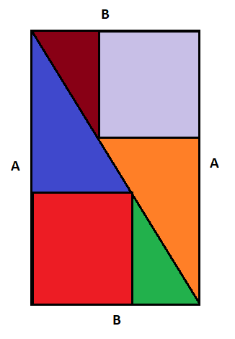

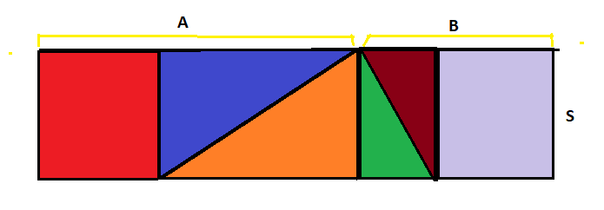

The area of the first rectangle would be $A*B$. The area of the second rectangle should be the same as the first rectangle as the constituent shapes of the first rectangle are rearranged to form the second rectangle. The area of the second rectangle can also be represented by the product of their sides which are $A+B$ and $S$.
So $A*B= (A+B)*S$ $→\frac{AB}{A+B}=S$

