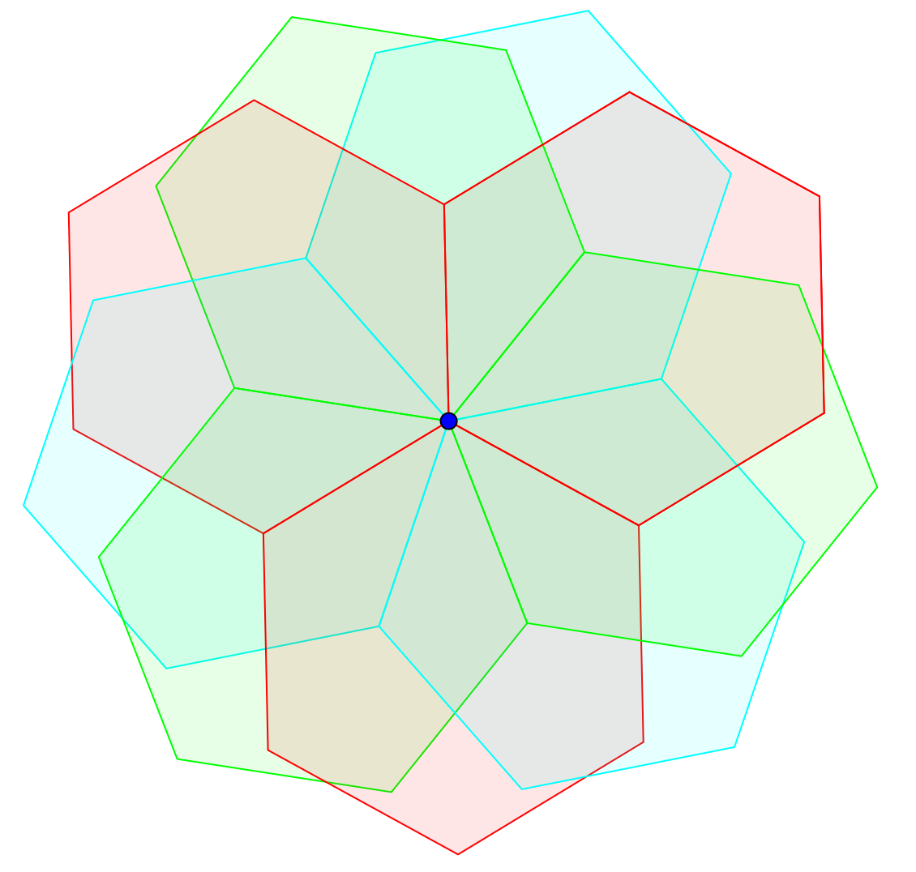
There are nine angles around the middle, and angles around a point equal 360º , and 360/9=40, so the middle angles are 40º each, which means that the shape was rotated using a 40º angle.

The shape rotated is a hexagon because it has 6 sides.

I worked out the rest of the angles by finding the different shapes in the design, and working out the angles in those shapes.

