Finding Circles:
To complete this task, I believe that knowing the equation of a circle ${(x-h)}^{2}+ {(y-k)}^{2}=r^{2}$ where h represents x and k represents y of the co-ordinates of the circle’s centre. Secondly, the being able to determine the mid-point of a line I found was crucial to this investigation where $\frac{x_{1}+x_{2}}{2},\frac{y_{1+}y_{2}}{2}$ gives the co-ordinates for the mid-point of a line. Lastly, the ability to find the equation of a perpendicular line where the gradients of the original equation and equation of the perpendicular line should = -1.
The points (3,8) and (5,2) lies at the ends of a diameter of a circle. What is the equation of the circle?
Since it is stated that these two points are ends of the diameter of this circle, it is possible to use the mid-point equation to find the middle which is also the centre of circle and thus lead to the equation of a circle equation. By applying the mid-point equation, $\frac{5+3}{2},\frac{8+2}{2}=\left(4,5\right).$ For the ${(x-h)}^{2}+ {(y-k)}^{2}=r^{2}$, r is determined via the use of Pythagoras Theorem where the ${rise}^{2}+{run}^{2}={gradient}^{2}$ and therefore $6^{2}+2^{2}=40{(which is the diameter)}^{2}$. Therefore the radius is $\sqrt{10}$. The equation for this circle is therefore ${(x-4)}^{2}+ {(y-5)}^{2}={10}^{2}$.
In the previous question, two points were enough to specify a circle. But is that always the case? For each of the following three statements, is the answer ALWAYS, SOMETIMES or NEVER? Justify your answers.
If we specify two (distinct) points in the plane, there is a unique circle that passes through them.
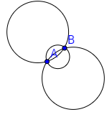
Two points in the problem above where enough to specify a circle, however, if the two points only make a chord, it is not possible to determine the equation of a circle. With two point, there are a multitude of ways a circle could be drawn, and therefore a unique circle cannot be made as shown by the diagram to the left.

If we specify three (distinct) points in the plane, there is a unique circle that passes through them.
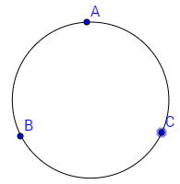
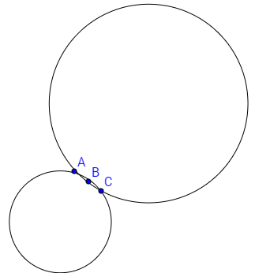
If three points are specified, it is always able to find the equation of that circle with the use of chords and perpendicular lines to find the centre point. However, three distinct points does not always determine a unique circle if the points are collinear. If the points aren’t collinear then a unique circle will be formed.
Diagram 2: Non- Collinear Points
Diagram Error! No text of specified style in document.-2: Collinear Points
If we specify four distinct points in the plane, there is a unique circle that passes through them.
The same restrictions apply to this question as to the one before. If the points are collinear, then more than one circle is possible, therefore making it not unique. However, if the points aren’t collinear, then it will make a unique circle.

So if we are given three points, we would like to find the equation of the circle that passes through them. How many ways can you find to do this using the given points below?
- A(3,2) B(3,6) C (5,8)
- A(0,4) B(4,0) C(-6,0)
- A(-1,-5) B(-2,2) C (2,-1)
- A(3,3) B(1,-2) C(4,1)
Simultaneous equations:
The first method I tried was simultaneous equations using the equation of a circle.
$$\begin{matrix}{(3-h)}^{2}+{(2-k)}^{2}=r^{2} \\ {(3-h)}^{2}+{(6-k)}^{2}=r^{2} \\ {(5-h)}^{2}+{(8-k)}^{2}= r^{2}\end{matrix}$$
Where h= 7, k=4 and r= $2\sqrt{5}$ and therefore the equation of the circle is ${(x-7)}^{2}+{\left(y-4\right)}^{2}=20$
$$\begin{matrix}{\left(-h\right)}^{2}+{\left(4-k\right)}^{2}=r^{2} \\ {(4-h)}^{2}+ {(-k)}^{2}=r^{2} \\ {(-6-h)}^{2}+{(-k)}^{2}=r^{2}\end{matrix}$$
Where h= -1, k= -1, r= $\sqrt{26}$ and therefore the equation of the circle is ${(x-(-1)}^{2}+{y-(-1)}^{2}=26$
$$\begin{matrix}{(-1-h)}^{2}+{(-5-k)}^{2}=r^{2} \\ {(-2-h)}^{2}+{(2-k)}^{2}=r^{2} \\ {(2-h)}^{2}+{(-1-k)}^{2}=r^{2}\end{matrix}$$
Where h= $-\frac{3}{2}$, k= $-\frac{3}{2}$, r=$\frac{5\sqrt{2}}{2}$ and therefore the equation of the circle is ${(x-(-\frac{3}{2})}^{2}+{(y-(-\frac{3}{2})}^{2}=\frac{25}{2}$
$$\begin{matrix}{(3-h)}^{2}+{(3-k)}^{2}=r^{2} \\ {(1-h)}^{2}+{(-2-k)}^{2}=r^{2} \\ {(4-h)}^{2}+{(1-k)}^{2}=r^{2}\end{matrix}$$
Where h= $\frac{7}{6}$, k = $\frac{5}{6}$, r= $\frac{\sqrt{290}}{6}$ and therefore the equation of the circle is ${(x-\frac{7}{6})}^{2}+{(y-\frac{5}{6})}^{2}= \frac{145}{18}$.
Construction of perpendicular lines with a compass & ruler:
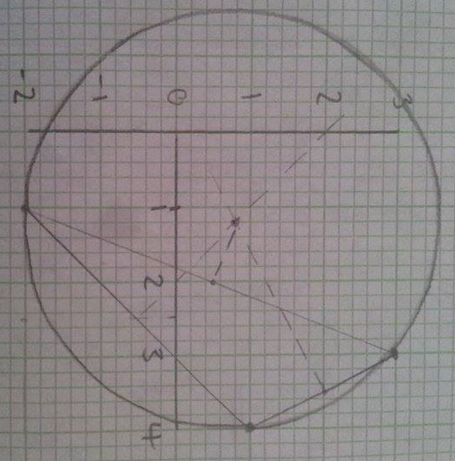
With the construction of this circle, the points are placed on the Cartesian Plane according to the first set of coordinates. These points are joined together to form chords, and ultimately, a triangle. Using the mid-point of a line equation, the middle of each line is found. A perpendicular bisector is then produced using a compass and marking a 90∘ angle from the point of each line. These are the dotted lines shown on the diagram to the left. From these dotted lines, the centre of the circle is found from where the lines intersect each other. At first, I thought to find the radius I had to use the gradient equation, $\frac{y_{2}-y_{1}}{x_{2}-x_{1}}$, where y and x are substituted with the centre of the circle coordinates and a point on the outside of the circle. Then I realised, this calculates to slope at which the linear functions increases or decreases rather than the actual length of the line. Therefore, I used Pythagoras’s theorem to determine to radius. These were the results for
- ${(x-7)}^{2}+{(y-4)}^{2}=20$
- ${(x-(-1)}^{2}+{(y-(-1)}^{2}= 26$
- ${(x-(-1.5)}^{2}+{(y-(-1.5)}^{2}=\frac{25}{2}$
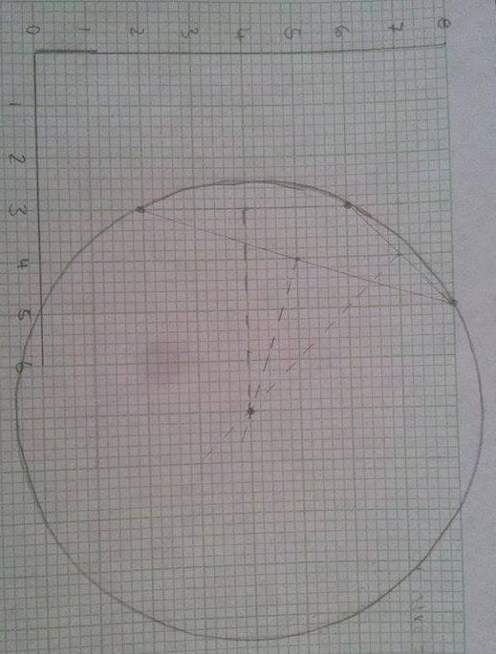
- ${(x-1.2)}^{2}+{(y-0.8)}^{2}=\frac{197}{25}$
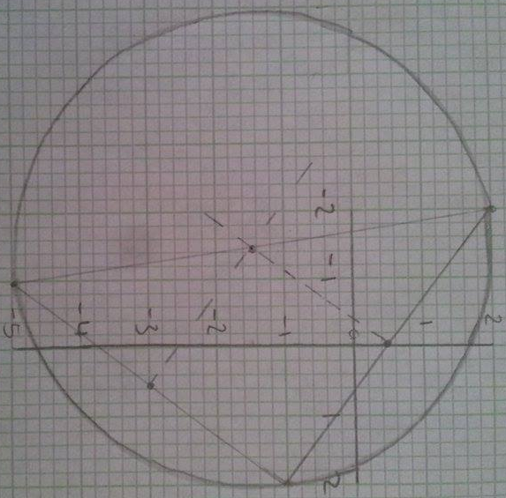
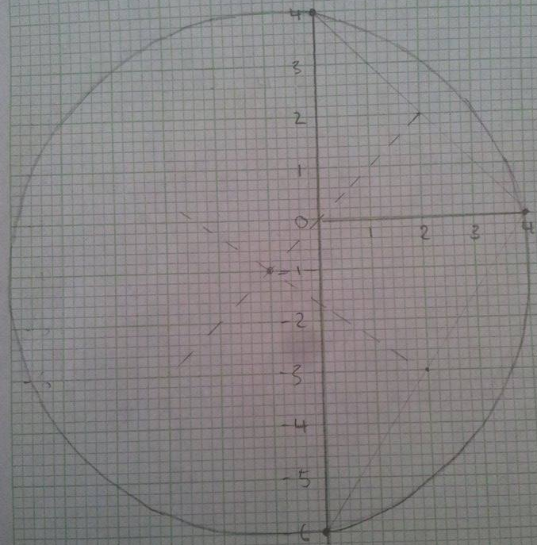

Perpendicular line equations:
This method I found a little bit long-winded but overall, I believe it produced accurate results. Firstly, the line of each equation must be solved. Then the mid-point of the line must be found so that its coordinates can be substituted into the perpendicular line. This is done for all the lines. Solve the equations together for x, and then, y. Demonstrating the first set of coordinates given, the line of the equations between (5,8) & (3,6), (5,8)& (3,2) and (3,6) & (3,2) are found via firstly the calculation of the gradient via the gradient formula. For the set (5,8) & (3,6) the gradient was 1. This is then substituted into the equation y=mx+c where m represents the gradient and c represents the y-intercept. From here, I can use either (5,8) or (3,6) to be substituted into the equation so that 8=5+c or 6=3+c where c= 3 in both instances and therefore the equation of this line is y=x+3. This method is then repeated for the remaining two coordinates. Using the (5,8) & (3,6) as an example again, the midpoint is found where $\left(\frac{5+3}{2}, \frac{8+6}{2}\right)=(4,7)$. To find the equation of the perpendicular line, $m_{1}m_{2}= -1$ and therefore the gradient for the perpendicular line of y=x+3 is -1 so that y=-x+c. The points (4,7) are substituted in to make 7=-4+c and therefore c= 11 to make the equation y=-x+11. These steps are repeated for the remaining two sets of coordinates where the coordinates (5,8) & (3,2) have a perpendicular line of y=-$\frac{1}{3}x+\frac{19}{3}$ and the coordinates (3,6) & (3,2) have a perpendicular line of y= 4. These equations are combined to find x as we know that y must be 4. $4= -\frac{1}{3}x+\frac{19}{3}=-x+11$ where x is 7 giving the midpoint (7,4) and thus the equation of the circle ${(x-7)}^{2}+{(y-4)}^{2}=20$.
The answers which I gained from this method were the same as the answers I gained from the simultaneous equations method for the rest of the remaining coordinates.
Which of your approaches is the most effective?
The second method used was the least effective and was solved geometrically rather than the more accurate algebraic methods. This is shown via the difference in answers for the 4th set of coordinates, although the margin of difference was small, it demonstrates the ineffectiveness in the method compared to the algebraic methods. Another problem associated with this method is the ruling and ensuring that the points marked are exact and that 90∘ is formed. The centre point could be misread if the scaling isn’t large enough, and thus the equation of the circle changes completely.
I believe that the 1st and 3rd method were the most effective as they both received the same answers and work algebraically to gain these results, however, in terms of time, I believe the simultaneous equations method is far quicker and easier to use than the perpendicular line equations method.

