3. Finding Circles

3.1 The points (3,8) and (5,2) lie at the ends of a diameter of a circle. What is the equation of the circle?

Since we are told that the points lie on the ends of a diameter of circle, if we find the midpoint of the two points we are able to find the centre of the circle as a co-ordinate. Having this enables us to use the general equation of a circle:

$${(x-a)}^{2}+{\left(y-b\right)}^{2}=r^{2}$$

So firstly by finding the midpoint, we would simply use formula of finding a midpoint.

$\frac{\left(x_{2}+x_{1}\right)}{2}=x coordinate of centre 'a'$→ $\frac{\left(5+3\right)}{2}$ → 4

$\frac{(y_{2}+y_{1})}{2}=y coordinate of centre 'b'$ → $\frac{(2+8)}{2}$→ 5

So the centre of this circle is at the point (4,5)

So now we have two of the needed variables, we need to find the radius of the circle ‘r’. This is done by finding the distance between one of the given points and the centre. Therefore the points that can be used are (3,8) or (5,2) and the centre (4,5).

This is done through the use of the distance between two points formula:
In this instance I have used the point (3,8) and the centre (4,5).

$\sqrt{{\left(y_{2}-y_{1}\right)}^{2}+ {\left(x_{2}-x_{1}\right)}^{2} }$ → $\sqrt{{\left(5-8\right)}^{2}+ {\left(4-3\right)}^{2} }=\sqrt{10 }$

∴ $r=\sqrt{10 }$

Now that we have all the variables we need for the equation, we can substitute them into the equation of the circle as mentioned above, which gives the equation of the circle to be:

$${(x-4)}^{2}+{\left(y-5\right)}^{2}={(\sqrt{10 })}^{2}$$

3.2 In the previous question, two points were enough to specify a circle. But is that always the case? For each of the following three statements, is the answer ALWAYS, SOMETIMES or NEVER? Do justify your answers!
3.2.1 If we specify two (distinct) points in the plane, there is a unique circle that passes through them.
No there is more than one circle that can pass through them. Say we use the points given in the previous question; there is always more than one circle.
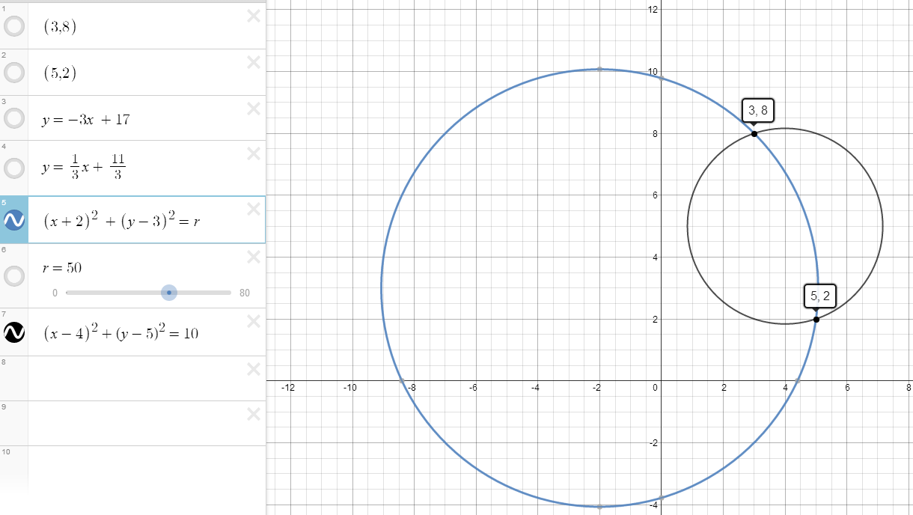
As you can see here, both these circles pass through the points (3,8) and (5,2) as labelled therefore if we are given two points in the plane, there is not a unique circle that passes through them.
Something to consider; the centres of the circles when given two points, all lie on a line that is perpendicular to the line that can be formed between the two given points, and passes through the midpoint of the two given points. For example with these points the centres of the circles all lie on the line:
$$y=\frac{1}{3}x+ \frac{11}{3}$$

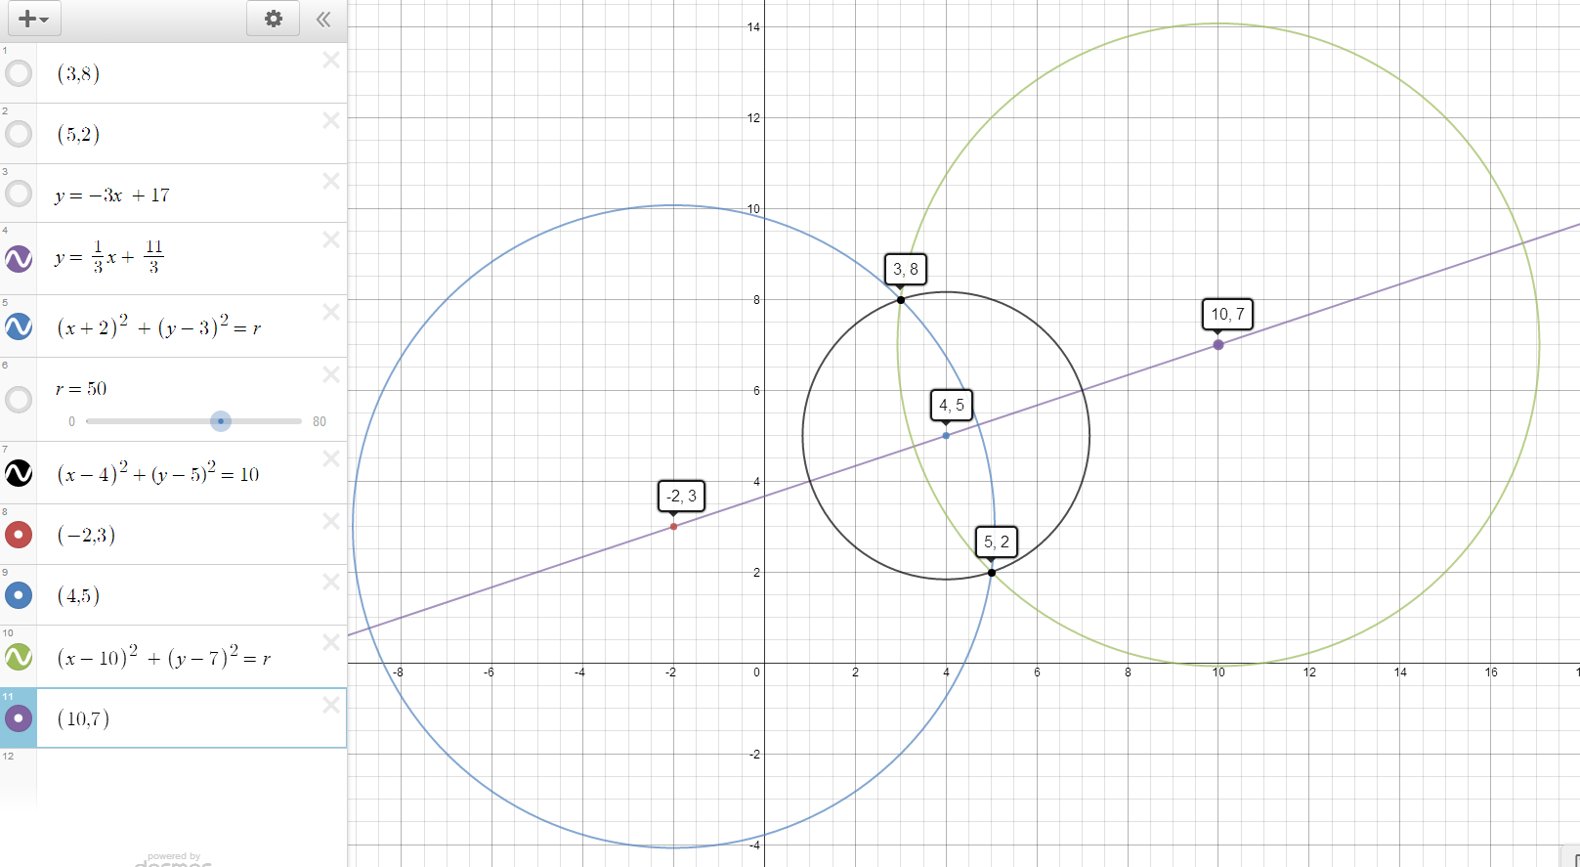
3.2.2 If we specify three (distinct) points in the plane, there is a unique circle that passes through them.

Yes. There is a unique circle however not always true. This is true because if you think about the equation of a circle, there are three unknowns in the general equation.

$${(x-a)}^{2}+{\left(y-b\right)}^{2}=r^{2}$$
With these three unknowns, if we are given three points, we can form three different conditions and thus solve. This allows only for one given solution and thus only a unique circle to pass through them. If we use the points such as (1,-1) (3,-3) and (8,9) for example, our three conditions would look similar too:

$\left\{\begin{aligned}{\left(x-1\right)}^{2}+{\left(y-1\right)}^{2}=r^{2} \\ {\left(x-3\right)}^{2}+{\left(y+3\right)}^{2}=r^{2} \\ {\left(x-5\right)}^{2}+{\left(y-9\right)}^{2}=r^{2}\end{aligned}\right\}$ x, y, r → $x= \frac{17}{2}, y=\frac{9}{4}, r= ±\frac{5\sqrt{37}}{4}$

Although it is given that r can be positive or negative, we cannot have a negative radius, and so only consider r to be positive, giving us only one set of solutions. Since only one set of solutions are generated we can confirm that there is a unique circle that passes through these three points.

This however is not always true if the three points are linear. If the points are all linear, a circle cannot be produced that passes through them all as no set of solutions can be made. This is because no matter where the centre of the circle might be, the distance from the centre of the circle to each of those points will be different.

3.2.3 If we specify four (distinct) points in the plane, there is a unique circle that passes through them.
There is not always a unique circle that passes through them. This can only happen if the points do happen to lie on a circle where the distance between the radius and the points are all the same. However this is a highly unlikely chance and if you are given four random points, a unique circle will most likely not pass through them.
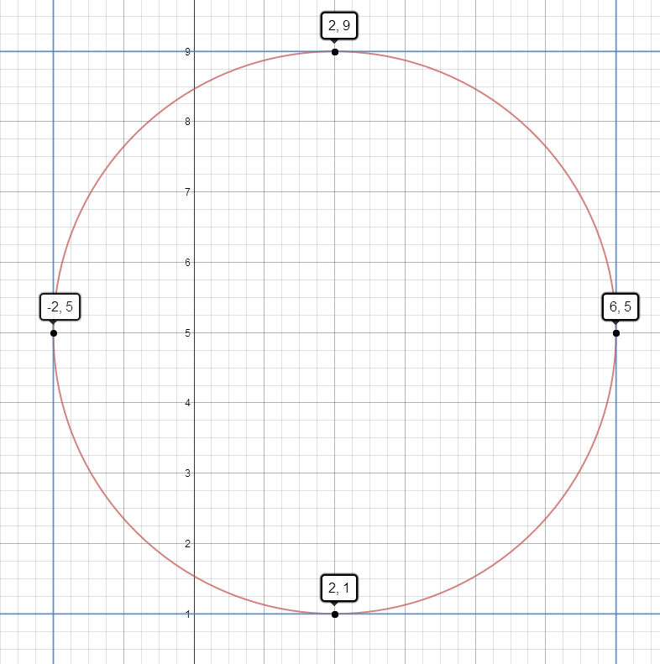
For example in the diagram above, if the four points happen to lie on a circle, there is a unique circle that passes through them. However if in the instance you are given four random points as shown in the diagram below, that don’t fall on a circle, there will not be a unique circle that passes through them all.

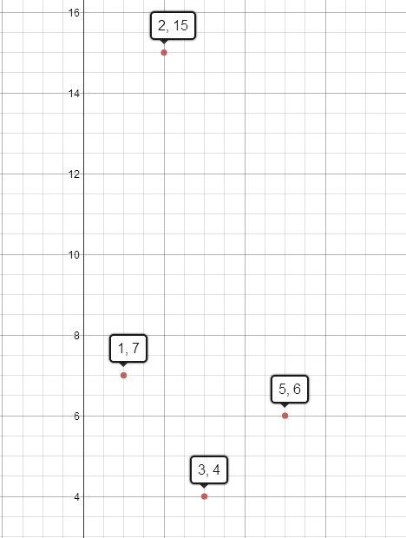

The points selected above are randomly selected and as you can see, they have no given shape to show that they lie on a circle.

3.3 We now know that given three distinct points in the plane, there is (usually) a unique circle passing through them. For each set of three points, find the equation of the circle passing through them.

3.3.1 (3,2), (3,6), (5,8)

$\left\{\begin{aligned}{\left(x-3\right)}^{2}+{\left(y-2\right)}^{2}=r^{2} \\ {\left(x-3\right)}^{2}+{\left(y-6\right)}^{2}=r^{2} \\ {\left(x-5\right)}^{2}+{\left(y-8\right)}^{2}=r^{2}\end{aligned}\right\}$ x, y, r → $x= 7, y=4, r= 2\sqrt{5}$

$${(x-7)}^{2}+{\left(y-4\right)}^{2}={(2\sqrt{5})}^{2}$$

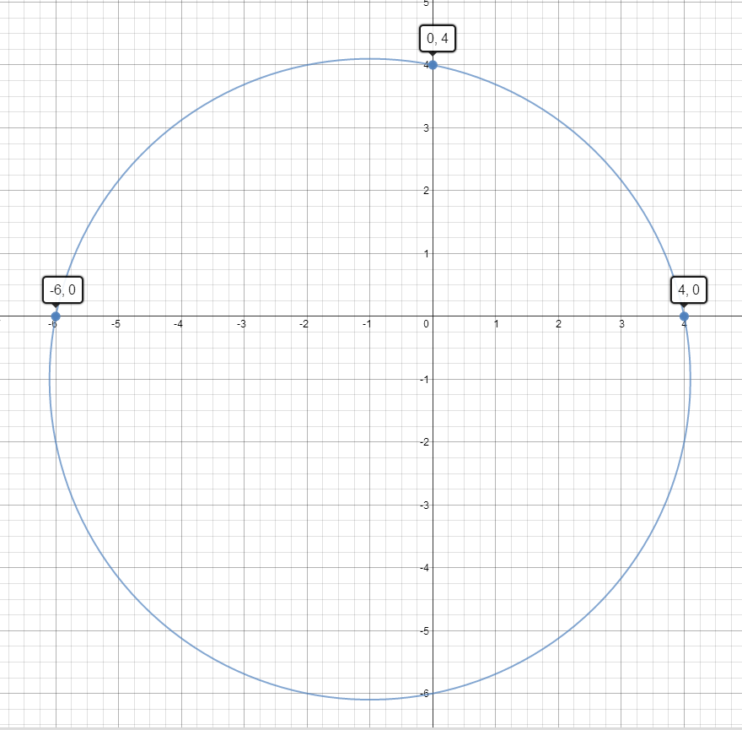
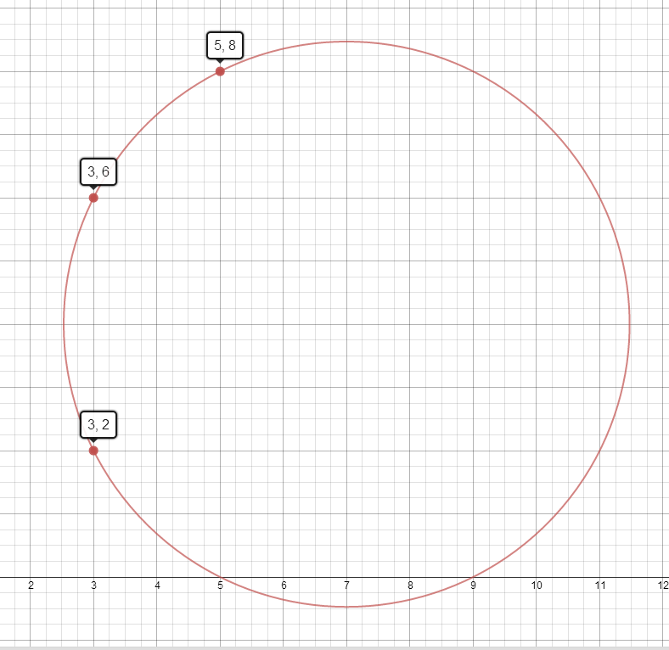

Figure 3.3.2 for Q 3.3.2
Figure 3.3.1 for Q 3.3.1

3.3.2 (0,4), (4,0), (−6,0)

$\left\{\begin{aligned}{\left(x-0\right)}^{2}+{\left(y-4\right)}^{2}=r^{2} \\ {\left(x-4\right)}^{2}+{\left(y-0\right)}^{2}=r^{2} \\ {\left(x+6\right)}^{2}+{\left(y-0\right)}^{2}=r^{2}\end{aligned}\right\}$ x, y, r → $x=-1, y=-1, r= \sqrt{26}$

$${(x+1)}^{2}+{\left(y+1\right)}^{2}={(\sqrt{26})}^{2}$$

3.3.3 (−1,−5), (−2,2), (2,−1)

$\left\{\begin{aligned}{\left(x+1\right)}^{2}+{\left(y+5\right)}^{2}=r^{2} \\ {\left(x+2\right)}^{2}+{\left(y-2\right)}^{2}=r^{2} \\ {\left(x-2\right)}^{2}+{\left(y+1\right)}^{2}=r^{2}\end{aligned}\right\}$ x, y, r → $x= -\frac{3}{2}, y=-\frac{3}{2}, r= \frac{5\sqrt{2}}{2}$

$${(x+\frac{3}{2})}^{2}+{\left(y+\frac{3}{2}\right)}^{2}={(\frac{5\sqrt{2}}{2})}^{2}$$

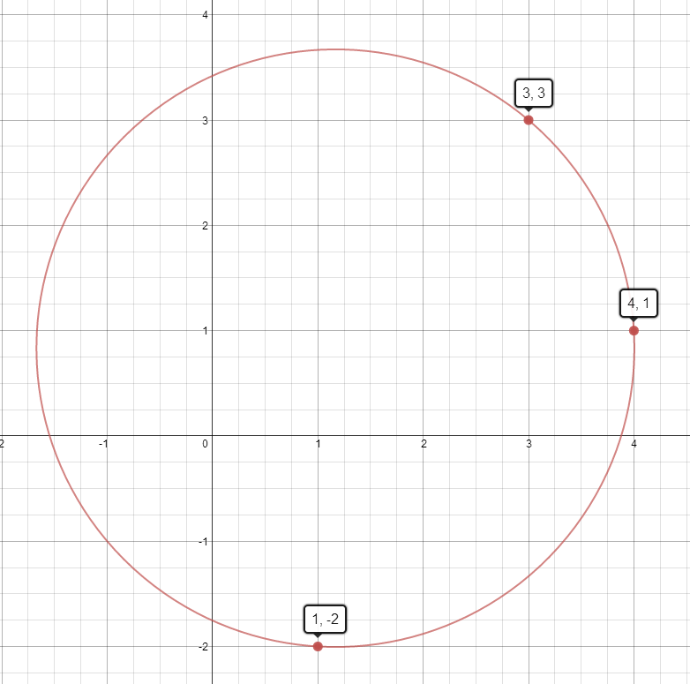
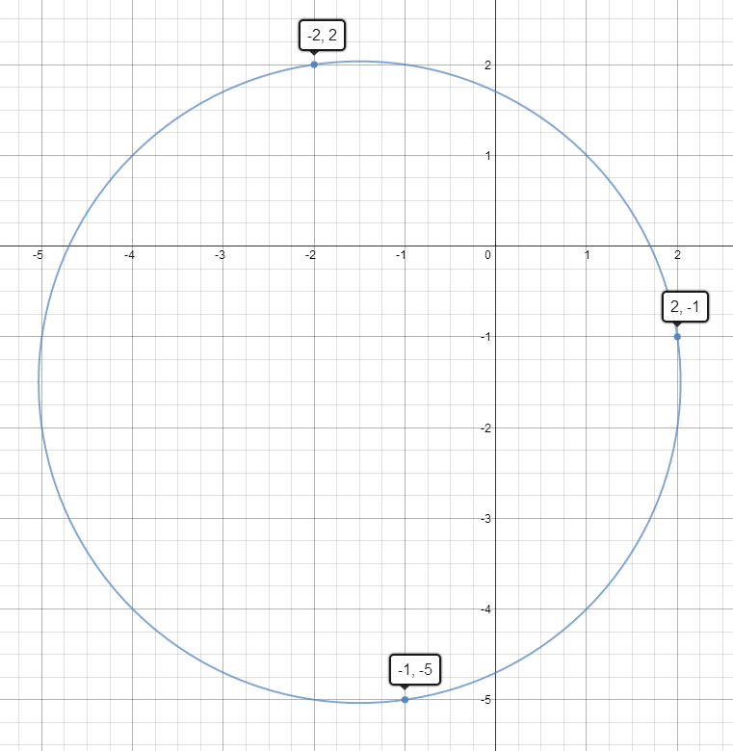
Figure 3.3.4 for Q 3.3.4
Figure 3.3.3 for Q 3.3.3

3.3.4 (3,3), (1,−2), (4,1)

$\left\{\begin{aligned}{\left(x-3\right)}^{2}+{\left(y-3\right)}^{2}=r^{2} \\ {\left(x-1\right)}^{2}+{\left(y+2\right)}^{2}=r^{2} \\ {\left(x-4\right)}^{2}+{\left(y-1\right)}^{2}=r^{2}\end{aligned}\right\}$ x, y, r → $x= \frac{7}{6}, y=\frac{5}{6}, r= \frac{\sqrt{290}}{6}$

$${(x-\frac{7}{6})}^{2}+{\left(y-\frac{5}{6}\right)}^{2}={(\frac{\sqrt{290}}{6})}^{2}$$

3.4 So if we are given three points, we would like to find the equation of the circle that passes through them. How many ways can you find to do this?

3.4.1 The first way in finding the equation of the circle that passes through all three points would be the way as investigating earlier in this investigation. This is by writing three conditions to solve for the three unknownvariables in the general equation of a circle being:

$${(x-a)}^{2}+{\left(y-b\right)}^{2}=r^{2}$$

Where a and b are (a,b) are the co-ordinates of the centre of the circle, and r is the radius. We then sub in three known points in place of the a and b to form three conditions such as done as previously when working out the equations of the circle passing through the three points (as above). From this we solve x, y and r, and input the x value as the a variable, the y value as the b variable and the r value for the r variable to form our equation of a circle.

3.4.2 The second way of finding the equations of the circle that passes through all three points is by graphing the points on a graph on desmos (or any other computer graph). We would then write equations of a circle that is centered at each of the points and for the radius of the circle, we would use r (or any other variable) and use a slider on this variable. We would then increase the length of the slider r, until the first point where all three circles would intersect. This point would be the centre of the new circle. We then click where they intersect to find out the centre of the circle, and we would read the value given for r (value on the slider) and that would be the radius of the new circle. From here we can form a new equation of the circle. For example if we used the points (3,2), (3,6), (5,8)

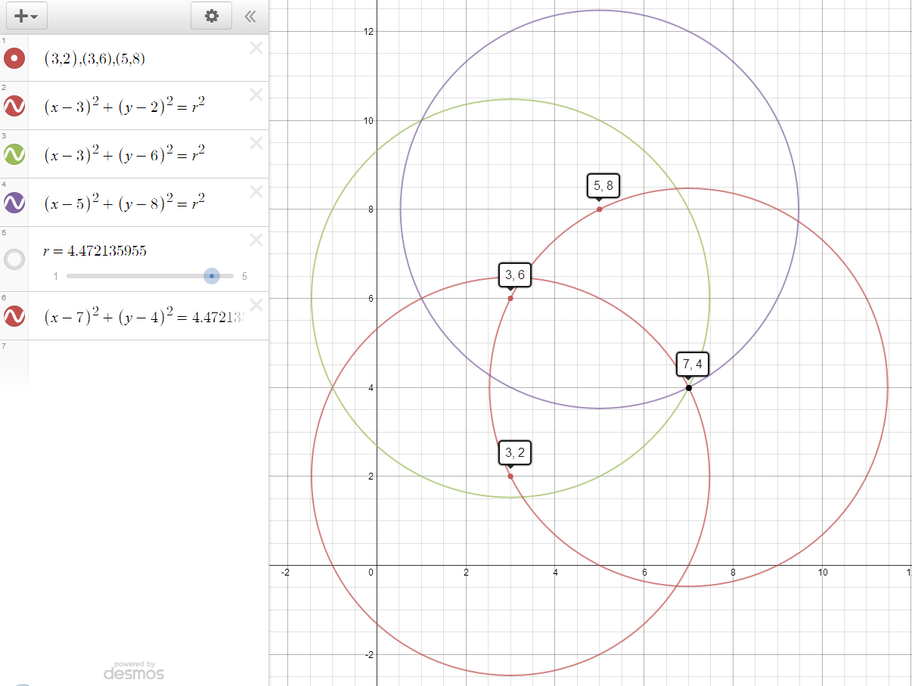
Thus the equation of the circle to be:
$${ (x-7)}^{2}+{\left(y-4\right)}^{2}={(4.472135955)}^{2}$$
$${or (x-7)}^{2}+{\left(y-4\right)}^{2}={(2\sqrt{5})}^{2}$$
3.4.3 The third approach that I have found is by drawing perpendicular lines. In this method we would graph the three given points, and draw a triangle with them. From this if done by hand, I would measure with a protractor 90 degrees from halfway of each line of the triangle, and draw in the perpendicular lines. These three lines would then intersect at one point, which is the centre of the new circle. If done to scale I would measure with a ruler the distance between the centre and one of the points, otherwise I would use the distance between two points formula to calculate the distance, and substitute into the equation of a circle.
i.e. {using point (3,2) and the centre (7,4)}
$\sqrt{{\left(y_{2}-y_{1}\right)}^{2}+ {\left(x_{2}-x_{1}\right)}^{2} }$→ $\sqrt{{\left(4-2\right)}^{2}+ {\left(7-3\right)}^{2} }=\sqrt{20 }$=$2\sqrt{5}$
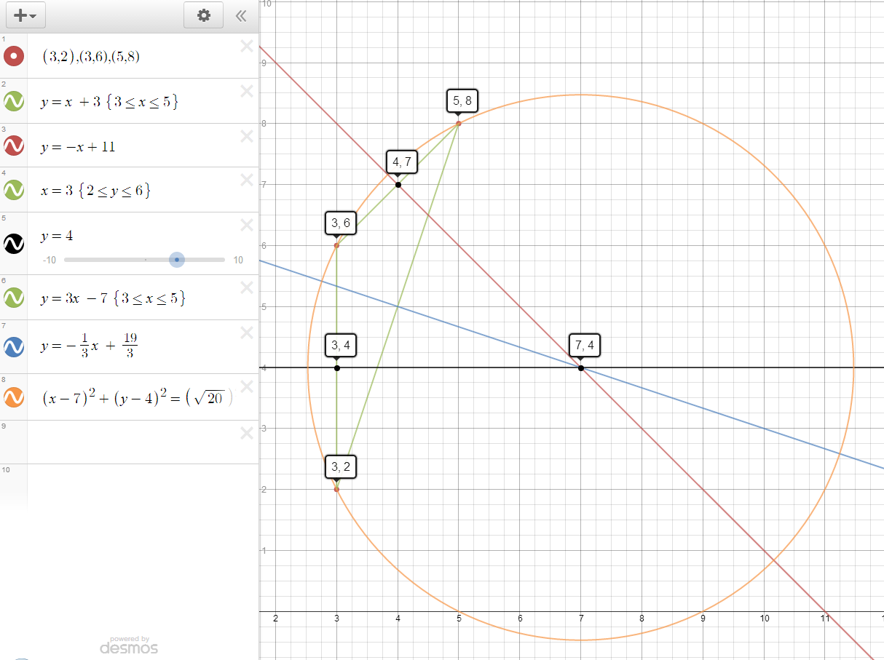
Thus the equation of this circle is:
$${(x-7)}^{2}+{\left(y-4\right)}^{2}={(\sqrt{20})}^{2}$$
$${ or (x-7)}^{2}+{\left(y-4\right)}^{2}={(2\sqrt{5})}^{2}$$

Alternatively if this is done through a computer or a series of equations, I would find the equation to draw the triangle by finding the equation between two points. Firstly by finding the gradient, then substituting a point into the y = mx + c general formula. This can be seen by the green coloured lines in the image above. From here I would find the line that has a perpendicular gradient to the lines I have found, as well as finding the midpoint of the line that is between the two points. Substituting the new gradient into y = mx + c and the midpoint, I would solve for c and thus find the line perpendicular. Similarly where these three lines intersect at one point, is the location of the centre of the new circle. Using the calculated distance between one point and the centre of the circle (the radius) I would substitute into the general equation of a circle to find the equation of the circle to be.
$${(x-7)}^{2}+{\left(y-4\right)}^{2}={(\sqrt{20})}^{2}$$
$${ or (x-7)}^{2}+{\left(y-4\right)}^{2}={(2\sqrt{5})}^{2}$$

3.5 Which of your approaches is the most effective?

Of these three methods, the first methods if done with the aid of a ClassPad would be the most efficient way. This is simply because one involves inputting a simultaneous equation into your calculator and solving the unknown variable before substituting into the general equation of a circle to find the equation.

The second method if done with the aid of a computer graphing program, would be the most efficient way as it is as simple as inputting three equations and moving a slider until all three circles intersect, clicking the intersection point to find the co-ordinates of the circle and then calculating the distance between one point and the centre before substituting into the general equation of a circle to find the equation.

However if this was done all manually, the third method of drawing a triangle and it’s perpendicular lines would be the most efficient way. This only requires graph paper, a ruler and a protractor and can be easily done to find the centre point quickly, then calculating the distance between two points to find the radius which can all be done by hand, before substituting into the general equation of a circle to find the equation.

Of these approaches if you are given a ClassPad, the first method would be easiest, if you are given a computer graphing program, the second method would be easiest and if this is to be done manually the third method would be easiest.

